OPPID Copy/Rename of File
- Create PID1.dgn – Pump, Tank, Line, Valve and Instrument.
- Synched this file to the DB.
- Exit OpenPlant PowerPID.
- Create copy of PID1.dgn file.
  - For a Non ProjectWise environment
    - In Windows Explorer copy PID1.dgn and rename the copy to PID2.dgn
  - In ProjectWise Explorer
    - Select PID1.DGN
    - Right click Copy
    - Right click Paste
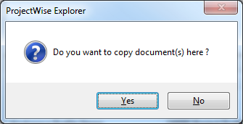
    - Select Yes
    - Use the Advanced Wizard
    - Go through prompts and rename to PID2.DGN
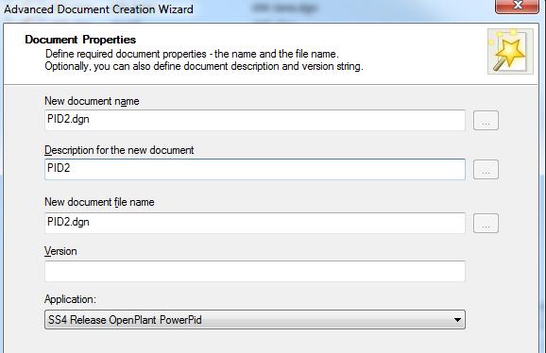

- Open the file
  - Non ProjectWise
    - Launch OpenPlant PowerPID.
    - Open PID2.dgn
  - In ProjectWise
    - Right click and open PID2.dgn
- When prompted with the dialog that asks “Has this drawing been moved or renamed OR has this drawing been copied” – Select the Copied option.
  - THIS will automatically initiate the disassociate command in the background and instruct the user to exit and reopen the file.
- Exit the file as requested.
- Open the file
  - Non ProjectWise
    - Launch OpenPlant PowerPID.
    - Open PID2.dgn
  - In ProjectWise
    - Right click and open PID2.dgn
- The system then prompts to pick the project that is desired to associate the file to (This is because the project DB variables are NOT hardcoded in the project PCF file. If this is hardcoded you will not get this prompt.)
  - Increment or change the tag number
  - Synch DGN->DB

