How to supplement a schema

Introduction
The OpenPlant_PID schema that is delivered with OpenPlant Power P&ID is a schema that combines the informational OpenPlant schema and the behavioral schemas bmf , schamtics and pid. The OpenPlant schema represents the ISO 15926 standard. The schemas bmf, schematics and pid contain the functional definitions and .Net function calls. Neither the OpenPlant schema nor the behavioral schemas should be changed in any way.
You could make changes in the OpenPlant_PID schema itself (add derived classes, add properties and custom attributes) but this schema is maintained and enhanced with every version. If you only want to alter existing classes and properties you should make the changes in a supplemental schema. You can open a supplemental schema directly in the ECClassEditor but supplementing the main schema gives you a much more comprehensive view on supplemented classes and properties.

- Launch the ECClassEditor and open the OpenPlant_PID schema in the schemas folder of your project.
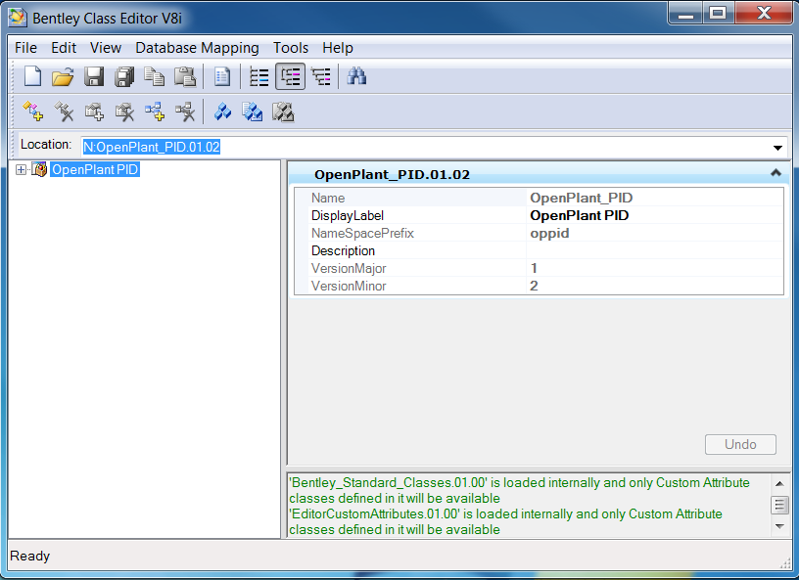
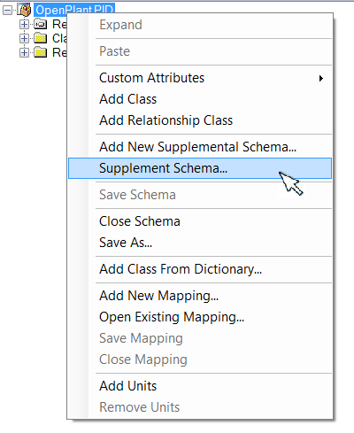
- Right-click the class title in the tree view and select “Supplement Schema…” from the context menu.

The Specify Supplement Schemas dialog box is displayed
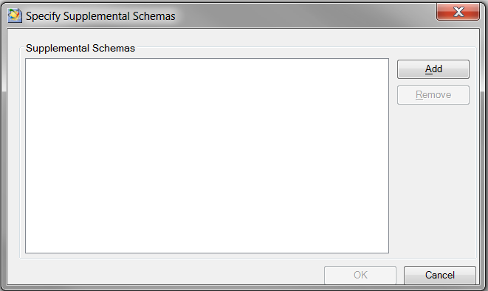
- Click the “Add” button
- If necessary navigate to your project’s schemas folder 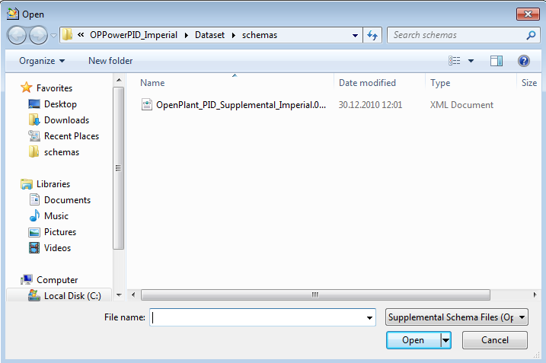
- Select the schema OpenPlant_PID_Supplemental_Imperial.01.02.ecschema and click Open
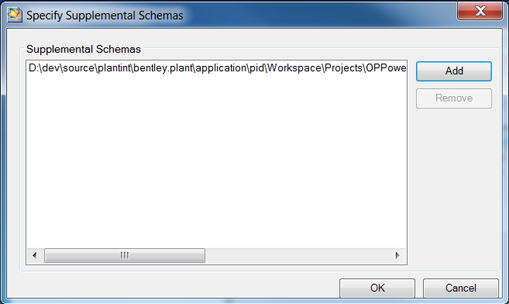
- The schema OpenPlant_PID is now displayed as “Supplemented”
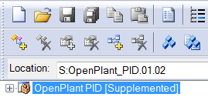
- Expand the schema OpenPlant_PID schema and also expand Classes > Plant Base Object > Named Item.
- Select the class Device and observe that this class has a custom attribute ECB Component Custom Attribute and that it is indicated that this custom attribute is defined in the supplemental schema
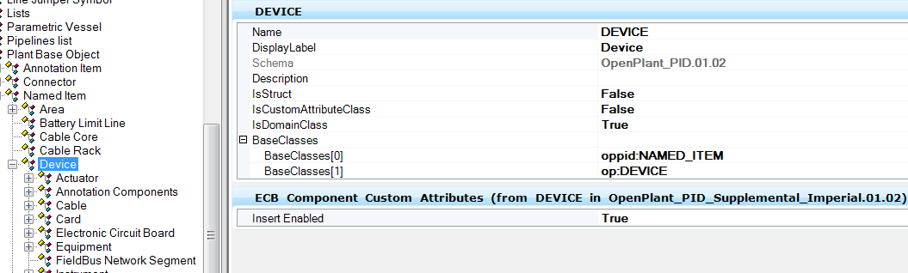
- Select the Properties tab and select the property Area. Observe that there are custom attributes that are directly defined in the OpenPlant_PID schema (Category) and other custom attributes that are defined in the supplenal schema (e.g. PropertyPriority)

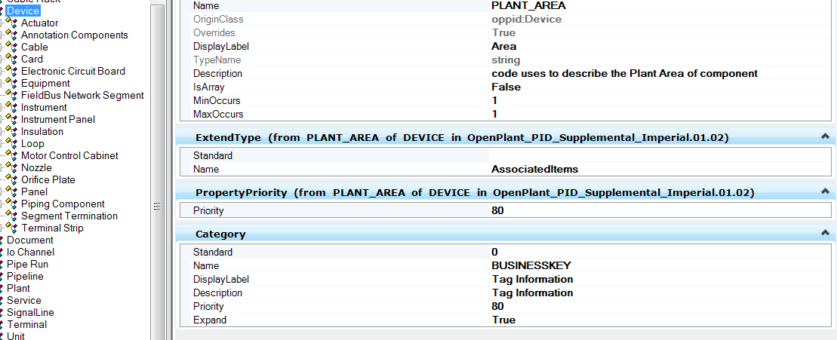

- What you can do and cannot do in a supplemental schema
  - In a supplemental schema you can add or change a custom attribute of an existing class or property
  - In a supplemental schema you cannot add a class or property. You cannot change the display label of an existing class or property

