Class Editor Schema Differencing
Document Type: TechNote
Product(s): OpenPlant PowerPID
Version(s): Selectseries 3+
Original Author: Class Editor Help

Description
You can compare one schema with a different schema, or you can compare different saved copies of the same schema.
The results of the comparison are displayed in the left pane of the Schema Differencing dialog. The results are displayed with respect to the target schema only.
The differences are color coded as follows:
- Gray (No Difference) — Specifies classes, properties, and/or relationships that are the same in the source and target schemas.
- Green (New) — specifies the new classes, properties, relationships, and custom attributes in the target schema.
- Red (Deleted) — specifies the classes, properties, relationships, and custom attributes that are in the target schema but not in the source schema.
- Blue (Modified) — specifies any changes to classes, properties, relationships, and custom attributes in the source and target schemas.

To compare classes in different schemas
- Open two non-supplemented schemas.
- Select Tools > Schema Differencing.
- Select a Source Schema from the drop-down list (for example, Schema1).
  - Only non-supplemented schemas appear in the list of Source and Target schemas
- Select a Target Schema from the drop-down list (for example Schema2).
- Click Compare.
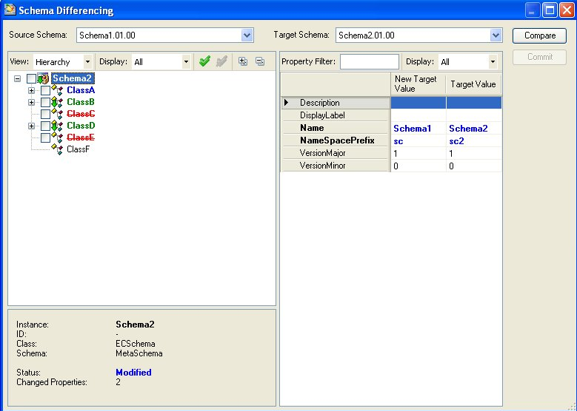
- Review the differences (with respect to the target schema) and compare the schemas.
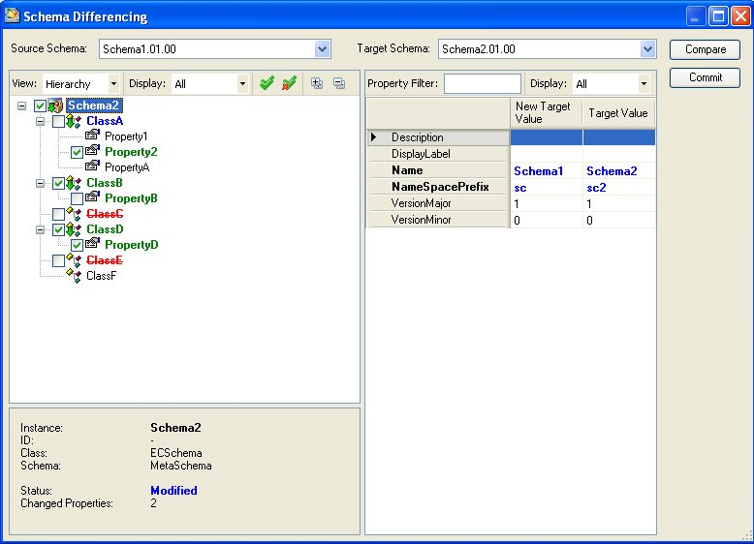
- (Optional) If a class exists in a target schema, you can select its properties and custom attributes.
- (Optional) If a class does not exist in a target schema, you can select only the class. You cannot select its properties and custom attributes.
- (Optional) If there is a new class in a target schema, you cannot select the properties without selecting the class.
- Select the check boxes for the classes and properties that you want to add to the target schema.
If you select a check box next to a red entry, the class or property will be deleted from the target schema.
- Select relationship classes and custom attributes the same way.
- Click Commit to finalize the changes.
Committing an item is subject to its association with other selected or unselected items. For example, if a relationship class is selected in order to commit it to the target schema, but its source and target constraints have not been selected, then its relationship class would be committed without its constraints.
New classes with their properties are added to Schema2.
- Review

- the target schema to confirm that the differences have been committed.
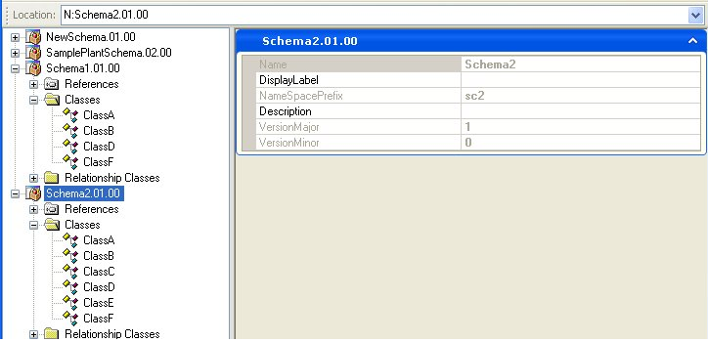
Sometimes all of the differences selected for the target schema will not be committed the first time that you click Commit. This is because of a certain ordering of classes, properties, and reference schemas that does not make it possible to commit them all at once. Therefore it is recommended that you evaluate the differences after clicking Commit to ensure that your changes have taken place. If they have not, you must click Commit again.

If different users have made changes to the same version of a schema and if they have saved these copies, you can run a difference report on that schema. In order to compare the copies of the same schema you have to open the schema in the Tree pane and place the copy of the schema in a different location. You cannot compare two copies of the same schema that are in the same location.

To compare saved copies of the same schema
- Open SamplePlantSchema in the Tree pane.
- Select Tools > Schema Differencing.
- Select SamplePlantSchema from the Source Schema drop-down list.
- Select Browse from the Target Schema drop-down list.
The Open dialog opens.
- Browse to the location of the copy of SamplePlantSchema.
- Click Compare.

Schema differencing dialog controls

Source Schema : Specifies the name of the source schema.

Target Schema : Specifies the name of the target schema.

View : Specifies options for different tree pane views:

Hierarchy: Classes and properties are grouped together.

Groups : Separate groups are made for classes and properties.

Display : Specifies options for displaying the comparison result.

All: Specifies all the classes of target schema and the ones not present earlier in the target schema.

Differences: Specifies only the classes not present earlier in the target schema.

Check All button : Selects all nodes in the tree pane.

Uncheck All button: Clears all nodes in the tree pane.

Expand All button: Expands all nodes in the tree pane.

Collapse All button: Collapses all nodes in the tree pane.

Property Filter : Provides the filter facility for the properties. For example, a criteria filter "D*" will show rows starting with the letter "D".

Display : Specifies options for displaying the filter result.

All : Specifies all the properties of target schema and the ones not present earlier in the target schema.

Differences: Specifies only the properties not present earlier in the target schema.

Description: Specifies a brief description about the target schema.

DisplayLabel: Specifies the label of the target schema.

Name: Specifies the name of the target schema.

NameSpacePrefix: Specifies the short name of the target schema.

VersionMajor: Specifies the version number. The number before the decimal point is the VersionMajor.

VersionMinor : Specifies the version number. The number after the decimal point is the VersionMinor.

New Target Value: Specifies the new values for the target schema after comparison.

Target Value: Specifies the actual values of the target schema.

Compare button: Enables you to make comparison between the selected schemas.

Commit button: Enables you to save the schema after comparison.

Summary Pane: Specifies the details for the node selected in the tree pane.

