OpenPlant PowerPID SS4 Custom Attributes

Description
Custom attributes allow for the extension of classes and properties and how they interact with OpenPlant applications.

1 bmf.01.02 3
1.1 .Net Assembly Class Information 3
1.2 Annotation Custom Attributes 4
1.3 CAD Custom Attributes 6
1.4 CAD Lock Settings 6
1.5 Class Name Display List 8
1.6 Cloud Custom Attributes 10
1.7 Component Builder Exclude 11
1.8 Component Custom Attributes 11
1.9 Displayable Property Classes and Categories 13
1.10 Doubles List 14
1.11 ECB Component Custom Attributes 15
1.12 Integer List 15
1.13 Notify Related Component of Property Value Change 17
1.14 Numeric Range Value custom attributes 18
1.15 Property Custom Attributes 20
1.16 Property Display Filter 21
1.17 Relationship Class Mapping 21
1.18 Relationship Property Value Notification Map 22
1.19 Size Numeric Display 23
1.20 Standard Action Values 24
1.21 String List 25
1.22 To from data 26
1.23 Value description attribute 27
1.24 Value keyin attribute 28
2 Schematics.01.02 29
2.1 BusinessKeyGetValueCriteria 29
2.2 Data Change Property Names 30
2.3 ECBusinessKeyGroup 31
2.4 Edit Handle Settings 31
2.5 Flow Arrow Mapping 32
2.6 Insertion Settings 33
2.7 Jumper Mapping 34
2.8 Orientation Data Change Property Name 34
2.9 Page Connector Property Name 35
2.10 Pointer to spec mapping class 36
2.11 Run Auto-Routing 37
2.12 Run Mapping 38
2.13 Run Property Names 38
2.14 Schematics Bubble Class List 39
2.15 Schematics CAD Custom Attributes 40
2.16 Schematics Component Custom Attributes 41
2.17 Schematics Document Information 41
2.18 Specification Definition Mapping 42
2.19 Specification Definition Mapping for OpenPlant Specs 44
3 Pid.01.02 46
3.1 Actuator List Class Name 46
3.2 Associated Item class list pointer 47
3.3 Auto Nozzle Class Name 47
3.4 Browse Source Instance 48
3.5 Control Valve Class Lists 48
3.6 External Data source Definition Mapping 49
3.7 Flow Arrow Direction 50
3.8 Increment Class Name 51
3.9 KKS External Data source Definition Mapping 51
3.10 Nozzle Direction values Custom attribute 53
3.11 P&ID Display List Attributes 54
3.12 Pipe line annotation class for connectors 54
3.13 Pipe Run Auto-Routing 55
3.14 Related component custom attribute 56
3.15 Tag Display Prompt Custom attribute 56
3.16 Vessel Heads 57
4 EditorCustomAttributes.01.01 59
4.1 BooleanDisplay 59
4.2 Category 59
4.3 ExtendType 61
4.4 HideProperty 65
4.5 RequiresRefresh 65
4.6 StandardValues 66
5 Bentley Standard Custom Attributes.01.02 67
5.1 Business Key Specification 67
5.2 Calculated ECProperty Specification 67

bmf.01.02

.Net Assembly Class Information
Class Name | DOTNET_ASSEMBLY_CLASS_INFO
Display Label | .Net Assembly Class Information
Schema | Bmf.01.01

Data Structure
Name | Display Label | Data Type
COMPONENT_HANDLER  ASSEMBLY_PATH  CLRName | Component Handler  Assembly Path  .Net Class Name | Bmf:Handler  string  string
ADD_IN_HANDLERS  ASSEMBLY_PATH  CLRName | Add In Handlers  Assembly Path  .Net Class Name | Bmf:Handler  string  string

Description
This custom attribute defines the settings for the .Net assembly functionality that is used for a component. This custom attribute provides the behavior of a component: how a component is placed and how it is manipulated.

Properties

Component Handler
Component handler defines the .Net behavior used for such things as placement and manipulation. The .Net assembly path defines the location of the DLL file where the .Net assembly is contained in. The .Net Class Name defines the .Net class in the .Net assembly.

Add In Handlers
The add in handlers define additional tab(s) for the Tag dialog. By default the dialog only contains a Properties tab. The .Net assembly path defines the location of the DLL file where the .Net assembly is contained in. The .Net Class Name defines the .Net class in the .Net assembly.

Example
Component for Placing Equipment Cells:
Component Handler | Assembly Path:  .Net Class Name: | %PID_ASSEMBLY_DIR%Bentley.Plant.Application.Pid.Catalog.dll Bentley.Plant.Application.Pid.Catalog.EquipmentCell
Add In Handlers | Not used

Example2
PID Document class
Component Handler | Assembly Path:  .Net Class Name: | %BMF_ASSEMBLY_DIR%bentley.plant.modelingframework.  objectmodel.dll  Bentley.Plant.ObjectModel.Model
Add In Handlers[0] | Assembly Path:  .Net Class Name: | %PID_ASSEMBLY_DIR%Bentley.Plant.Application.Pid.SettingsAddin.dll  Bentley.Plant.Application.Pid.SettingsAddin.SettingsAddIn
Add In Handlers[1] | Assembly Path:  .Net Class Name: | %BMF_ASSEMBLY_DIR%Bentley.Plant.ModelingFramework.  BusinessKeyControlsAddins.dll  Bentley.Plant.ModelingFramework.BusinessKeyControls.Addins.  AddInTitleSheets
Add In Handlers[2] | Assembly Path:  .Net Class Name: | %BMF_ASSEMBLY_DIR%Bentley.Plant.ModelingFramework.  BusinessKeyControlsAddins.dll  Bentley.Plant.ModelingFramework.BusinessKeyControls.Addins.  AddInSettingsAssociatedItems

Annotation Custom Attributes
Class Name | BMF_ANNO_CUSTOM_ATTRIBUTES
Display Label | Annotation Custom Attributes
Schema | Bmf.01.01

Data Structure
Name | Display Label | Data Type
ORIGIN_OFFSET | Origin Offset | point3d
DIRECTION | Direction | point3d
VISIBILITY | Visibility | boolean
TEXT_STYLE | Text Style | string
PLACEMENT_COUNT | Placement Count | string
ElementTemplate | Element Template | string

Description
Defines the settings that are used to place an annotation text string for a component

Properties

Direction
Defines the rotation of an annotation related to the local coordinate system. 1,0,0 is horizontal text. 0,1,0 is vertical text. The 3rd value is for the z axis and is not used in a 2D file.

Element Template
Defines the element template used to place the annotation text.

Origin Offset
Defines the offset, in sub-units, from the component’s origin where the annotation is placed. This is only used if PLACEMENT_COUNT=0.

Placement Count
Defines how many times the annotation is placed. 0 stands for automatic placement. 1 or more for user to be prompted that number of times for location of annotation.

Text Style
Defines a text style for the annotation

Visibility
Defines whether or not the annotation is visible. In class Device the visibility for the Tag Number property is turned on. For Fluid Regulators it is turned off.

Example
SIZE property of class FLUID_REGULATOR
Origin Offset | 0,0.25
Direction | 1,0
Visibility | True
Text Style | PID
Placement Count | 0
Element Template | None

CAD Custom Attributes
Class Name | BMF_CAD_CUSTOM_ATTRIBUTES
Display Label | CAD Custom Attributes
Schema | Bmf.01.01

Data Structure
Name | Display Label | Data Type
ElementTemplate | Element Template | string

Description
Defines CAD settings used to place the component.

Properties

Element Template
Defines the element template used to place the component

Example
Element Template | Misc\Default

CAD Lock Settings
Class Name | BMF_CAD_LOCK_SETTINGS
Display Label | CAD Lock Settings
Schema | Bmf.01.01

Data Structure
Name | Display Label | Data Type
AXIS_LOCK | Axis Lock | boolean
AXIS_LOCK_ANGLE | Axis Lock Angle | string
AXIS_START_ANGLE | Axis Start Angle | double
GRID_LOCK | Grid Lock | boolean
SNAP_DIVISOR | Snap Divisor | int
SNAP_LOCK | Snap Lock | boolean
SNAP_MODE | Snap Mode | int

Description
With the CAD Lock Settings the user is able to set the PowerDraft lock settings.
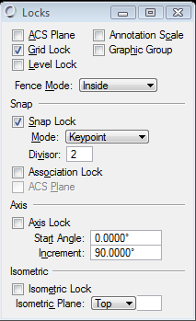

Properties

Axis Lock
Enable/disable the axis lock. If set to True the Axis Lock is switched on. If set to False the Axis Lock is switched off.

Axis Start Angle
Set the Axis Lock angle. Only applicable if Axis Lock is on.

Axis Lock Angle
Set the Axis Lock increment angle. Only applicable if Axis Lock is on.

Grid Lock
Enable/disable the Grid Lock. If set to True the Grid Lock is switched on. If set to False the Grid Lock is switched off.

Snap Lock
Enable/disable the Snap Lock. If set to True the Snap Lock is switched on. If set to False the Snap Lock is switched off.

Snap Mode
Set the snap mode.
Available Snap Modes
2 | Connect Point
4 | Key point
8 | Nearest
16 | Midpoint
32 | Center
64 | Origin
128 | Bisector
256 | Intersection
512 | Tangent
1024 | Tangent Point
2048 | Perpendicular
4096 | Perpendicular Point
8192 | Parallel
16384 | Point Through
32768 | Point On
65536 | Multi-snap 1
131072 | Multi-snap 2
262144 | Multi-snap 3

Snap Divisor
Set the snap lock divisor. Only applicable if Snap Lock is on.

Example
Axis Lock Angle | 0
Axis Lock | True
Grid Lock | True
Snap Lock | True

Class Name Display List
Class Name | CLASSNAME_DISPLAY_LIST
Display Label | Class Name Display List
Schema | Bmf.01.01

Data Structure
Name | Display Label | Data Type
ITEMS  CLASS_NAME  DISPLAY_NAME | Items  Class Name  Display Name | bmf:Class Name Display Structure  string  string

Description
This custom attribute is used to associate a few component classes to a compound component.
Example: A control valve has an actuator associated that is placed together with the valve body. The user can select from a list of several available actuators.

Properties

Items
This is an array of items that can provide a list of class names

Class Name
Class name

Display Name
Display label used with the class name. This display label is used instead of the displayLabel defined on the given class name.

Example
An example is the Border List. For a P&ID document a number of possible borders are provided. When a new drawing is created the user can select from a list of drawing borders. The border is automatically placed in the drawing and the document properties are automatically displayed in the drawing header. The border can be changed later on.
Item[0]  Display Name  Class Name | None  NONE_BORDER
Item[1]  Display Name  Class Name | A size title sheet  A_SIZE
Item[2]  Display Name  Class Name | B size  B_SIZE
Item[3]  Display Name  Class Name | C size  C_SIZE
Item[4]  Display Name  Class Name | D size  D_SIZE
Item[4]  Display Name  Class Name | E size  E_SIZE

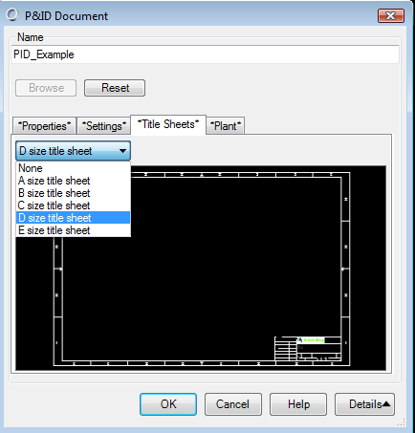

Cloud Custom Attributes
Class Name | BMF_CLOUD_CUSTOM_ATTRIBUTES
Display Label | Cloud Custom Attributes
Schema | Bmf.01.01

Data Structure
Name | Display Label | Data Type
ARC_LENGTH | Arc Length | double
ARC_RADIUS | Arc Radius | double
ARC_SWEEP_ANGLE | Arc Sweep Angle | double
DEFAULT_NUMBER_OF_ARCS | Default Number Of Arcs | int
INVERT_CLOUD | Invert Cloud | boolean
MARGIN | Margin | double

Description
A cloud component is used to emphasize another component. This custom attribute specifies the appearance of the cloud. A cloud consists of a number of arcs that surround an object

Properties

Arc Length
The length of a single arc in the cloud [sub units]

Arc Radius
The radius of any of the cloud arcs [sub units]

Arc Sweep Angle
The angle from arc start to arc end from the components origin [deg]

Default Number of Arcs
Number of arcs used to create cloud around a component during automatic placement when the user has not specified Arc Length and Arc Radius.

Invert Cloud
When set to true the arcs are drawn inverted, pointing away from the components origin

Margin
The gap between the actual Base Range of the component, which the cloud is being associated with and the actual rectangle range used for the cloud placement.

Example
ARC_LENGTH | -1
ARC_RADIUS | -1
ARC_SWEEP_ANGLE | 145
DEFAULT_NUMBER_OF_ARCS | 11
MARGIN | 1
INVERT_CLOUD | False

Component Builder Exclude
Class Name | BMF_COMPONENTBUILDER_EXCLUDE
Display Label | Component Builder Exclude
Schema | Bmf.01.01

Data Structure
Name | Display Label | Data Type
ExcludeSubClass | Exclude Sub Classes | boolean

Description
A few components, such as parametric equipment can’t be used with the Component Manager. Classes that have this custom attribute defined won’t appear in the class list of the Component Manager

Properties

Exclude Sub Classes
If set to True the class is excluded from the Component Manager

Example

Component Custom Attributes
Class Name | BMF_COMPONENT_CUSTOM_ATTRIBUTES
Display Label | Component Custom Attributes
Schema | Bmf.01.01

Data Structure
Name | Display Label | Data Type
INSERT_ENABLED | Insert Enabled | boolean
MIRROR_ENABLED | Mirror Enabled | boolean
MOVE_ENABLED | Move Enabled | boolean
PARENT_DISPLAY_ENABLED | Parent Display Enabled | boolean
REPEAT_INSERT | Repeat Insert | boolean
REPLACE_ENABLED | Replace Enabled | boolean
ROTATE_ENABLED | Rotate Enabled | boolean
SCALE_ENABLED | Scale Enabled | boolean
TRANSFORM_RELATED_ANNOTATION_ENABLED | Transform Related Annotation Enabled | boolean

Description
With the Component Custom Attributes the user can toggle the manipulation behavior of a component

Properties

Insert Enabled
Indicate whether a component can be inserted

Mirror Enabled
Indicate whether a component can be mirrored

Move Enabled
Indicate whether a component can be moved

Parent Display Enabled
Parent component is always displayed. Selected annotation will display parent component in element info, fly over and icons.

Repeat Insert
Allow repeat insertion of this component

Replace Enabled
Indicate whether a component can be replaced

Rotate Enabled
Indicate whether a component can be rotated

Scale Enabled
Indicate whether a component can be scaled

Transform Related Annotation Enabled
Indicate whether related annotation should be transformed with this component

Example
The custom attribute is used in class BASE_EQUIPMENT in the pid.01.01 ECSchema:
INSERT_ENABLED | False
MIRROR_ENABLED | False
MOVE_ENABLED | True
PARENT_DISPLAY_ENABLED | True
REPEAT_INSERT | True
REPLACE_ENABLED | True
ROTATE_ENABLED | True
SCALE_ENABLED | False
TRANSFORM_RELATED_ANNOTATION_ENABLED | False

Displayable Property Classes and Categories
Class Name | DISPLAYABLE_PROPERTY_CLASSES
Display Label | Displayable Property Classes and Categories
Schema | Bmf.01.01

Data Structure
Name | Display Label | Data Type
DISPLAYABLE_CLASSES  CLASS_NAME_OR_CATEGORY  ISDISPLAYABLE  ISREADONLY | Displayable Classes  Class Name or Category  Is Class or Category Displayable  Is Read only | bmf:Displayable Properties Structure  string  boolean  boolean

Description
In the Element Information dialog box properties are displayed grouped by a category. There are a few MicroStation and system internal properties which would be more disturbing and confusing rather than being informative. Those unwanted categories and class names can be excluded from being displayed by this custom attribute. Currently this custom attribute is only used once and globally in the bmf schema.

Properties

Displayable Classes

Class Name or Category
Specify the class name or the category

Is Class or Category Displayable
Indicate whether the class or category is displayable

Is Read only
Indicate whether the class or category is read only

Example
Usage in the bmf schema:
Item[0]  Class Name or Category  Is Class or Category Displayable  Is Read only | MstnProp  False  True
Item[1]  Class Name or Category  Is Class or Category Displayable  Is Read only | MstnGraphHeader  False  True
Item[2]  Class Name or Category  Is Class or Category Displayable  Is Read only | MstnCellProperties  False  True
Item[3]  Class Name or Category  Is Class or Category Displayable  Is Read only | MstnComplex  False  True
Item[4]  Class Name or Category  Is Class or Category Displayable  Is Read only | MstnLockedElement  False  True
Item[5]  Class Name or Category  Is Class or Category Displayable  Is Read only | MstnRotation  False  True
Item[6]  Class Name or Category  Is Class or Category Displayable  Is Read only | MstnScale  False  True
Item[7]  Class Name or Category  Is Class or Category Displayable  Is Read only | Miscellaneous  False  True
Item[8]  Class Name or Category  Is Class or Category Displayable  Is Read only | End Conditions  False  True
Item[9]  Class Name or Category  Is Class or Category Displayable  Is Read only | ComponentInformation  False  True

Doubles List
Class Name | DOUBLES_LIST
Display Label | Doubles List
Schema | Bmf.01.01

Data Structure
Name | Display Label | Data Type
ITEMS | Items | double

Description
This custom attribute is used to define a double value for a property.

Properties

Items
A double value

Example
With this double value the spacing between components can be specified. The definition of the pipe run spacing is defined using this custom attribute.
Item[0]  Item | 0.125

ECB Component Custom Attributes
Class Name | BMF_ECB_CUSTOM_ATTRIBUTES
Display Label | ECB Component Custom Attributes
Schema | Bmf.01.01

Data Structure
Name | Display Label | Data Type
INSERT_ENABLED | Insert Enabled | boolean

Description
Indicate whether a component can be inserted from the Item Browser (formerly ECBrowser)

Properties

Insert Enabled
Switch on or off whether a component can be inserted from the Item Browser

Example
Currently all components deriving from class DEVICE can be insterted
Insert Enabled | True

Integer List
Class Name | INTEGER_LIST
Display Label | Integer List
Schema | Bmf.01.01

Data Structure
Name | Display Label | Data Type
ITEMS | Items | int

Description
Similar to the Doubles List this custom attribute defines integer values

Properties

Items
An integer value that is defined for a component

Example
Currently not used

Logical Group Configuration
Class Name | LOGICAL_GROUP_CONFIGURATION
Display Label | Logical Group Configuration
Schema | Bmf.01.01

Data Structure
Name | Display Label | Data Type
CONTAINED_CLASS_NAME_FILTERS | Contained Class Name Filters | string
DEFAULT_COMPONENTS_LIST_NAME | Default Components List Name | string
LOGICAL_RELATIONSHIP_CLASS_NAME | Logical Relationship Class Name | string

Description
This custom attribute defines the components and relationships of a logical group

Properties

Contained Class Name Filters
This value determines the default types that can be added to a Logical Group.

Default Components List Name
Name of the class containing the list of components to insert by default

Logical Relationship Class Name
Name of the relationship class used for logical grouping of components

Example
One of the logical groups used in a P&ID is the Instrument Loop
Default Components List Name | INSTRUMENTS_FOR_INSTRUMENT_LOOP
Logical Relationship Class Name | LOOP_HAS_COMPONENT
Contained Class Name Filters | DEFAULT_FILTERS_FOR_INSTRUMENT_LOOP

Notify Related Component of Property Value Change
Class Name | BMF_NOTIFY_RELATED_COMPONENT_OF_PROPERTY_VALUE_CHANGE
Display Label | Notify Related Component of Property Value Change
Schema | Bmf.01.01

Data Structure
Name | Display Label | Data Type
BMF_NOTIFY_RELATIONSHIPS  NOTIFY_TARGET  RELATIONSHIP_CLASS_NAME  RELATED_CLASS_NAME  RELATED_CLASS_PROPERTY_NAME  CASCADE_PROPERTY_VALUE_CHANGE  SET_DEFAULT_PROPERTY_VALUE | Notify Relationships  Notify Target of Relationship  Relationship Class Name  Related Class Name  Related Class Property Name  Cascade Property Value change  Set Default Property Value | bmf:Notify Relationship  boolean  string  string  string  boolean  boolean

Description
With the Notify Relationship custom attribute a related component can be notified of a property value changed and the related property is updated

Properties

Notify Relationships

Notify Target of Relationship
Notify target of relationship.

Relationship Class Name
Relationship Class Name that is used for notification

Related Class Name
Optional property value used to filter down the classes that get updated. If not filled out all items of the related type will be updated.

Related Class Property Name
Property Name of a Related Class that will be updated as result of this property change. Optional when the notified property name is different from the notifying property name

Cascade Property Value change
Indicates if the Property Value change should be cascaded to the Related Property Name

Set Default Property Value
When set to True the notified property is only updated on instantiation. Later property changes are not notified. When set to False the notified property is always updated

Example
The design size property of the pipeline (piping network system) updates the size property of the pipe run (piping network segment). This happens only on pipeline creation. Later the pipeline might consist of several pipe runs with different sizes (inserted reducers). A change of the pipeline size then won’t update the pipe run sizes.
Item[0]  Notify Target of Relationship  Relationship Class Name  Related Class Name  Related Class Property Name  Cascade Property Value change  Set Default Property Value | True  PIPELINE_HAS_PIPE_RUN  oppid:PIPING_NETWORK_SEGMENT  SIZE  False  True

Numeric Range Value custom attributes
Class Name | BMF_NumericRangeValueCustomAttributes
Display Label | Numeric Range Value custom attributes
Schema | Bmf.01.01

Data Structure
Name | Display Label | Data Type
UpperLimit | Upper value limit | double
LowerLimit | Lower value limit | double
KeyInUpperExceeded | Key-In if upper limit exceeded | string
KeyInLowerExceeded | Key-In if lower limit exceeded | string
KeyInInRange | Key-In numeric value in range
ExpressionParser | Expression that can be used to parse property | string
ResetInvalidInput | Reset Invalid input of ranges | boolean
DisplayMessageonInvalidInput | Display message on invalid input of ranges | boolean
ApplyKeyInToRelatedComponents | Apply Key In To Related Components | boolean
RelationshipClassNames | Relationship Class Names | string

Description
This custom attribute allows a rule to be set on a property that would evaluate a numeric value range.

Upper value limit
The lower value limit

Lower value limit
The lower value limit

Key-In if upper limit exceeded
When the limit is exceeded a key-in is executed

Key-In if lower limit exceeded
When the limit is exceeded a key-in is executed

Key-In numeric value in range
When the value is in range a key-in is executed

Expression that can be used to parse property
A regular expression that is used to parse a property value.

Reset Invalid input of ranges
If the input numeric value does not fall within the custom attributes upper and lower ranges, the value will be reset.

Display message on invalid input of ranges
Display a message if the input ranges are invalid

Apply Key In To Related Components
The command executed by the key-in is also used on components that are related to the current component. E.g. when this custom attribute is used on an instrument loop then the key-in is also used on all loop members (instruments, control valves, etc.).

Relationship Class Names
The relationship class name to be used for the key-in

Example
Example of a pressure check for pipe runs (not configured in standard delivery)
UpperLimit | 200
LowerLimit | 45
KeyInUpperExceeded | pid component assigntemplate Invalid\InvalidUpper
KeyInLowerExceeded | pid component assigntemplate Invalid\InvalidLower
KeyInInRange | pid component assigntemplate
ExpressionParser | (\d+)
ResetInvalidInput | False
DisplayMessageonInvalidInput | False
ApplyKeyInToRelatedComponents | True
RelationshipClassNames  Relationship Class Name [0]  Relationship Class Name [1]  Relationship Class Name [2] | RUN_HAS_IN_RUN  OBJECT_HAS_INSTRUMENT  REDUCER_CONNECTS_TO_SEGMENT

Property Custom Attributes
Class Name | BMF_PROP_CUSTOM_ATTRIBUTES
Display Label | Property Custom Attributes
Schema | Bmf.01.01

Data Structure
Name | Display Label | Data Type
DefaultValue | Default Value | string
IsGraphical | IsGraphical | boolean
FormatString | Format String | string

Description
With the Property Custom attribute you can apply a default value for a property

Properties

DefaultValue
The default value. For boolean properties use the string “True” and “False”

IsGraphical
Specify whether the value influences the graphical appearance of a component

FormatString
A .NET format string

Example
Setting a default value for the Device Type Code of a pump
DefaultValue | PMP
IsGraphical | True
FormatString | None

Example 2
Setting a default value for the number property
DefaultValue | GetNextAvailableValue
IsGraphical | True
FormatString | {0:D4}
The reserved word “GetNextAvailablevalue” for the DefaultValue field automatically assigns the next available number to the property. The format string restricts this number to 4 digits.

Property Display Filter
Class Name | PROPERTY_DISPLAY_FILTERS
Display Label | Property Display Filter
Schema | Bmf.01.01

Data Structure
Name | Display Label | Data Type
Visible | IsVisible | boolean
ReadOnly | IsReadOnly | boolean

Description
With the Property Display Filter custom attribute you can set a property to read-only or hide it.

Properties

IsVisible
If set to False the property won’t appear in the Element Info dialog box

ReadOnly
If set to True the property appears grayed-out in the Element Info dialog box and cannot be edited

Example
This custom attribute is used for the IS_VERTICAL property of the Tower component. Since there cannot be a horizontal tower this property is set to read-only and is also not shown in the Element Info
Visible | False
ReadOnly | True

Relationship Class Mapping
Class Name | RELATIONSHIP_CLASS_MAPPING
Display Label | Relationship Class Mapping
Schema | Bmf.01.01

Data Structure
Name | Display Label | Data Type
RELATIONSHIP_MAPPING  SOURCE_CONSTRAINT_NAME  TARGET_CONSTRAINT_NAME  SYSTEM_RELATIONSHIP_NAME  INFORMATION_RELATIONSHIP_NAME | Relationship Mapping  Source Constraint Name  Target Constraint Name  System Relationship Class Name  Information Relationship Name | bmf:Relationship Class Criteria Structure  string  string  string  string

Description
These mappings are stored in the OpenPlant_PID_Lists.01.01.ecschema.xml schema. These mappings allow for addition relationships to be created without application hard coding. A relationship contains a source and a target.
. In some cases the source might correspond to the child end of a parent-child relationship, etc. The table below shows some how you might map other semantics onto our source/target semantics.
Source | Origin | ForeignKey | Child | Detail | From
Target | Destination | Key | Parent | Master | To

Relationship Strengths
Sometimes a relationship just represents a reference from one object to another, and sometimes it means that one object “owns” another… or at least shares ownership of it.

Referencing
“Referencing” relationships imply no ownership and no cascading deletes when the object on either end of the relationship is deleted. It can be represented in UML as a simple association. For example a Document object may have a reference to the User that last modified it.
Holding
“Holding” relationships imply shared ownership. A given object can be “held” by many different objects, and the object will not get deleted unless all of the objects holding it are first deleted (or the relationships severed.) It can be represented as “aggregation” in UML (which is an association with an open diamond on the source end of the relationship.) For example, an Equipment component may have been imported from two different documents (each document held different business properties that were extracted) and so Each document “holds” the Equipment, and if both documents go way, the Equipment goes away. You could also think of “holding” as “grouping”.
Embedding
“Embedding” relationships imply exclusive ownership and cascading deletes. An object that is the target of an “embedding” relationship may also be the target of other “referencing” relationships, but cannot be the target of any “holding” relationships (the ownership is exclusive, remember.) “Embedding” relationships can be represented by “composition” in UML, an association with a closed diamond on the source end. For example, a Folder “embeds” the Documents that it contains. You could also think of “embedding” as “containment”
Role Labels
The RoleLabel defined on the "Source" constraint of the ECRelationshipClass should be used when reading from source to target, e.g. if the role label on the Source constraint was "contains" and the role label on the Target constraint was "is contained by" then we would expect to see:

{source} contains {target}
{target} is contained by {source}

Cardinality
Relationship cardinality allows you to restrict the number of instances allowed on each endpoint of a relationship. Each relationship instance connects one source and one target instance so cardinality deals with a collection of relationships of a given type that share a source or target instance. For example let's talk about a DocumentParent relationship which connects a document and its containing folder.

Properties

Relationship Mapping
The relationship mapping definition. You can add multiple mappings with this custom attribute.

Source Constraint Name
The name of the source class name.

Target Constraint Name
The name of the target class name

System Relationship Class Name
The name of system relationship. This denotes that the relationship is used by the system, thus is low level and should not be changed or modified.

Information Relationship Name
The name of information relationship. This relationship is more specific, such as Document has object or Equipment has nozzle.

Example

Type | Value
Source | oppid:EQUIPMENT
Target | oppid:NOZZLE
System Relationship | BMF_CONNECT_POINT_CONNECTS_TO_CONNECT_POINT
Information Relationship | oppid:EQUIPMENT_HAS_NOZZLE

In this example the source is a piece of equipment. That equipment component references the nozzle thru the EQUIPMENT_HAS_NOZZLE relationship. The cardinality on the equipment is 1. Only one piece of equipment can live in this relationship. The cardinality on the nozzle is N. This indicates that many (or unlimited) number of nozzles can have a relationship with a particular piece of equipment.
<ECRelationshipClass typeName="EQUIPMENT_HAS_NOZZLE" displayLabel="Equipment Has Nozzle" isDomainClass="True" strength="referencing" strengthDirection="forward">
<BaseClass>ASSEMBLY_OF_INDIVIDUAL</BaseClass>
<Source cardinality="(0,1)" roleLabel="Equipment Has Nozzle" polymorphic="True">
<Class class="EQUIPMENT" />
</Source>
<Target cardinality="(0,N)" roleLabel="Equipment Has Nozzle (reversed)" polymorphic="True">
<Class class="NOZZLE" />
</Target>
</ECRelationshipClass>

The system relationship BMF_CONNECT_POINT_CONNECTS_TO_CONNECT_POINT is the relationship class used to graphically link components. It uses the class BMF_CONNECT_POINT. This is a one to one relationship. This relationship and class should NEVER be modified.

Relationship Property Value Notification Map
Class Name | RelationshipPropertyValueNotificationMap (deprecated, not used in any code)
Display Label | Relationship Property Value Notification Map
Schema | Bmf.01.01

Data Structure
Name | Display Label | Data Type
RelationshipClassName | Relationship Class Name | string
Direction | Direction | string

Size Numeric Display
Class Name | SIZE_NUMERIC_DISPLAY
Display Label | Size Numeric Display
Schema | Bmf.01.01

Data Structure
Name | Display Label | Data Type
ITEMS  DISPLAY  NOMINAL_VALUE | Items to be displayed  Display  Nominal Value | bmf:Size Numeric Display Structure  String  String

Description
With this custom attribute you can create a sizes list

Properties

Items to be displayed
List of sizes

Display
A display label for the sizes

Nominal Value
Nominal size value

Example
Usage in class Imperial Pipe Sizes
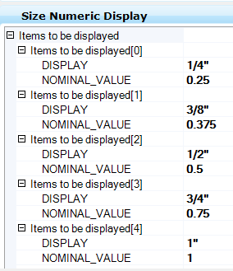

Standard Action Values
Class Name | StandardActionValues
Display Label | Standard Action Values
Schema | Bmf.01.01

Data Structure
Name | Display Label | Data Type
ValueActionMap  DisplayString  Value  KeyIn | Value Action Map  Display String  [none]  Key-In | bmf:Value Action Map  string  string  string
MustBeFromList | Must Be From List | boolean
SELECT_COMPONENT_BEFORE_ACTION | Select Component Before Action | boolean

Description
Provides a list of values that are displayed as list in the element info dialog. Optionally a key-in can be executed

Properties

Value Action Map
List of action values

Display String
Display String Value that appears in the dropdown menu

Value
The value that is assigned to the property

Key-In
Key-In associated with value

Must Be From List
If set to false the user can enter other values.

Select Component Before Action
Selects the component that property belongs to before executing any action (Key-in).

Example
Design State for components. The key-in is not used in the standard delivered product. If the “Must Be From List” flag is set to true, you can assign alternative element templates to components when selecting a design state.

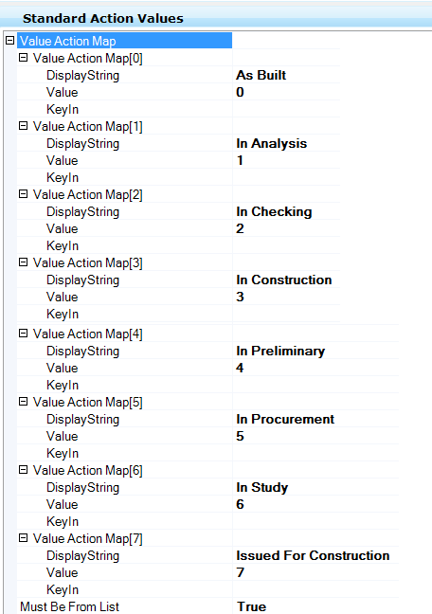

String List
Class Name | STRING_LIST
Display Label | String List
Schema | Bmf.01.01

Data Structure
Name | Display Label | Data Type
ITEMS | Items | String (Array)

Description
With the string list you can define a simple list of strings. This list is used in combination with other classes, properties or custom attributes.

Properties

Items
An array of string values

Example
Used in the class Reducer Merge Run Property List. The string list defines the properties that are displayed in the merge run dialog box
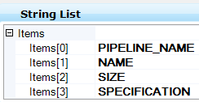

To from data
Class Name | TO_FROM_DATA
Display Label | To from data
Schema | Bmf.01.01

Data Structure
Name | Display Label | Data Type
TO_FROM_MAPPING  IntermediateRelationship  IntermediateDisplayProperty  DestinationRelationship  AlternateConnectionDisplayString  ShowIntermediateTag | To From Mapping  Intermediate Relationship  Intermediate Display Property  Destination Relationship  AlternateConnectionDisplayString  Show Intermediate Tag | bmf:To From Class Criteria Structure  string  string  string  string  boolean

Description
This custom attribute allows for the viewing of source and destination of Pipelines. The relationships are interpreted in code and displayed in tree and node form in a modal dialog

Properties

To From Mapping

IntermediateRelationship
Relationship between connecting components

IntermediateDisplayProperty
Property to be displayed for the relationship

DestinationRelationship
Explain in a few words usage of this property (usually Flow Direction)

AlternateConnectionDisplayString
An alternate string to be displayed( e.g. “Connects to”)

ShowIntermediateTag
Specify whether the intermediate tag is displayed or not

Example
To-From data for pipelines
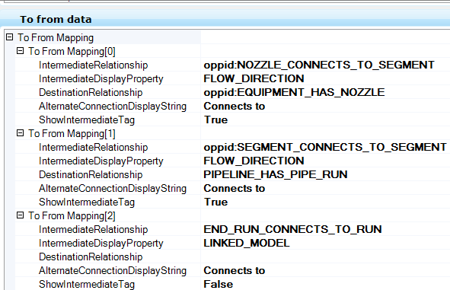

Value description attribute
Class Name | VALUE_DESCRIPTION_ATTRIBUTE
Display Label | Value description attribute
Schema | Bmf.01.01

Data Structure
Name | Display Label | Data Type
Column1 | Column1 | string
Column2 | Column2 | string
ITEMS  VALUE  DESCRIPTION | Items  Value  Description | bmf:Value Description structure  string  string

Description
User can create a simple value list to assign a property

Properties

Column1
The 1st column header of the list

Column2
The 2nd column header of the list

Items
One or more items can be added that make up the list values

Value
The selectable value which is to be assigned to the property

Description
A descriptive text of the value

Example
The value description attribute is used to provide a list of letter codes for instruments
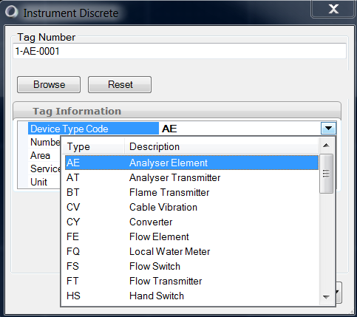
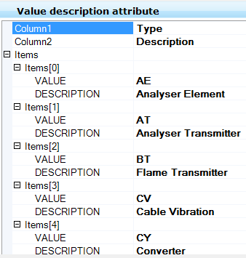

Value keyin attribute
Class Name | VALUE_KEYIN_ATTRIBUTE
Display Label | Value keyin attribute
Schema | [Schema]

Data Structure
Name | Display Label | Data Type
ITEMS  VALUE  KEYIN | Items  Value  Keyin | bmf:Value Keyin structure  string  string

Description
Allows for a key-in to be executed (run) or a template change be made, based on a property value input.

Properties

Items
The values, key-ins and templates

Value
The matching value that would trigger a key-in or template change

Keyin
Key-in to be run when the Value is matched with the property that is typed in

Template
Template to change to when the Value is matched with the property that is typed in

Example
Add this to service. So when a Service is changed to Future, the components template will be changed to Future. The templates must be created in the OPPID application (Menu->Element->Element Templates)
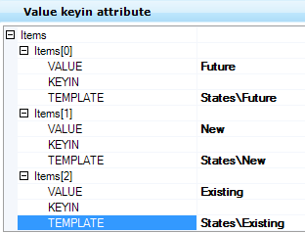

Schematics.01.02

BusinessKeyGetValueCriteria
Class Name | BusinessKeyGetValueCriteria (deprecated, not used in any code calls)
Display Label | BusinessKeyGetValueCriteria
Schema | Schematics.01.01
Base Class | sch:SCHEMATICS_BUSINESSKEY_DEFINITIONS

Data Change Property Names
Class Name | DATA_CHANGE_PROPERTY_NAMES
Display Label | Data Change Property Names
Schema | schematics.01.01

Data Structure
Name | Display Label | Data Type
MERGE_RUN_PROPERTY_LIST_NAME | Merge Run Property List Name | string
TEXT_PROPERTY_NAME_1 | Text Property Name 1 | string
TEXT_PROPERTY_NAME_2 | Text Property Name 2 | string
RUN_TEXT_PROPERTY_NAME | Run Text Property Name | string

Description
This custom attribute defines the Merge Run Property List for a Data Change component

Properties

Merge Run Property List Name
Specifies the Merge Run Property List Name

Text Property Name 1
Property name to store value that will be used as annotation

Text Property Name 2
Property name to store value that will be used as annotation

Run Text Property Name
Property name to get value from that will be used in annotation

ORIENTATION_PROPERTY_NAME_1
Property name to be used in parsing a reducing size.

ORIENTATION_PROPERTY_NAME_2
Property name to be used in parsing a reducing size.

RUN_ORIENTATION_PROPERTY_NAME
Property name to get value from that will be used in parsing. Used with the ORIENTATION_PROPERTY_NAME _1 and ORIENTATION_PROPERTY_NAME_ 2 property values.

Example
MERGE_RUN_PROPERTY_LIST_NAME | REDUCER_MERGE_RUN_PROPERTY_LIST
TEXT_PROPERTY_NAME_1 | MAIN_SIZE
TEXT_PROPERTY_NAME_2 | REDUCING_SIZE
RUN_TEXT_PROPERTY_NAME | SIZE
ORIENTATION_PROPERTY_NAME_1 | NOMINAL_DIAMETER
ORIENTATION_PROPERTY_NAME_2 | NOMINAL_DIAMETER_REDUCING_END
RUN_ORIENTATION_PROPERTY_NAME | NOMINAL_DIAMETER

Reducer example:
SIZE (RUN_TEXT_PROPERTY_NAME) values are retrieved: (after a reducer is placed in a line). There would be two SIZE values.
NOMINAL_DIAMETER (RUN_ORIENTATION_PROPERTY_NAME) values are retrieved: (after a reducer is placed in a line). There would be two NOMINAL_DIAMETER values.
The SIZE and NOMINAL_DIAMETER values are evaluated. The values are they placed in the MAIN_SIZE, REDUCING_SIZE, NOMINAL_DIAMETER and NOMINAL_DIAMETER_REDUCING_END properties.

ECBusinessKeyGroup
Class Name | ECBusinessKeyGroup
Display Label | ECBusinessKeyGroup
Schema | Schematics.01.01
Base Class | sch:SCHEMATICS_BUSINESSKEY_DEFINITIONS

Data Structure
Name | Display Label | Data Type
GROUP_DISPLAY_NAME | [none] | string
GROUP_NAME | [none] | string
ICON_NAME | [none] | string

Description
Used for grouping like class types in various lists. Also used setting icon values. Icon value names would be defined in dgnlibs files.

Properties

GROUP_DISPLAY_NAME
The name that is displayed in the Item Browser for the group

GROUP_NAME
The group’s name

ICON_NAME
Name of an icon that is displayed with the group. The icon must exist in one of the referenced dgn libraries.

Example
GROUP_DISPLAY_NAME | Instruments
GROUP_NAME | INSTRUMENT
ICON_NAME | instruments

Edit Handle Settings
Class Name | EDIT_HANDLE_SETTINGS
Display Label | Edit Handle Settings
Schema | Schematics.01.01

Data Structure
Name | Display Label | Data Type
BY_CONNECT_POINT | Drag By Connect Point | boolean
BY_RANGE_CORNERS | Drag By Range Corners | boolean
BY_RANGE | Drag By Range | boolean

Description
Sets the manipulation behavior of a component

Properties

Drag By Connect Point
Allows dragging via pre-defined connect points

Drag By Range Corners
Allows dragging via range corners

Drag By Range
Allows dragging via the eight range points

Example
Definition of the Schematics Base Component
Drag By Connect Point | True
Drag By Range Corners | False
Drag By Range | True

Flow Arrow Mapping
Class Name | FLOW_ARROW_MAPPING
Display Label | Flow Arrow Mapping
Schema | Schematics.01.01

Data Structure
Name | Display Label | Data Type
DIRECTIONAL_CLASSNAME | Directional Class Name | string
BI_DIRECTIONAL_CLASSNAME | Bi-Directional Class Name | string

Description
Determines directional or bi-directional flow arrow to be placed on a pipe run

Properties

Directional Class Name
Directional flow arrow class name

Bi-Directional Class Name
Bi-directional flow arrow class name

Example
Flow Arrow definition in the Imperial supplemental schema
Directional Class Name | oppid:PIPE_FLOW_ARROW_BREAK
Bi-Directional Class Name | oppid:PIPE_FLOW_ARROW_BIDIR

Insertion Settings
Class Name | INSERTION_SETTINGS
Display Label | Insertion Settings
Schema | Schematics.01.01

Data Structure
Name | Display Label | Data Type
BY_CONNECT_POINT | Insert By Connect Point | boolean
BY_RANGE_CORNERS | Insert By Range Corners | boolean
BY_RANGE | Insert By Range | boolean
BY_DEFAULT | Insert By Default | string

Description
Component insertion options.

Properties

Insert By Connect Point
Allows placement via pre-defined connect points

Insert By Range Corners
Allows placement via range corners

Insert By Range
Allows placement via 8 range points

Insert By Default
Default insertion point: origin, connect point: name, range: name

Example
Settings for the Schematics Base Component
Insert By Connect Point | True
Insert By Range Corners | False
Insert By Range | False
Insert By Default | Origin

Jumper Mapping
Class Name | JUMPER_MAPPING
Display Label | Jumper Mapping
Schema | Schematics.01.01
Base Class | bmf:bmf_display_list_attributes

Data Structure
Name | Display Label | Data Type
CLASS_NAME | Class Name | string
ORDER | Priority | int

Description
Class priority and jumper to use

Properties

Class Name
Defines the jumper class

Priority
Sets the priority of which line type (Major/Minor/Existing Pipeline, Equipment) will be gapped.

Example
Class Name | PID_JUMPER
Priority | 6

Orientation Data Change Property Name
Class Name | ORIENT_DATA_CHANGE_PROPERTY_NAMES
Display Label | Orientation Data Change Property Name
Schema | Schematics
Base Classes | sch:DATA_CHANGE_PROPERTY_NAMES

Data Structure
Name | Display Label | Data Type
MERGE_RUN_PROPERTY_LIST_NAME | Merge Run Property List Name | string
ORIENTATION_PROPERTY_NAME_1 | Orientation Property Name 1 | string
ORIENTATION_PROPERTY_NAME_2 | Orientation Property Name 2 | string
RUN_ORIENTATION_PROPERTY_NAME | Run Orientation Property Name | string
TEXT_PROPERTY_NAME_1 | Text Property Name 1 | string
TEXT_PROPERTY_NAME_2 | Text Property Name 2 | string
RUN_TEXT_PROPERTY_NAME | Run Text Property Name | string
(Properties inherited from base class in italics)

Description
This custom attribute defines the Merge Run Property List for a Data Change component

Properties

Merge Run Property List Name
Specifies the Merge Run Property List Name

Text Property Name 1
Property name to store value that will be used as annotation

Text Property Name 2
Property name to store value that will be used as annotation

Run Text Property Name
Property name to get value from that will be used in annotation

ORIENTATION_PROPERTY_NAME_1
Property name to be used in parsing a reducing size.

ORIENTATION_PROPERTY_NAME_2
Property name to be used in parsing a reducing size.

RUN_ORIENTATION_PROPERTY_NAME
Property name to get value from that will be used in parsing. Used with the ORIENTATION_PROPERTY_NAME _1 and ORIENTATION_PROPERTY_NAME_ 2 property values.

Example
MERGE_RUN_PROPERTY_LIST_NAME | REDUCER_MERGE_RUN_PROPERTY_LIST
TEXT_PROPERTY_NAME_1 | MAIN_SIZE
TEXT_PROPERTY_NAME_2 | REDUCING_SIZE
RUN_TEXT_PROPERTY_NAME | SIZE
ORIENTATION_PROPERTY_NAME_1 | NOMINAL_DIAMETER
ORIENTATION_PROPERTY_NAME_2 | NOMINAL_DIAMETER_REDUCING_END
RUN_ORIENTATION_PROPERTY_NAME | NOMINAL_DIAMETER

Reducer example:
SIZE (RUN_TEXT_PROPERTY_NAME) values are retrieved: (after a reducer is placed in a line). There would be two SIZE values.
NOMINAL_DIAMETER (RUN_ORIENTATION_PROPERTY_NAME) values are retrieved: (after a reducer is placed in a line). There would be two NOMINAL_DIAMETER values.

Page Connector Property Name
Class Name | PAGE_CONNECTOR_PROPERTY_NAMES
Display Label | Page Connector Property Name
Schema | Schematics.01.01

Data Structure
Name | Display Label | Data Type
TYPE_PROPERTY_NAME | Type Property Name | string
PIPE_LINE_PROPERTY_NAME | Pipe Line Property Name | string
PIPE_RUN_PROPERTY_NAME | Pipe Run Property Name | string
RUN_SIZE_PROPERTY_NAME | Run Size Property Name | string
PIPE_SPEC_PROPERTY_NAME | Pipe Spec Property Name | string
DOCUMENT_PROPERTY_NAME | Document Property Name | string

Description
Used to display the property names in the offpage connector dialog

Properties

Type Property Name
The property value of the offpage connector type (On or Off)

Pipe Line Property Name
The property value of the of the Pipeline (Tag number) Property

Pipe Run Property Name
The property value of the of the Pipe Run Property

Run Size Property Name
The property value of the of the Size Property

Pipe Spec Property Name
The property value of the of the Pipe spec Property

Document Property Name
The property value of the of the Document name Property

Example
Definition in the OffPage Connector class
Type Property Name | OFFPAGE_CONNECTOR|TYPE|Type
Pipe Line Property Name | oppid:PIPING_NETWORK_SYSTEM|NAME|Pipeline
Pipe Run Property Name | oppid:PIPING_NETWORK_SEGMENT|NAME|Piperun
Run Size Property Name | oppid:PIPING_NETWORK_SEGMENT|SIZE|Size
Pipe Spec Property Name | oppid:PIPING_NETWORK_SEGMENT|SPECIFICATION|Pipe Spec
Document Property Name | oppid:PID_DOCUMENT|FILE_NAME|Document

Pointer to spec mapping class
Class Name | SPEC_POINTER
Display Label | Pointer to spec mapping class
Schema | Schematics.01.01
Base Class | sch:SPEC_DEFINITION_CONTAINER

Data Structure
Name | Display Label | Data Type
SPEC_MAPPING_CLASS | Spec mapping class | string
SPEC_MAPPING_CLASS_FOR_OPENPLANT_SPECS | Spec mapping class for OpenPlant specs | string
USE_ECCLASS_FOR_OPENPLANT_SPECS | Alternate lookup class for OpenPlant specs | string

Description
This custom attributes provides pointers to spec mapping classes

Properties

Spec mapping class
Pointer to AutoPlant specs

Spec mapping class for OpenPlant specs
Pointer to OpenPlant specs

Alternate lookup class for OpenPlant specs
Alternate pointer to OpenPlant spaces

Example
Spec mapping pointers for valves
Spec mapping class | SPEC_VALVE_MAPPING
Spec mapping class for OpenPlant specs | SPEC_VALVE_MAPPING_FOR_OPENPLANT_SPECS
Alternate lookup class for OpenPlant specs | [not defined]

Run Auto-Routing
Class Name | RUN_AUTO_ROUTING
Display Label | Run Auto-Routing
Schema | Schematics.01.01

Data Structure
Name | Display Label | Data Type
END_DISTANCE | Auto-routing End Distance | double
PROMPT_FOR_DIRECTION_FROM_RUN | Prompt For Direction From Run | boolean

Description
Properties for auto-routing a Pipe Run

Properties

Auto-routing End Distance
Distance from end of run for auto-routing

Prompt For Direction From Run
Flag set to specify whether the user is prompted tom specify the run flow direction

Example
This custom attribute class is base class of pid:PIPE_RUN_AUTO_ROUTING

Run Mapping
Class Name | RUN_MAPPING
Display Label | Run Mapping
Schema | Schematics.01.01
Base Class | bmf:bmf_display_list_attributes

Data Structure
Name | Display Label | Data Type
CLASS_NAME | Class Name | string
[Property2] | [DisplayLabel2] | [DataType2]

Description
Pointer to the pipe run class

Class Name
Specifies the Run Mapping class Name

Example
Usage for the off page connector
Class Name | oppid:PIPING_NETWORK_SEGMENT

Run Property Names
Class Name | RUN_PROPERTY_NAMES
Display Label | Run Property Names
Schema | Schematics.01.01

Data Structure
Name | Display Label | Data Type
TEXT_SIZE_PROPERTY_NAME | Run Text Size Property Name | [DataType1]
DESIGN_SIZE_PROPERTY_NAME | Run Design Size Property Name | [DataType2]
NOMINAL_DIAMETER_PROPERTY_NAME | Run Nominal Diameter Property Name

Description
Used to defined size property

Properties

Run Text Size Property Name
Specifies the size property name of the pipe run class

Run Design Size Property Name
Specifies the design size property name of the pipe run class

Run Nominal Diameter Property Name
Specifies the nominal diameter property name of the pipe run class

Example
Definition in class PIPING_NETWORK_SYSTEM
Run Text Size Property Name | SIZE
Run Design Size Property Name | DESIGN_SIZE
Run Nominal Diameter Property Name | NOMINAL_DIAMETER

Schematics Bubble Class List
Class Name | SCHEMATICS_BUBBLE_CLASS_LISTS
Display Label | Schematics Bubble Class List
Schema | Schematics.01.01

Data Structure
Name | Display Label | Data Type
BODY_LIST_NAME | Body List Name | string
DIVIDER_LIST_NAME | Divider List Name | string

Description
Pointers to List Classes for Annotation Bubbles and Instruments.

Properties

Body List Name
Pointer to instrument bubble list

Divider List Name
Pointer to instrument divider list

Example
Definition for Instrument Annotation class
Body List Name | CONTROL_VALVE_ANNOTATION_BODY_LIST
Divider List Name | CONTROL_VALVE_ANNOTATION_DIVIDER_LIST

Schematics CAD Custom Attributes
Class Name | SCHEMATICS_CAD_CUSTOM_ATTRIBUTES
Display Label | Schematics CAD Custom Attributes
Schema | Schematics.01.01
Base Classes | bmf:BMF_CAD_CUSTOM_ATTRIBUTES

Data Structure
Name | Display Label | Data Type
ElementTemplate | Element Template | string
CellName | [none] | string
CellLibrary | [none] | string
CELL_TEXT_ORIENTATION | Cell Text Orientation | int

Description
Schematics CAD General Default Settings

Properties

ElementTemplate
Specifies the Element Template that is assigned to the component

CellName
Specifies the cell name of the component (to be omitted for linear components)

CellLibrary
Specifies the cell library the cell is contained in (to be omitted for linear components)

[Property2]
This custom attribute sets the orientation of text elements within the cell. Possible values: 0 ignore, 1 left to right for horizontal, 2 left to right horizontal bottom to top for vertical

Example
An instrument function cell component
Element Template | Instrumentation\Instruments
CellName | Inst_Function_Difference
CellLibrary | Instruments.cel
Cell Text Orientation | [not specified]

Schematics Component Custom Attributes
Class Name | SCHEMATICS_COMPONENT_CUSTOM_ATTRIBUTES
Display Label | Schematics Component Custom Attributes
Schema | Schematics.01.01

Data Structure
Name | Display Label | Data Type
USE_PREDEFINED_POINTS_FOR_RANGE | Use Predefined Points for Range | boolean
[Property2] | [DisplayLabel2] | [DataType2]

Description
Indicate whether to use predefined connect points to determine the component's

Properties

Use Predefined Points for Range
Flag to set whether to use predefined connect points to determine the component's range or not

Example
Setting for valves
Use Predefined Points for Range | True

Schematics Document Information
Class Name | SCHEMATICS_DOCUMENT_INFORMATION(Legacy)
Display Label | Schematics Document Information
Schema | Schematics.01.01

Data Structure
Name | Display Label | Data Type
CLASS | Class | string
DESCRIPTION | Description | string
INSTANCE | Instance | string
SCHEMA | Schema | string
Description | P&ID Document
Instance | Internal
Schema | OpenPlant_PID.01.0X.ecschema.xml

Specification Definition Mapping
Class Name | SPEC_DEFINITION_MAPPING
Display Label | Specification Definition Mapping
Schema | Schematics.01.01
Base Class | sch:SPEC_DEFINITION_CONTAINER

Data Structure
Name | Display Label | Data Type
TABLES_LIST | Tables List | string (array)
SQL_SELECT | Sql Select Where Statement | string
PROPERTY_MAPPING  SOURCE_FIELDNAME  DESTINATION_FIELDNAME  SOURCE_DISPLAYNAME  PORT_NAME | Property Mapping  Source Field Name  Destination Field Name  Source Display Name  Port Name | sch:Specification Definition Structure  string  string  string  string
QUERY_MAPPING  EC_QUERY_FIELDNAME  EC_QUERY_FIELDNAME_SUFFIX_VALUE  REMOVE_SUFFIX | Query Mapping fields  EC Property Query Field Name  EC Property Query Field name suffix Value  Remove suffix value | sch:Specification Definition Query Structure  string  string  boolean
ALIAS_MAPPING  PROPERTY  SOURCE_VALUE  DESTINATION_VALUE | Alias Mappings  Property Alias Name  Source value to match with destination value  Value to populate in EC Property | sch:Specification Alias Structure  string  string  string

Description
Custom attribute for defining how a component reads for an external data source (spec)

Properties

Property Mapping

Source Field Name
Source Field Name in which to populate destination field value.

Destination Field Name
Destination Field Name from spec database

Source Display Name
Source Display Name to be displayed in record selection dialog

Port Name
3D Port Name property field name

Tables List
List of tables within the spec databases to search for components

Sql Select Where Statement
Select statement to query for the spec

Query Mapping fields

EC_QUERY_FIELDNAME
EC Field Name inwhich to get value to query by.

VALUE_FIELDNAME

VALUE_SUFFIX

REMOVE_SUFFIX

Alias Mappings
Alternate or alias map name

Example
Spec mapping for valves
Tables List | valvbw  valve  valvfl  valvscsw
Sql Select Where Statement | Where MAIN_SIZE ='SIZE' and STYPE ='SPECIFIC_TYPE' and GTYPE = 'GENERAL_TYPE'
Query Mapping fields[0]  EC Property Query Field Name  EC Property Query Field name suffix Value  Remove suffix value  Query Mapping fields[1]  EC Property Query Field Name  EC Property Query Field name suffix Value  Remove suffix value  Query Mapping fields[2]  EC Property Query Field Name  EC Property Query Field name suffix Value  Remove suffix value | SIZE  "  True  SPECIFIC_TYPE  [none]  [none]  GENERAL_TYPE  [none]  [none]
Alias Mappings[0]  Property Alias Name  Source value to match with destination value  Value to populate in EC Property  Alias Mappings[1]  Property Alias Name  Source value to match with destination value  Value to populate in EC Property  Alias Mappings[2]  Property Alias Name  Source value to match with destination value  Value to populate in EC Property  … | END_CONDITION_DISPLAY  FL  End_Condition_Flanged  END_CONDITION_DISPLAY  BW  End_Condition_Buttweld  END_CONDITION_DISPLAY  SWF  End_Condition_Threaded
Property Mapping  Source Field Name  Destination Field Name  Source Display Name  Port Name | [not used]

Specification Definition Mapping for OpenPlant Specs
Class Name | SPEC_DEFINITION_MAPPING_FOR_OPENPLANT_SPECS
Display Label | Specification Definition Mapping for OpenPlant Specs
Schema | Schematics.01.01
Base Class | sch:SPEC_DEFINITION_CONTAINER

Data Structure
Name | Display Label | Data Type
PROPERTY_MAPPING  SOURCE_FIELDNAME  DESTINATION_FIELDNAME  SOURCE_DISPLAYNAME  PORT_NAME | Property Mapping  Source Field Name  Destination Field Name  Source Display Name  Port Name | sch:Specification Definition Structure  string  string  string  string
CONDITION_MAPPING  EC_QUERY_FIELDNAME  VALUE_FIELDNAME  VALUE_SUFFIX  REMOVE_SUFFIX | Condition Mapping  Source Field Name  Destination Field Name  Condition Field suffix Value  Remove suffix value | sch:Specification Condition Structure  string  string  string  boolean
ALIAS_MAPPING  PROPERTY  SOURCE_VALUE  DESTINATION_VALUE | Alias Mappings  Property Alias Name  Source value to match with destination value  Value to populate in EC Property | sch:Specification Alias Structure  string  string  string

Description
Allow a data source to be read, values queried, value return and populated to matching EC properties

Properties

Property Mapping

Source Field Name
Source Field Name in which to populate destination field value.

Destination Field Name
Destination Field Name from spec database

Source Display Name
Source Display Name to be displayed in record selection dialog

Port Name
3D Port Name property field name

Condition Mapping

Source Field Name

Destination Field Name

Condition Field suffix Value

Remove suffix value

Alias Mappings
Alternate or alias mapping value

Example
Spec Valve Mapping for OpenPlant Specs
Property Mapping[0]  Source Field Name  Destination Field Name  Source Display Name  Port Name  Property Mapping[1]  Source Field Name  Destination Field Name  Source Display Name  Port Name  Property Mapping[2]  Source Field Name  Destination Field Name  Source Display Name  Port Name  … | NOMINAL_DIAMETER  NOMINAL_SIZE  Size  DESCRIPTION  DESCRIPTION  Short Description  CATALOG_NAME  Catalog
Condition Mapping[0]  Source Field Name  Destination Field Name  Condition Field suffix Value  Remove suffix value | NOMINAL_DIAMETER  NOMINAL_DIAMETER
Alias Mappings[0]  Property Alias Name  Source value to match with destination value  Value to populate in EC Property  Alias Mappings[1]  Property Alias Name  Source value to match with destination value  Value to populate in EC Property  Alias Mappings[2]  Property Alias Name  Source value to match with destination value  Value to populate in EC Property  … | END_CONDITION_DISPLAY  FLANGED  End_Condition_Flanged  END_CONDITION_DISPLAY  BUTT_WELD  End_Condition_Buttweld  END_CONDITION_DISPLAY  SOCKET_WELD_FEMALE  End_Condition_Socketweld

Pid.01.02

Actuator List Class Name
Class Name | ACTUATOR_CLASS_NAME_LIST
Display Label | Actuator List Class Name
Schema | Pid.01.01

Data Structure
Name | Display Label | Data Type
CLASSNAME | Class Name | string

Description
Specifies the list name of actuators for control valves

Properties

Class Name
Pointer to the actuator list

Example
None available

Associated Item class list pointer
Class Name | ASSOCIATED_ITEM_LIST_POINTER
Display Label | Associated Item class list pointer
Schema | Pid.01.01

Data Structure
Name | Display Label | Data Type
ASSOCIATED_ITEM_CLASS | Associated Item class list | string

Description
Provides a pointer to the associated item class

Properties

Associated Item class list
Pointer to the associated item class

Example
Associated item list pointer for valves
Associated Item class list | ASSOCIATED_ITEMS_LIST_FOR_VALVES

Auto Nozzle Class Name
Class Name | AUTO_NOZZLE_CLASS
Display Label | Auto Nozzle Class Name
Schema | Pid.01.01

Data Structure
Name | Display Label | Data Type
CLASSNAME | Class Name | string

Description
Provides a pointer to a nozzle class

Properties

Class Name
Pointer to the nozzle class

Example
Auto Nozzle for vessels
Class Name | SINGLE_NOZZLE

Browse Source Instance
Class Name | BROWSE_SOURCE_INSTANCE (not used in code)
Display Label | Browse Source Instance
Schema | Pid.01.01
Base Class | pid:PROP_DISPLAY_LISTS

Data Structure
Name | Display Label | Data Type
SEARCH_CLASSES | Classes to search | String (array)

Description
This is currently not used or utilized in code.

Properties

Classes to search

Example

Control Valve Class Lists
Class Name | CONTROL_VALVE_CLASS_LISTS
Display Label | Control Valve Class Lists
Schema | Pid.01.01
Base Class | pid:PROP_DISPLAY_LISTS

Data Structure
Name | Display Label | Data Type
BODY_LIST_NAME | Body List Name | string
ACTUATOR_LIST_NAME | Actuator List Name | string
FAIL_MODE_LIST_NAME | Fail Mode List Name | string

Description
This custom attribute contains pointers to list classes for control valves

Properties

Body List Name
Pointer to a list class for control valve body types

Actuator List Name
Pointer to a list class for control valve actuators

Fail Mode List Name
Pointer to a list class for control valve fail mode symbols

Example
Control Valve Class Lists for angle control valves in the OpenPlant_PID_Supplemental_ISO.01.01.ecschema
Body List Name | ANGLE_CONTROL_VALVE_LIST
Actuator List Name | ANGLE_CONTROL_VALVE_ACTUATOR_LIST
Fail Mode List Name | CONTROL_VALVE_FAIL_MODE_LIST

External Data source Definition Mapping
Class Name | EXTERNAL_DATSOURCE_DEFINITION_MAPPING
Display Label | External Data source Definition Mapping
Schema | Pid.01.01

Data Structure
Name | Display Label | Data Type
DATA_CONNECTION_STRING | Data connection string | string
FILENAME | File Name of database (can be blank) | string
PATH_LOCATION | Path location of database (can be blank) | string
SQL_SELECT | Sql Select Statement | string
PROPERTY_MAPPING  ECPROPERTY  TABLE_FIELDNAME | Property Mapping  ECProperty name  Table Field name | pid:Definition Structure  string  string

Description
With this custom attribute you can create a dropdown to assign a value to a property list based on a database query

Properties

Data connection string
Data connection string to the database

File Name of database
File Name of database (can be blank, e.g. when using a database server)

Path location of database
Path location of database (can be blank, e.g. when using a database server)

Sql Select Statement
SQL query to create the list

Property Mapping
To map database fields with the EC Properties

ECProperty name
The name of the EC property

Table Field name
The name of the field in the database table

Example

<ECProperty propertyName="DEVICE_TYPE_CODE" typeName="string" description="code uses to describe the type of component." displayLabel="Device Type Code">
<ECCustomAttributes>
<EXTERNAL_DATSOURCE_DEFINITION_MAPPING xmlns="pid.01.01">
<PROPERTY_MAPPING>
<UPDATE_DEFINITION_STRUCTURE>
<TABLE_FIELDNAME>Type</TABLE_FIELDNAME>
<ECPROPERTY>DEVICE_TYPE_CODE</ECPROPERTY>
</UPDATE_DEFINITION_STRUCTURE>
<UPDATE_DEFINITION_STRUCTURE>
<TABLE_FIELDNAME>Description</TABLE_FIELDNAME>
<ECPROPERTY>DESCRIPTION</ECPROPERTY>
</UPDATE_DEFINITION_STRUCTURE>
</PROPERTY_MAPPING>
<DATA_CONNECTION_STRING>provider=Microsoft.ACE.OLEDB.12.0; data source = </DATA_CONNECTION_STRING>
<FILENAME>PickLists.accdb</FILENAME>
<PATH_LOCATION />
<SQL_SELECT>SELECT Type,Description from EquipmentTypes where Key='DEVICE_TYPE_CODE'</SQL_SELECT>
</EXTERNAL_DATSOURCE_DEFINITION_MAPPING>
<ExtendType xmlns="EditorCustomAttributes.01.00">
<Name>ShowPickListviewDataBase</Name>
</ExtendType>
</ECCustomAttributes>
</ECProperty>

Flow Arrow Direction
Class Name | FLOW_ARROW_DIRECTION
Display Label | Flow Arrow Direction
Schema | [Schema]
BaseClass | pid:PROCESS_LIST_CONTAINER
Custom Attributes | EditorCustomAttributes.01.00: StandardValues

Standard Values
Name | Value
MustBefromList | not set
ValueMap[0]  DisplayString  Value  ValueMap[1]  DisplayString  Value  ValueMap[2]  DisplayString  Value | Forward  0  Backward  1  Bidirectional  2

Data Structure
No properties defined. The standard values custom attribute directly provides a dropdown list with values defined in the custom attribute. The display string is displayed in the element info property. The value is the actual value stored on the instance.

Description
This custom attribute maps the flow arrow direction with the flow direction value [???]

Increment Class Name
Class Name | INCREMENT_NUMBER_VALUES
Display Label | Increment Class Name
Schema | Pid.01.01
Base Class | pid:PROP_DISPLAY_LISTS

Data Structure
Name | Display Label | Data Type
RelationshipClassName | Relationship Class Name | string
IncrementPropertyName | Increment Property name | string
StringFormat | String Number Format | string

Description
This custom attribute allows a number property to be increment based on a relationship to another component

Properties

Relationship Class Name
The relationship to the other component

Increment Property name
The property that is to be incremented

String Number Format
A number format string

Example
This custom attribute is used to increment the nozzle number per equipment
Relationship Class Name | EQUIPMENT_HAS_NOZZLE
Increment Property name | NUMBER
String Number Format | {0:D1}

KKS External Data source Definition Mapping
Class Name | KKS_EXTERNAL_DATSOURCE_DEFINITION_MAPPING
Display Label | KKS External Data source Definition Mapping
Schema | Pid.01.01

Data Structure
Name | Display Label | Data Type
DATA_CONNECTION_STRING | Data connection string | string
FILENAME | File Name of database (can be blank) | string
PATH_LOCATION | Path location of database (can be blank) | string
SQL_SELECT_1 | Sql Select Statement 1 | string
SQL_SELECT_2 | Sql Select Statement 2 | string
SQL_SELECT_3 | Sql Select Statement 3 | string
PROPERTY_MAPPING  ECPROPERTY  TABLE_FIELDNAME | Property Mapping  ECProperty name  Table Field name | pid:Definition Structure  string  string
KEYFIELDNAME | Key field name to be used in sql statements | string
FIELD_DISPLAY_LIST | Fields to be displayed | string (array)

Description
This custom attribute is a special enhancement of the External Data source Definition Mapping custom attribute. It is designed to query for the KKS System Code triplets (KKS Kraftwerks-Kennzeichnungs-System = Power Plant Designation System)

Properties

Data connection string
Data connection string to the database

File Name of database
File Name of database (can be blank, e.g. when using a database server)

Path location of database
Path location of database (can be blank, e.g. when using a database server)

Sql Select Statement 1
SQL query for 1st letter of System Code triplet

Sql Select Statement 2
SQL query for 2nd letter of System Code triplet

Sql Select Statement 3
SQL query for 3rd letter of System Code triplet

Property Mapping
To map database fields with the EC Properties

ECProperty name
The name of the EC property

Table Field name
The name of the field in the database table

Key field name to be used in sql statements

Fields to be displayed

Example
The usage of this custom attribute in the KKS workspace to query the System Calssification
Data connection string | provider=Microsoft.ACE.OLEDB.12.0; data source =
File Name of database | KKS_Codes.accdb
Path location of database
Property Mapping[0]  Table Field name  ECProperty name  Property Mapping[1]  Table Field name  ECProperty name  Property Mapping[2]  Table Field name  ECProperty name | KKS_Code  SYSTEM_CLASSIFICATION  TEXT  KKS_CODE_DESCRIPTION  REMARK  DESCRIPTION
Key field name to be used in sql statements | KKS_Code
Sql Select Statement 1 | SELECT * from system_code where LEVEL = 1
Sql Select Statement 2 | SELECT * from system_code where LEVEL = 2 AND KKS_Code LIKE 'KKS_Code|TOKEN%'
Sql Select Statement 3 | SELECT * from system_code where LEVEL = 3 AND KKS_Code LIKE 'KKS_Code|TOKEN%'
Fields to be displayed[0]  Fields to be displayed[1] | KKS_CODE  TEXT

Nozzle Direction values Custom attribute
Class Name | NOZZLE_DIRECTION_OPTIONS
Display Label | Nozzle Direction values Custom attribute
Schema | Pid.01.01

Data Structure
Name | Display Label | Data Type
NozzleDirectionValues  StartString  EndString  FieldName | NozzleDirectionOptions  Display  Display  Display | pid:Nozzle Direction structure  string  string  string

Description
These customs attribute lets clients define the string value used for direction to be placed in the specified property name. When a pipe run is connected to a nozzle or a piece of equipment (auto nozzle), the direction of the flow (usually To or From) can be set.

Properties

NozzleDirectionOptions

StartString
The string value to be used for the start or first point picked

EndString
The string value to be used for the end or last point picked

FieldName
Property Field name to use to store the StartString and EndString

Example
This custom attribute in on the NOZZLE class
StartString To
EndString From
FieldName FLOW_DIRECTION

P&ID Display List Attributes
Class Name | pid_display_list_attributes
Display Label | P&ID Display List Attributes
Schema | Pid.01.01
Base Class | bmf:bmf_display_list_attributes

Data Structure
Name | Display Label | Data Type
CLASS_NAME | Class Name | string

Description
This custom attributes is e.g. used to assign one of the available pipe sizes lists (imperial, metric) to the active sizes list.

Properties

Class Name
Defines the display list class

Example
Assign a sizes list to the active sizes list
Class Name | IMPERIAL_PIPE_SIZES

Pipe line annotation class for connectors
Class Name | PIPE_LINE_ANNOTATION_CONNECTOR_CLASS
Display Label | Pipe line annotation class for connectors
Schema | Pid.01.01
Base Class | pid:PROP_DISPLAY_LISTS

Data Structure
Name | Display Label | Data Type
CLASSNAME | Class Name | string

Description
Assigns a pipeline annotation class as annotation for the off page connector

Properties

Class Name
Class name of the pipe annotation class

Example
Class Name | PIPE_LINE_ANNOTATION

Pipe Run Auto-Routing
Class Name | PIPE_RUN_AUTO_ROUTING
Display Label | Pipe Run Auto-Routing
Schema | Pid.01.01
Base Class | sch:RUN_AUTO_ROUTING

Data Structure
Name | Display Label | Data Type
END_DISTANCE | Auto-routing End Distance | double
PROMPT_FOR_DIRECTION_FROM_RUN | Prompt For Direction From Run | boolean
PERPENDICULAR_DIRECTION_OUT_OF_VESSEL_EDGE | Use Perpendicular Direction Out of Vessel Edge | boolean

Description
These variables are used to define the direction of auto Pipe Run line placement.

Properties

Auto-routing End Distance
Distance from end of run for auto-routing

Prompt For Direction From Run
Flag set to specify whether the user is prompted tom specify the run flow direction

Use Perpendicular Direction Out of Vessel Edge
Force perpendicular direction of pipe for auto routing

Example
This custom attribute is used on the Piping Network Segment class
Auto-routing End Distance | 0.5
Prompt For Direction From Run | False
Use Perpendicular Direction Out of Vessel Edge | True

Related component custom attribute
Class Name | RELATED_COMPONENT_CUSTOM_ATTRIBUTES
Display Label | Related component custom attribute
Schema | Pid.01.01

Data Structure
Name | Display Label | Data Type
RelationShipName |  | string

Description
Provides a brows button besides the property name where all components that are related to the actual object via the specified relationship are displayed

Properties

RelationShipName
Specify the relationship name

Example
Usage in class Piping Network Segment on the Related Inrun Components porperty
RelationShipName | RUN_HAS_IN_RUN

Tag Display Prompt Custom attribute
Class Name | TAG_DISPLAY_PROMPT_CUSTOM_ATTRIBUTE
Display Label | Tag Display Prompt Custom attribute
Schema | [Schema]

Data Structure
Name | Display Label | Data Type
Tag_Display_Options  AlwaysOn  AlwaysOff  SyncWithTagDisplayVariable | Tag Display Options | pid:Tag display structure options  boolean  boolean  boolean

Description
Allows tag prompting to be set On or Off or to Sync with the settings variable (In Setting dialog). This could be set per component

Properties

Tag Display Options

AlwaysOn
Tag prompting always on for this component type

AlwaysOff
Tag prompting always off for this component type

SyncWithTagDisplayVariable
Sync with the settings variable in the setting Dialog ( Tag Prompt)

Example
This is used on nozzles
AlwaysOn | False
AlwaysOff | True
SyncWithTagDisplayVariable | False

Vessel Heads
Class Name | VESSEL_HEADS
Display Label | Vessel Heads
Schema | Pid.01.01

Data Structure
Name | Display Label | Data Type
ITEMS  DISPLAY  ENUM_VALUE  HORIZONTAL_ENABLED  VERTICAL_ENABLED  TOPHEAD  BOTTOMHEAD | Items  Display  Enum value  Horizontal Enabled  Vertical Enabled  Display in Top Head List  Display in Bottom Head List | pid:Vessel Head Structure  string  int  boolean  boolean  boolean  boolean

Description
This custom attribute controls whether and where a certain vessel head is available and can be configured.

Properties

Items

Display
Display label for the vessel head

Enum value
Internal type number (doubles for each new item)

Horizontal Enabled
Flag set to enable or disable horizontal type

Vertical Enabled
Flag set to enable or disable vertical type

Display in Top Head List
Flag set to enable or disable whether the vessel head is available as top head

Display in Bottom Head List
Flag set to enable or disable whether the vessel head is available as bottom head

Example
Usage in the VESSEL_HEADS class
Items[0]  Display  Enum value  Horizontal Enabled  Vertical Enabled  Display in Top Head List  Display in Bottom Head List | None  1  True  True  True  True
Items[1]  Display  Enum value  Horizontal Enabled  Vertical Enabled  Display in Top Head List  Display in Bottom Head List | Hemispherical  2  True  True  True  True
⁞ | ⁞
Items[4]  Display  Enum value  Horizontal Enabled  Vertical Enabled  Display in Top Head List  Display in Bottom Head List | Floating Roof  16  False  True  True  False

EditorCustomAttributes.01.01

BooleanDisplay
Class Name | BooleanDisplay
Display Label | BooleanDisplay
Schema | EditorCustomAttributes.01.01

Data Structure
Name | Data Type
TrueString | string
FalseString | string

Description
Custom attribute to set a Boolean property to True or False, however the strings displayed for these two values are different

Properties

TrueString
String to be displayed for “True”

FalseString
String to be displayed for “False”

Example
Boolean Display custom attribute used to switch the instrument bubble leader line on and off
TrueString | Leader On
FalseString | Leader Off

Category
Class Name | Category
Display Label | Category
Schema | EditorCustomAttributes.01.01

Data Structure
Name | Data Type
Standard | int
Name | String
DisplayLabel | String
Description | String
Priority | Int
Expand | Boolean

Description
Defines the category of a property in the Element info and item browser

Properties

Standard
This value should be left empty.

Name
The name of the property category

DisplayLabel
The display label of the category (this is translated for I18N)

Description
A description of the category (this is translated for I18N)

Priority
Defines the position and order of the category in the property pane

Expand
Display the category expanded or collapsed on startup

Example
The category “Operating Conditions”
Standard | 0
Name | OPERATING_CONDITIONS
DisplayLabel | Operating Conditions
Description | Operating Condition Properties
Priority | 100
Expand | not set

Note: The property category is defined or each property that is to be displayed for this category separately, however, only the first instance of this custom attribute that is encountered is used to set the display label and priority. Make sure that you define one category equal for all instances.
Note: The property category is stored in the preferences or OpenPlant PowerPID. Any change of a category priority or introduction of a new category is not correctly displayed until the corresponding GroupPanels.xml file is deleted and newly created. For each project a separate xml file is maintained.

ExtendType
Class Name | ExtendType
Display Label | ExtendType
Schema | EditorCustomAttributes.01.01

Data Structure
Name | Data Type
Standard | int
Name | string

Description
With the “ExtendType” custom attribute you can add an extended functionality to a property.

Properties

Standard
Leave empty

Name
Name of the extension

Example
Usage on the PLANT_AREA property to assign associated items
Standard
Name | AssociatedItems

Available ExtendTypes

AssociatedItems
This extended type provides a dropdown list with the corresponding available associated item.
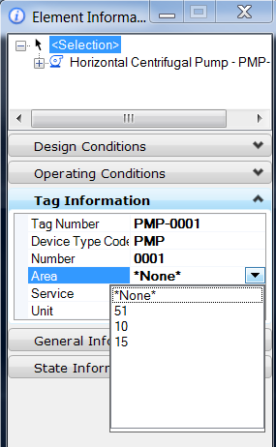

BubbleLocation
This extended type provides a dropdown list with the available bubble locations. Selecting a bubble location changes the bubble graphics.
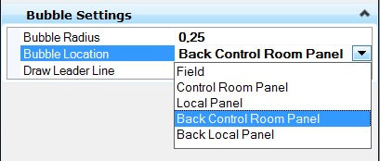

BusinessKey
This extended type provides a browse butten on the property that opens the Business Key dialog box.
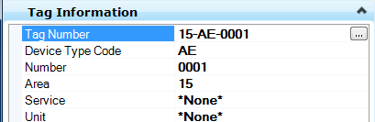

DesignStates
This extended type provides a dropdown list with the available design states.
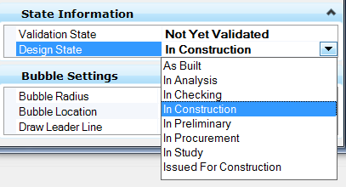

GetNextValue
This extended type provides a dropdown dialog box to select the next available number.
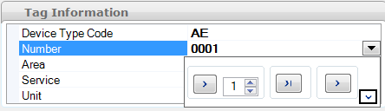

PipingSpecSelection
This extended type provides a dropdown list with all the available pipe specifications. The list is generated from the available spec files.
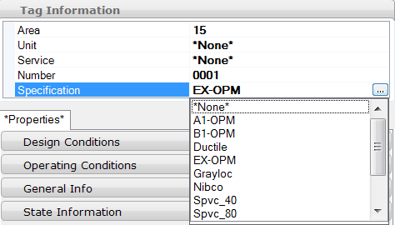

RelatedComponent
This extended type provides a browse button that opens a dialog box with all related components.
Example: For a Pipe Run all related inline components (Valves, Control valve, Flow elements, any component that is in the Pipe Run) can be displayed
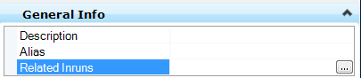
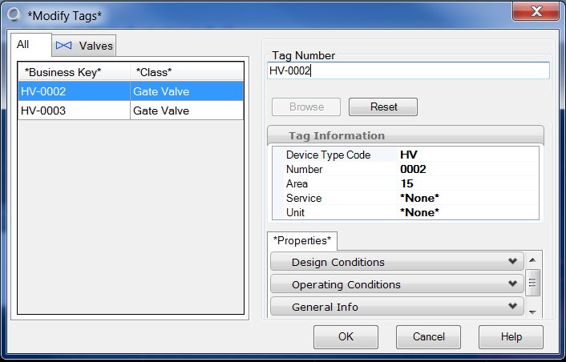

ShowPickListview
Provides a dropdown list with a defined list of values. The selected value is assigned to the property. The value list must be defined via the Value description attribute custom attribute

ShowPipeSizes
Provides a dropdown list displaying the active sizes list

ToFromData
Provides a browse button that opens the “To From” data dialog box showing the components a pipeline is connected to
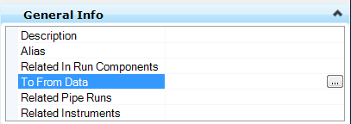
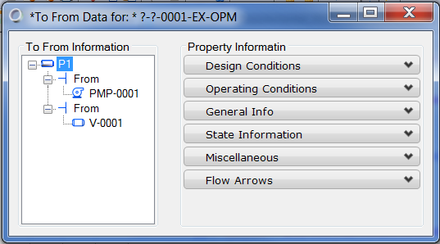

ValveEndConditions
Provides with a dropdown list of the available valve end conditions. The valve end conditions are displayed graphically by symbols.
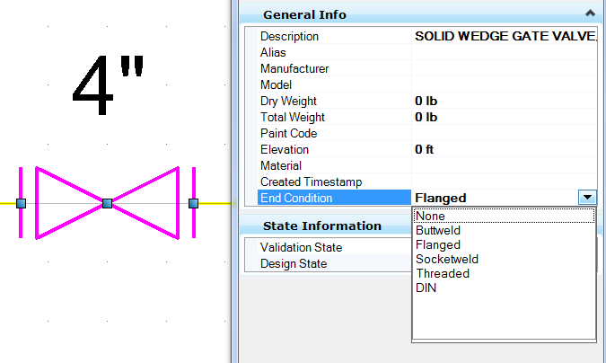

HideProperty
Class Name | HideProperty
Display Label | HideProperty
Schema | EditorCustomAttributes.01.01

Data Structure
Name | Data Type
If2D | Boolean
If3D | Boolean

Description
Hides a property from the property pane in the element information and item browser

Properties

If2D
If set to True it hides the property in an 2D application (e.g. OPPID)

If3D
If set to True it hides the property in an 3D application (e.g. OPM)

Example
In the ISO standard instrument bubbles can be elongated to fit longer annotation strings. This is not the case for imperial standards. The property is therefore hidden
If2D | True
If3D | True

RequiresRefresh
Class Name | RequiresRefresh
Display Label | RequiresRefresh
Schema | EditorCustomAttributes.01.01

Data Structure
There are no properties defined for this custom attribute

Description
This custom attribute is used to trigger property refresh.

Example
The custom attribute is used on the SIZE property of class PIPE

StandardValues
Class Name | StandardValues
Display Label | StandardValues
Schema | EditorCustomAttributes.01.01

Data Structure
Name | Data Type
MustBeFromList | Boolean
ValueMap  DisplayString  Value | string  string

Description
With the StandardValue custom attribute you can create a list of predefined values

Properties

MustBeFrom List
Force to use a value from the list. A user defined key-in is not possible

ValueMap

DisplayString
A string that is displayed in the dropdown menu

Value
The value that is assigned to the property when selected

Example
Set the vessel internals type.
MustBeFromList | not set
ValueMap[0]  DisplayString  Value  ValueMap[1]  DisplayString  Value  ValueMap[2]  DisplayString  Value  ValueMap[3]  DisplayString  Value | None  1  Packed  2  Trayed  4  Plate  8

The corresponding binary values (0001, 0010, 0100 and 1000) illustrate the internals types that are switched on and off.

Bentley Standard Custom Attributes.01.02

Business Key Specification
Class Name | BusinessKeySpecification
Display Label | Business Key Specification
Schema | Bentley Standard Custom Attributes.01.02

Data Structure
Name | Display Label | Data Type
PropertyName | Property Name | [DataType1]

Description
Specifies the property that is used for the BusinessKey

Properties

Property Name
Name of Property to use for displaying ECBusinessKey.StringValue

Example
Business Key Specification
Property Name | NAME

Calculated ECProperty Specification
Class Name | CalculatedECPropertySpecification
Display Label | Calculated ECProperty Specification
Schema | [Schema]

Data Structure
Name | Display Label | Data Type
ECExpression | ECExpression | string
FailureValue | Failure value | string
ParserRegularExpression | Parser regular expression | string
IsDefaultValueOnly | Is calculated as default value only | boolean
RequiredSymbolSets | Required ECExpression SymbolSets | string

Description
See Bentley.ECObjects.Standards.CalculatedECPropertySpecification. ECCustomAttributeClass for specifying an ECExpression to be used for calculating the value of a given ECProperty.

Properties

ECExpression
The ECExpression used to calculate an ECProperty's value.

Failure value
The string representation of the value to use when the value cannot be calculated due to missing dependents or any other reason.

Parser regular expression
Will be used when converting from the property value back into its constituent properties. This may be null, and is mostly applicable when the expression has been used to concatentate multiple other property values.

Is calculated as default value only
Indicates that the value will only be calculated once on the initial get.

Required ECExpression SymbolSets
ECExpressions SymbolSets required for evaluation of the ECExpression

Example
ECExpression | this.GetRelatedInstance("PLANT_AREA_HAS_NAMED_ITEM:1:PLANT_AREA, NAME:?").NAME &amp; "-" &amp; this.DEVICE_TYPE_CODE &amp; "-" &amp; this.NUMBER
FailureValue | Device
ParserRegularExpression | ^[?\w]*-(?&lt;DEVICE_TYPE_CODE&gt;[?\w]*)-(?&lt;NUMBER&gt;.*)|(?&lt;NUMBER&gt;.*)
IsDefaultValueOnly | False
RequiredSymbolSets | False
UseLastValidValueOnFailure | True

