Current drafting procedures for 4 way valves
Document Type: TechNote
Product(s): OpenPlant PowerPID
Version(s): Selectseries 3+
Original Author: Steve Morrow

Current drafting procedures for 4 way valves
- Using 3 runs to place 4way.

- Draw horizontal pipeline
- Draw 1st vertical pipeline (or run) branch connecting (going up) with horizontal pipeline
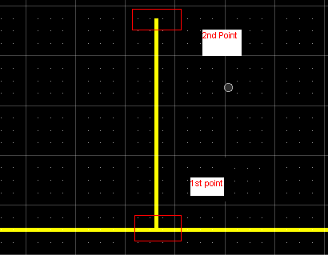
- Draw 2nd vertical pipeline (or run) branch connecting (going down) with horizontal pipeline
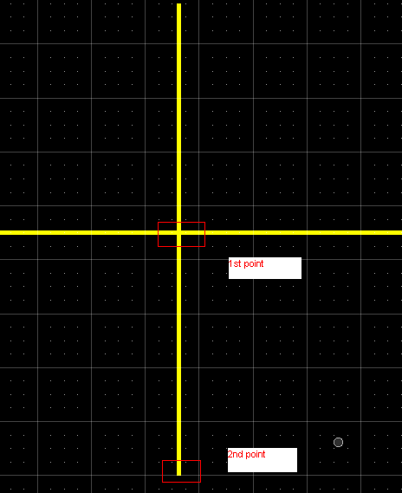
- Place 4way valve at the intersection of the 3 lines
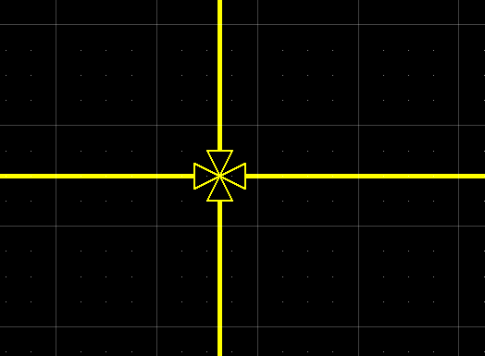

- Using a single vertical line, then placing pipruns from existing 4 way valve
  - Draw horizontal pipeline
  - Place 4 way valve in pipe run
  - Draw pipeline (runs) from branches of 4 way valve
