How to Determine Database Sync Issues
Document Type: TechNote
Product(s): OpenPlant PowerPID
Version(s): Selectseries 3+
Original Author: Steve Morrow

Contents
Description 1
Setting up variables 1
Determining the issue 2
Using the Sql Statement 2
Solutions 3
Note on reestablishing a database connection to a copied drawing. 3
Getting the error message to determine the issue 5
Integrity Check 6
Clues to find out why this happens 7
Configuration variable checks 9
Sync errors Field Mismatch 11

Description
When syncing to an Alternate Repository (database), sometimes issues occur. The most common issue is that a property field exceeds that database column length. This document will go thru steps on how to determine which component and field could be causing this problem. We will also go thru multiple solutions.

Setting up variables
- Open pid.cfg
- Change the tracing level to -3
PID_LOG_LEVEL : -3
- Open PowerPID.exe.config
  - File is located in \Bentley\PowerPID (SELECTseries 3)\PowerPID
  - Add the sql logging statement
<appSettings>
<add key="ECExchangeControlsMultithreading" value="false" />
<add key="ApplicationSchemaName" value="OpenPlant_PID.01.01" />
<add key="SqlStatementsLogFile" value="SqlLogFile.xml" />
</appSettings>

This is detailed in the BE Communities Post

Determining the issue
- Open the drawing in question
- Sync to the database
- Errors occur
- Look in the in Message Center.
2-7-11 09:10:24 LOG_ERROR - Bentley.Plant.ModelingFramework.SQLPluginAdapter - *Synchronization stopped because of error 'Failed to execute commit statement 'INSERT INTO [TAG_REG] ( [TAG_NO] , [CREATE_TM] , [KEYTAG_GUID_PK] , [KEYTAG] , [TAG_TYPE] ) VALUES ( ? , ? , ? , ? , ? ) ' for an instance of class NOZZLE
because of an exception of the type OleDbException with the message 'The field is too small to accept the amount of data you attempted to add. Try inserting or pasting less data.''*
- This gives a general idea of what the error could be. In this case a property string value is larger than what is defined in the database column.
- Close the drawing and exit OPPID
- Open SqlLogFile.xml. This file is located in the same location as the DGN file
- Search this file for similar strings, such as “Try inserting or pasting less data”.
INSERT INTO [TAG_REG] ( [TAG_NO] , [CREATE_TM] , [KEYTAG_GUID_PK] , [KEYTAG] , [TAG_TYPE] ) VALUES ( '?-?-REBOILER-BOTTOMSPUMP@COL1B-SSSS-<146,186><141,88><15878,13>110' , '00010101000000' , '{70A8F1BC-3930-4E40-A6EF-8153D0C6FD3F}' , '0000000871' , 'AT_PID_NOZZLE' )
The field is too small to accept the amount of data you attempted to add. Try inserting or pasting less data.
- This will give some clue to what is going on. In this case the tag number is too long. The TAG_REG.TAG_NO has a defined column length of 64 chars.and the ec property value is 66 chars long.

Using the Sql Statement
- Sql statement
INSERT INTO [TAG_REG] ( [TAG_NO] , [CREATE_TM] , [KEYTAG_GUID_PK] , [KEYTAG] , [TAG_TYPE] ) VALUES ( '?-?-REBOILER-BOTTOMSPUMP@COL1B-SSSS-<146,186><141,88><15878,13>110' , '00010101000000' , '{70A8F1BC-3930-4E40-A6EF-8153D0C6FD3F}' , '0000000871' , 'AT_PID_NOZZLE' )
- Open Access or SQL Server
- Paste the sql statement
- Run the sql statement
- Examine the results.
- If a error dialog is displayed examine and research the result (via google)
- If no error is dialog is displayed examine the tables and compare the inserted results.

My result was that the tag number was truncated in the TAG_REG.TAG_NO field. So I compared the SQL statement values to the database column values
SQL Statement = ?-?-REBOILER-BOTTOMSPUMP@COL1B-SSSS-<146,186><141,88><15878,13>110
Database Result = ?-?-REBOILER-BOTTOMSPUMP@COL1B-SSSS-<146,186><141,88><15878,13>1

Solutions
- Modify the ecproperty value in the element info dialog to fix in the database column
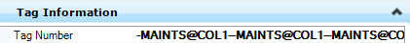

- Change the database column size
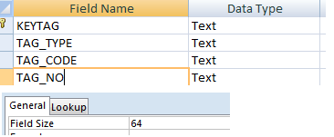

- Modify the missingfields.xml and alter the TAG_NO column
<RECORD>
<AlterColumn>TAG_REG</AlterColumn>
<ColumnName>TAG_NO</ColumnName>
<DataType>VARCHAR(100)</DataType>
</RECORD>
  - Location
    - C:\Program Files (x86)\Bentley\PowerPID (SELECTseries 3)\PowerPID\assemblies\ECFramework\extensions\

Note on reestablishing a database connection to a copied drawing.
I ran into an issue from an emailed drawing. This drawing was created in a Metric environment and I had previously been working in an Imperial environment. When I opened the DGN I got this message.
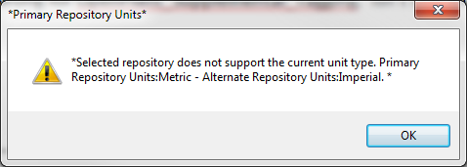
This means that the units in the drawing do not match the units in the database.
- Pick ok on the Working Offline dialog
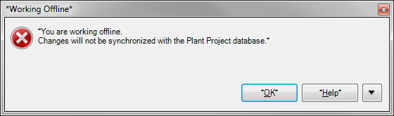
- Use “The file was copied” Option.
- Pick ok on the next dialog
- Next go to the file menu and pick the “Work offline” to go back to the database
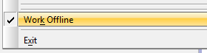
- Select the current project database
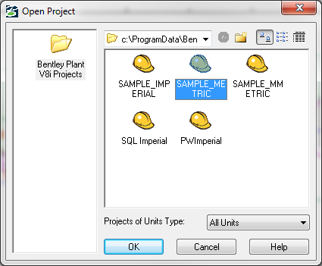

Getting the error message to determine the issue
If an error occurs, pick the expand button to get the exact message
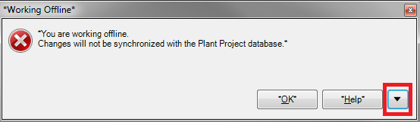
Send screen copy this. We are looking for the “Exception Message” at the bottom
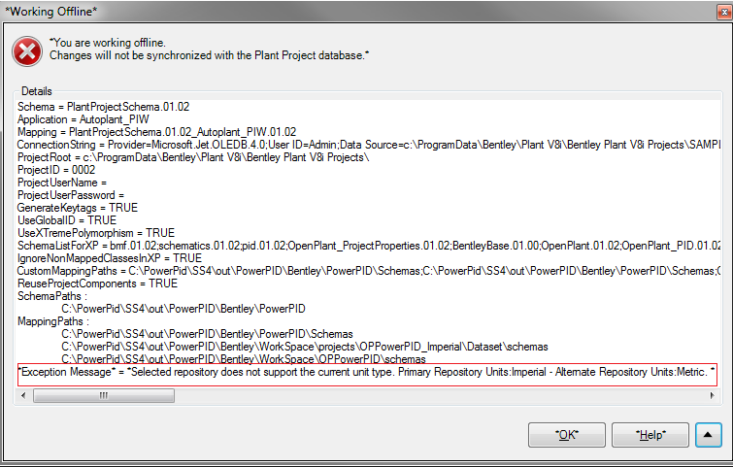

Integrity Check
Symptom: I can select a Database Project but my OPPID Sync menu option is disabled.
Cause: The Bentley Project Administrator Integrity Check is enabled. Ensure the “Enable Integrity Check Engine Globally” is unchecked.
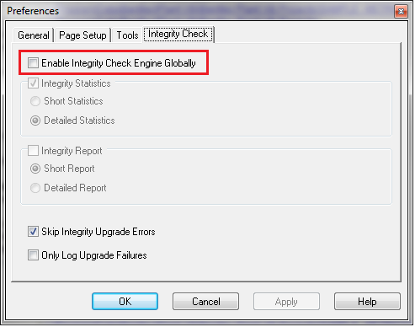

Clues to find out why this happens
- Turn the OPPID logging to -4
- Open OPPID and select a Database Project
- Examine the Message log and look for “InitEx”
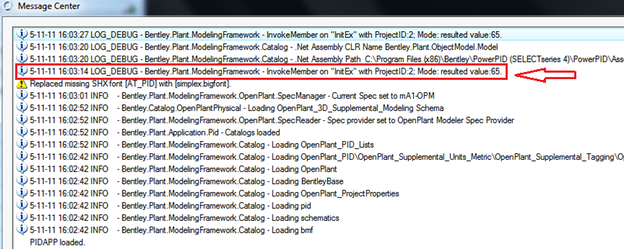

This shows a result of 65. A valid initialization of a project return result= 1.

Here is the list of return values form the initialization of a Database Project

Result | Description
0 | Unknown error
1 | No errors
2 | Exclusive locked
4 | Already opened by smb.
8 | Need to be upgraded
16 | Has no 3D config subdirectory, possible 2D project
32 | Has no Properties3D table, possible 2D project
64 | DB Integrity Warning
128 | DB Integrity Failed
256 | DB Integrity Upgrade Failed

Another example would be the return of 17. This is a combination of 1 and 16. The Config folder in the DataBase Project folder is missing
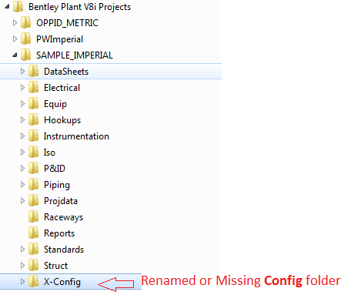

Configuration variable checks
Below is a list of variable to check to ensure they are set correctly. These variables can be set in: pid.cfg, project.pcf or user.ucf. Please be sure check to check each file for these cfg variables. Some are required and some are optional.

- ACTIVE_ALTERNATEREPOSITORY_PLUGINID
Required variable: should NOT BE MODIFIED.
This variable is defined in the pid.cfg. It must be set to AutoPlantDBSQLECPlugin. If this is set to any other value, a connection to the database will not be established. If this value is changed the following error will be displayed:
LOG_ERROR - Bentley.Plant.ModelingFramework.ObjectModel - Exception : Object reference not set to an instance of an object. Stack Trace : at Bentley.Plant.ObjectModel.Model.updateIntervalSyncTimer(Boolean forceStop) at Bentley.Plant.ObjectModel.Model.Open() at Bentley.Plant.ObjectModel.Workspace.OpenModel(String cadDocName, String modelId)

- PLANT_PROJECT_SHOW_SYNC_COMPLETE_DIALOG
0 or 1

- PLANT_PROJECT_SYNC_ON_FILECLOSE
0 or 1

- PLANT_PROJECT_BYPASS_PRIMARY_UNITS_CHECK
0 or 1

- PLANT_PROJECT_WORKOFFLINE
0 or 1

- PLANT_PROJECT_INTEGRATION
0 or 1

- PLANT_PROJECT_HIDE_WORKOFFLINE_DIALOG
0 or 1

- AP_ADDITIONAL_MISSING_FIELDS_XML_FILENAMES
Optional list of addition xmlfile names to add/append/modify database columns

- ALLOW_SYNC_DELETE_FROM_DRAWING
Optional variable
0 or 1

- DISABLE_PLANT_PROJECT_INTEGRATION
Optional variable
0 or 1

- PLANT_PROJECT_SYNC_ON_FILEOPEN
Always_Ask = 0,
DGN_2_ALTREPO = 1,
ALTREPO_2_DGN = 2

- PLANT_PROJECT_SYNC_DIRECTION
Always_Ask = 0,
DGN_2_ALTREPO = 1,
ALTREPO_2_DGN = 2

- SYNC_DIRECTION_ON_FILEOPEN
Always_Ask = 0,
DGN_2_ALTREPO = 1,
ALTREPO_2_DGN = 2

- PLANT_PROJECT_SYNC_MODE
Sync_None = 0,
Sync_Instant = 1,
Sync_Interval = 2,
Sync_Manual = 3

- PLANT_PROJECT_SYNC_INTERVAL
Integer value
default is 5 mins (300000)

Sync errors Field Mismatch
These errors can occur when the database column have a field value type that does not match an OPPID field value type: DB Column type = STRING, ECProperty type = DOUBLE.
- OPPID tries to convert the value in the database to match schema mapping.
  - If the value in a database string column is 100 and that column is mapped to an OPPID property that is defined as a double, the value 100 is accepted.
  - If that database value is 100 lbf, an error will occur.
An example of this would be if PIPERUN.POPP has a value of 100lbf.
PIPE_RUN
POPP
100 lbf

OPPID would have a message center error possibly like:
3-21-12 17:08:09 LOG_ERROR - Bentley.Plant.ModelingFramework.SQLPluginAdapter - *Synchronization stopped because of error 'Failed to execute commit statement 'INSERT INTO [PIPE_RUN] ( [DESIGNTEMPF] , [PSZ] , [KEYTAG_GUID_PK] , [PRESS_MAX] , [INSMATL] , [NOM_DIAMETER] , [POPT] , [CRITICAL_PRESS] , [DESIGNPRESSPSIG] , [INSTHKNS] , [PSPEC] , [RUN_NAME] , [TRACERTEMP] , [TEMP_MIN] , [PCLASS] , [PFLOW] , [POPP] , [KEYTAG] ) VALUES ( ? , ? , ? , ? , ? , ? , ? , ? , ? , ? , ? , ? , ? , ? , ? , ? , ? , ? ) ' for an instance of class PIPING_NETWORK_SEGMENT
because of an exception of the type OleDbException with the message 'The changes you requested to the table were not successful because they would create duplicate values in the index, primary key, or relationship. Change the data in the field or fields that contain duplicate data, remove the index, or redefine the index to permit duplicate entries and try again.''*
Input string was not in a correct format.
To fix this error remove the lbf from the PIPE_RUN.POPP field
PIPE_RUN
POPP
100

The Database column types for most tables are defined as strings. This includes pressure and temperature columns. OPPID defines the types as doubles. As shown with the example above PIPE_RUN.POPP is defined as string type where as NORMAL_OPERATING_PRESSURE is defined as a double. Mapping in PlantProjectSchema.01.03_Autoplant_PIW.01.03.mapping.xml
<Property name="NORMAL_OPERATING_PRESSURE" state="Active">
<Column name="PIPE_RUN.POPP" />
</Property>

