Related Document Searches in ProjectWise
Product(s): OpenPlant PowerPID,ProjectWise
Version(s): SelectSeries 3+
Original Author: Tony DeRosa

- Create a new relational search in ProjectWise Explorer via the Search Form.
  - To get the proper attribute name load the ProjectWise Class Editor – see step 3 below.
- Define the parameters as shown below – see the ProjectWise Explorer help file for information. Save the search.
NOTE – The Application setting of Acrobat PDF – this will limit the search to these types of documents only. If you want the search to look for other types of documents create multiple relational searches for the different document types.
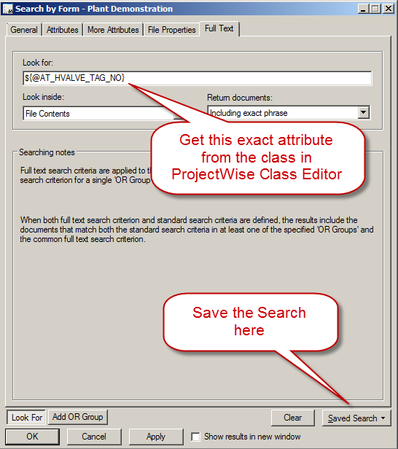

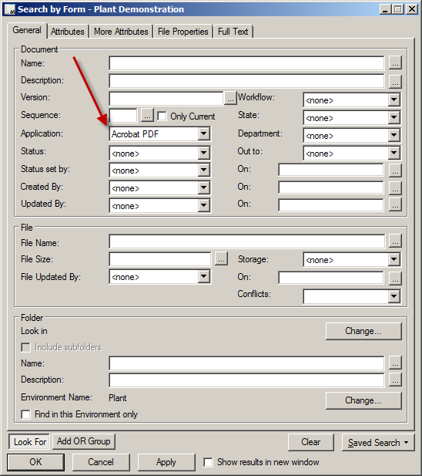

- Load the ProjectWise Class Editor.
  - Expand the Component node
  - Look for the AT_HVALVE class.
  - Note the AT_HVALVE_TAG_NO attribute – use this name in the search parameters in step 1 above.
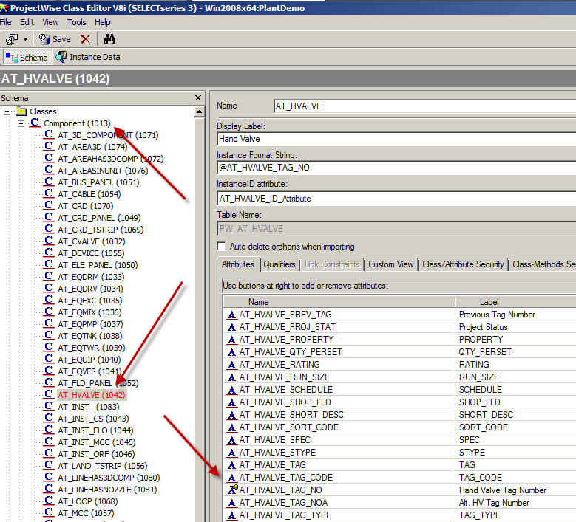
  - Switch to the Related Components tab.

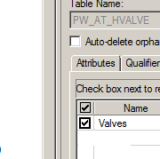
  - You should see the search you created and saved in ProjectWise Explorer.
  - Check this on to use it for this component class.
- Save the class in ProjectWise Class Editor.
- Back in ProjectWise Explorer expand the component index and locate a valve tag.
- From the right hand pane select the Find Related Documents tab and you will find a list of documents that contain the valve tag number. In the example only one report is in the project datasource.
