OPPID Project Units explained or What makes a Metric project a Metric Project
Document Type: TechNote
Product(s): OpenPlant PowerPID
Version(s): Selectseries 3+
Original Author: Steve Morrow

Description
Units are “real world” values used for measurements in design models. OPPID recognizes Metric and English units. These units consist of Master and Sub units (Meter-Millimeters, Feet-Inches). These values are set in the Design File Settings dialog (Menu->Settings->Design File…). The seed file is used to store these units. Each Workspace Project contains a seed file, so each Workspace Project can be individually set to store a specific unit. OPPID offers three types of units (Imperial, Metric and Mixed Metric). These Workspace projects match up with Alternate repository (database) project units.

Workspace vs Database
Currently in the OpenPlant world there are two types of projects: Workspace and Database. The Workspace project consists of customized data files, such as cell libraries and line style libraries, identified by configuration variables in the project configuration file (.pcf). The Database project is a repository for storing metadata. We use the AutoPLANT framework data structure. The two projects types work in conjunction to link graphical representations with metadata.

Drawing Unit Definitions
As described above, the drawing units are set in the seed file. The seed file is defined in the project.pcf.
MS_DESIGNSEED = $(_USTN_PROJECTDATASET)seed/seed_eng.dgn

- Drawing Unit Types
- Imperial
- Metric

- Metric modes (extended by cfg variable in project.pcf).
- Metric
- Mixed Metric

  - Mixed Metric is defined by
- Units = Metric (Meter-Millimeters)
and
- Cfg Variable in Project.pcf
_BMF_USE_MIXED_METRIC_UNITS =1

Once this variable is set, it can be confirmed by opening the OPPID Drawing settings (Menu->Settings-Drawing)
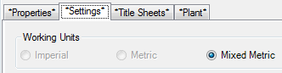

Database Unit Definition
- Database unit types
  - Imperial 1
  - Metric 2
  - Mixed metric 3
  - Unknown 0

The unit type is defined in the config.ini located in project database folder (*\Bentley Plant V8i Projects\SAMPLE_METRIC\Config)
[System]
Units = Metric
Units_Type = 2

Unit bypass variable
- To bypass any unit check add the following to the project pcf file
PLANT_PROJECT_BYPASS_PRIMARY_UNITS_CHECK

Mixed Metric Example
The current Metric project can be used to setup a Mixed Metric Workspace Project.
- Create new Workspace Project.
  - Use Existing Metric Workspace Project
    - Follow steps from BE Post
- Open pcf file (MyNewMixedMetric.pcf)
  - Add cfg variable: _BMF_USE_MIXED_METRIC_UNITS =1
- Ensure the seed file units set to Metric
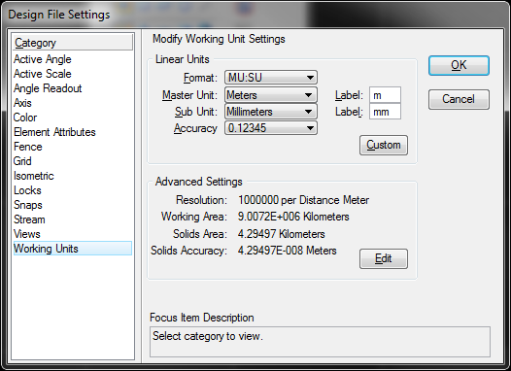
- Create AutoPLANT database thru the Project Administrator or use sample projects
- Ensure that the config.ini file has Mixed Metric settings. Units_Type = 3 denotes Mixed Metric.
[System]
Units = Metric
Units_Type = 3
- Create new drawing in new Mixed Metric Workspace Project
- Select Mixed Metric Database
