OpenPlant Power P&ID Database Documents and their Component Links

Description

One of OpenPlant Power P&ID’s strengths is found in the open environment of application data tables. Application data tables contain data associated with tagged objects created by OpenPlant Power P&ID.

Whenever a graphical object is created, OpenPlant Power P&ID creates a tag associated with this object type. OpenPlant Power P&ID will either generate an automatic tag or prompt for a tag based on the system settings. This tag value is then stored in the tag register and an internal tag ID is generated for reference within the database. A unique tag ID will be generated for each item independent of whether the external tag can be unique or not.

The mechanism for connecting graphic objects within a drawing to the data associated with tags stored in external databases utilizes two different types of identifiers: links and keytags. A link is stored in a tagged object's extended data. This link will specify the Link table and unique link ID within that Link table. This link data is used to locate the link record in the specified Link table that corresponds to the object. There is a one-to-one relationship between graphic objects with links and external link records. The link record contains information about the link such as the tag type, internal drawing number and link handle, and the physical location of the link within the drawing.

The link table name and link ID can also be used in the Key Link table to identify the link's KEYTAG. A keytag is the internal tag ID that is unique across an entire project and is the primary identifier for all tags or objects within a project. A single keytag (or database object) can have multiple links connecting it to multiple graphic objects. For example, a process line that is included on more than one drawing will have one link for each drawing in which it appears. Selecting this process line in any of the drawings will link to the same data associated with the process line.

Usage

The KEY_LINK table is the primary storage point for link data in the project database. Each graphical link in the OpenPlant Power P&ID drawing has data association with the KEY_LINK table. There are seven link tables. These link tables contain data that defines the Drawing ID in which the link resides, the link’s handle in the drawing and the location of link in the drawing.

Link Diagram

LINK TABLES
EQP_LNK
INST_LNK
PID_LNK
PID_TLNK
PROC_LNK
VAL_LNK
DOC_REG
Drawing Graphic
Link
KEY_LINK

Tag Registers
TAG_REG
INSTR
RUN_CONN

SOURCE TABLES
VALVE
EQUIP
PROCESS
PIPE_RUN
NOZZLE
PID_TOFR
SPEC_ITM
Tie_in

Table Storage

Equipment | KEY_LINK | EQP_LNK | TAG_REG | EQUIP |  | DOC_LINK
Instruments | KEY_LINK | INST_LNK | INSTR |  |  | DOC_LINK
Control Valves | KEY_LINK | INST_LNK | INSTR |  | RUN_CONN | DOC_LINK
Valves | KEY_LINK | VAL_LNK | TAG_REG | VALVE | RUN_CONN | DOC_LINK
Process and Pipe Runs | KEY_LINK | PROC_LNK | TAG_REG | PROCESS  PIPE_RUN | RUN_CONN | DOC_LINK
Nozzles | KEY_LINK | PID_LNK | TAG_REG | NOZZLE |  | DOC_LINK
Run Terms | KEY_LINK | PID_LNK |  | NOZZLE |  | DOC_LINK
To From | KEY_LINK | PID_TLNK |  | PID_TOFR |  | DOC_LINK
Specialty Item | KEY_LINK | PID_LNK | TAG_REG | SPEC_ITM |  | DOC_LINK
Tie In | KEY_LINK | PID_LNK | TAG_REG | TIE_IN |  | DOC_LINK

Link tables
Below are the table views for an Equipment pump placed in an OpenPlant Power P&ID document. The KEYTAG value is used to store tag number (TAG_REG) and source tables (EQUIP). There should only be one KEYTAG per component. The LINK_ID is the link to document that it was placed on. There could be multiple links per component.

LINK_TAB | LINK_ID | KEYTAG | TAG_TYPE
EQP_LNK | 0000000001 | 0000000630 | AT_EQPMP

LINK_ID | TAG_TYPE | DWG_NAME
0000000001 | AT_EQPMP | 0000000629

DOC_ID | TAG_TYPE | DOC_NAME | DOC_FNAME
0000000629 | AT_DWG_NAME | Plant1 | Plant1.dgn

EQUIP
KEYTAG | ETYP | ENUM | EAREA | ESERV
0000000630 | PMP | 0001 | B | S100

TAG_REG
KEYTAG | TAG_TYPE | TAG_NO
0000000630 | AT_EQPMP | PMP-0001

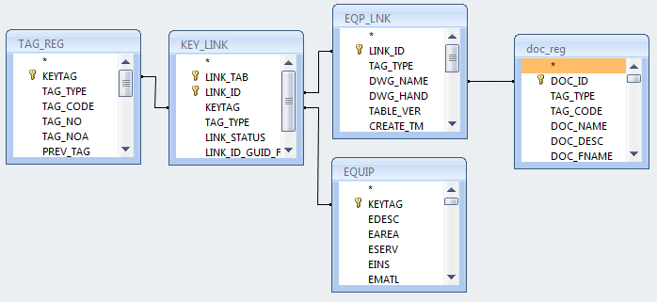

Sql query to show how equipment components are linked to documents
SELECT TAG_REG.TAG_NO, TAG_REG.TAG_TYPE, DOC_REG.DOC_NAME, TAG_REG.KEYTAG, EQUIP.EDESC
FROM (((KEY_LINK INNER JOIN TAG_REG ON KEY_LINK.KEYTAG = TAG_REG.KEYTAG) INNER JOIN EQP_LNK ON KEY_LINK.LINK_ID = EQP_LNK.LINK_ID) INNER JOIN DOC_REG ON EQP_LNK.DWG_NAME = DOC_REG.DOC_ID) INNER JOIN EQUIP ON KEY_LINK.KEYTAG = EQUIP.KEYTAG;

