OpenPlant PowerPID

Customization Trouble Shooting Guide

Version 1.0

March 30, 2011

Trademarks

Bentley, the “B” Bentley logo, MicroStation, ProjectWise and AutoPLANT are registered trademarks of Bentley Systems, Inc or Bentley Software, Inc.

Microsoft, Windows and SQL Server are registered trademarks of Microsoft Corporation.

AutoCAD is a registered trademark of Autodesk, Inc.

Oracle 11g, 10g and Oracle 9i are registered trademarks of Oracle Corporation.

Other brands and product names are the trademarks of their respective owners.

Copyrights

© 2010 Bentley Systems, Incorporated

No part of this document may be reproduced, translated, or transmitted in any form or by an means, electronic or mechanical, for any purpose without the express written permission of Bentley Systems, Inc, and then only on the condition that this notice is included in any such reproduction. No information as to the contents of this document may be communicated to any third party without the prior written consent of Bentley Systems, Inc.

Information in this document is subject to change without notice and does not represent a commitment on the part of Bentley Systems, Inc. Bentley Systems, Inc. is not liable for errors contained in this document or for incidental or consequential damages in connection with furnishing or use of this material.

Including software, file formats, and audiovisual displays; may only be used pursuant to applicable software license agreement contains confidential and proprietary information of Bentley Systems, Inc. and/or third parties which is protected by copyright and trade secret law and may not be provided otherwise made available without proper authorization.

RESTRICTED RIGHTS LEGENDS

Use, duplication, or disclosure by the government is subject to restrictions as set forth in subparagraph (c)(1)(ii) of the Right in Technical Data and Computer Software clause in DFARS 252.227-7013 or subparagraphs (c)(1) and (2) of the Commercial Computer Software – Restricted Rights in 48 CFR 52.227-19 as applicable.

Unpublished – rights reserved under the Copyright Laws of the United States and International treaties.

Downloaded files from Bentley-related Internet websites and files included on MySELECT CDs are subject to the legal terms, conditions, policies and usage restrictions posted on the website(s), which may significantly alter the rights granted in the license agreement included with these materials.

Document Version History

Version | Date | Author | Comments
1.0 | 3/30/2011 | Tony DeRosa | Initial Release

Reviewed By | Date | Approved By | Date

Software Versions

Application Name | Version
OpenPlant PowerPID | 08.11.07.22 and higher
Bentley Class Editor V8i | 08.11.07.415

Table of Contents

Overview 5
OpenPlant PowerPID Specific Items 5
PID Log Level Settings 5
Retrieving Component Class Name, Relationship and Property Data 7
Retrieving Component Connection Point Locations 9
Manually Placing New Components – No Task Exist 10
Schema and Other Files 11
Manually Editing Connect Points in the Cell Library XML file. 11
Notes 13

Overview
This document is compilation of tips and tricks to assist the administrator in trouble shooting OpenPlant PowerPID and its related schemas. Included are system debug settings and what to look for in regards to common issues found when customizing the application and schemas.

OpenPlant PowerPID Specific Items

PID Log Level Settings

- Modify the PID.cfg file located in the product install directory …\config\appl set the section shown below to level “-3” for day to day customization verification and level “-5” for more detailed information when you’re completely stumped as to the root of an error. MOST OFTEN level “-3” is sufficient.

# Message logging level
# FATAL = 0
# ERROR = -1
# WARNING = -2
# INFO = -3
# DEBUG = -4
# TRACE = -5
PID_LOG_LEVEL : 0
- You can also set this variable in the UCF file by loading OpenPlant PowerPID.
  - From the menu select Workspace>Configuration…
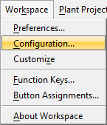
  - In the Configuration: User [untitled] dialog and the View/modify all configuration variables section select PID_LOG_LEVEL and then pick the Edit… button.
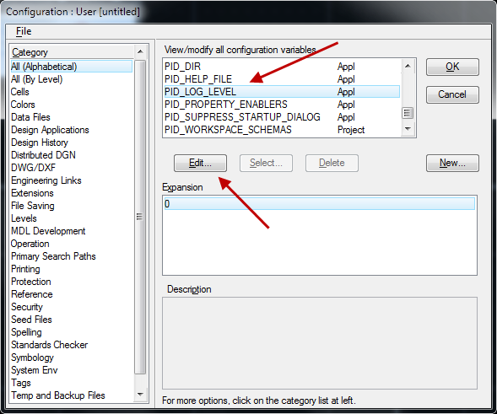
  - In the Edit Configuration Variable dialog set the New Value: to the desired level and select the OK button.
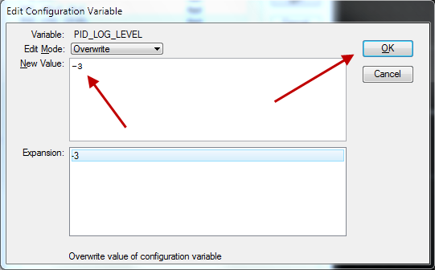
  - Back at the Configuration: User [untitled] dialog select the OK button and when prompted with the Alert to save changes select the Yes button and then exit OpenPlant PowerPID. The next time this is loaded the new log level setting will be honored.
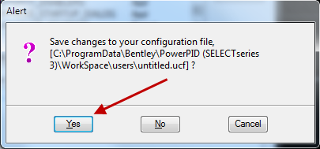

Retrieving Component Class Name, Relationship and Property Data

- Place the component in a PID drawing.
- Select the component using the Selection tool.
- From the Key-in window type in “pid component dump” (less quotes) and then hit the enter key.
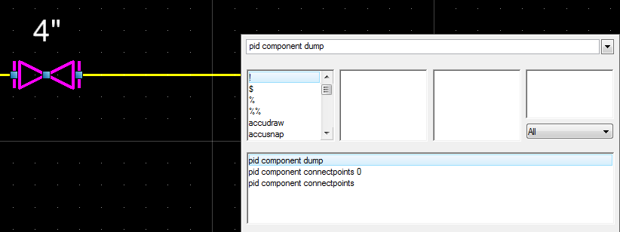
- The subsequent dialog(s) will contain the necessary information in regards to class name, relationships with other components and property data.
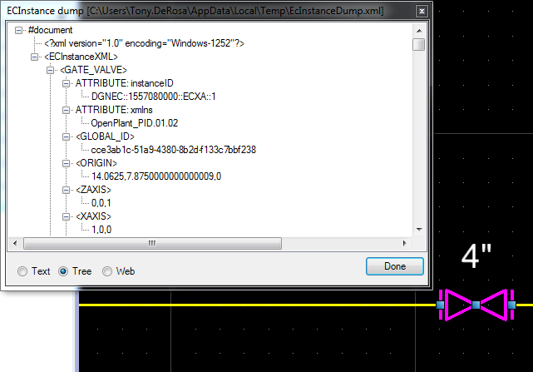

Retrieving Component Connection Point Locations

- Place the component in a PID drawing. Example a Valve.
- Select the valve using the Selection tool.
- Load the key-in window.
- Type in “pid component connectpoints” (less quotes) and hit enter.
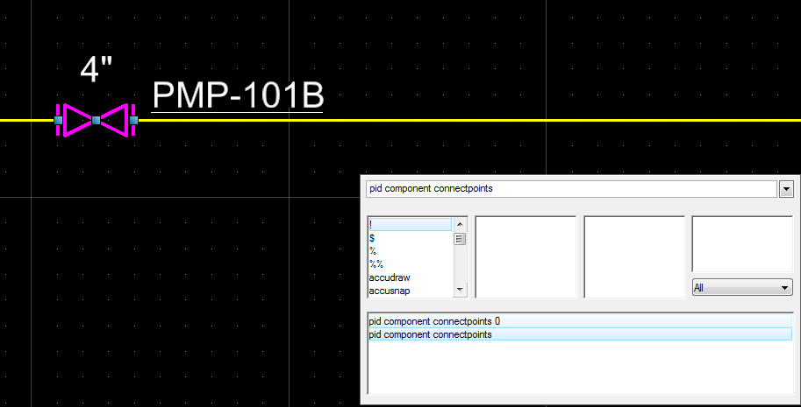

Results
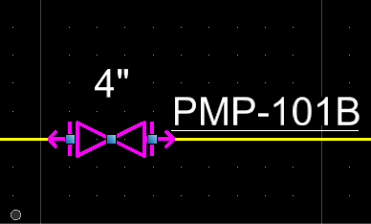
- To disable the connect points – select the component and load the key-in window.
- Type in “pid components connectpoints 0” (less quotes) and hit enter.
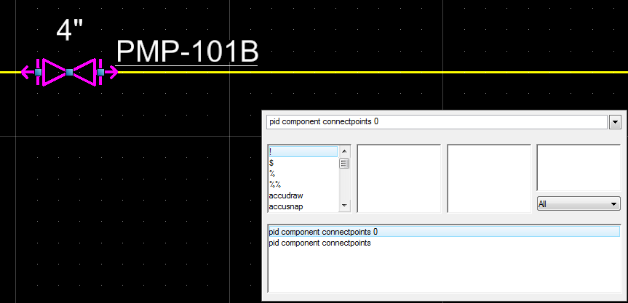

Manually Placing New Components – No Task Exist

- Load OpenPlant PowerPID and create a new or load an existing PID.
- Load the key-in window and type the following “pid insert openplant_pid CONE_ROOF_TANK and press enter. As noted below the syntax is
pid insert = Insertion command
openplant_pid = Schema name
CONE_ROOF_TANK = Class Name of component.
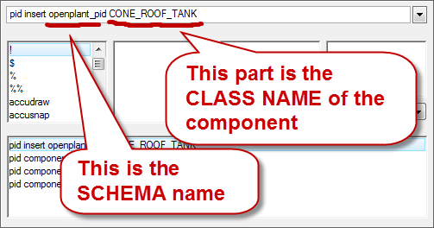

Schema and Other Files

Manually Editing Connect Points in the Cell Library XML file.

- Load the desired cell library XML file in a text editor.
- Locate the desired cell by cell name.
- Edit or add connect points as required. Note break down of required vs. optional fields for each cell record.
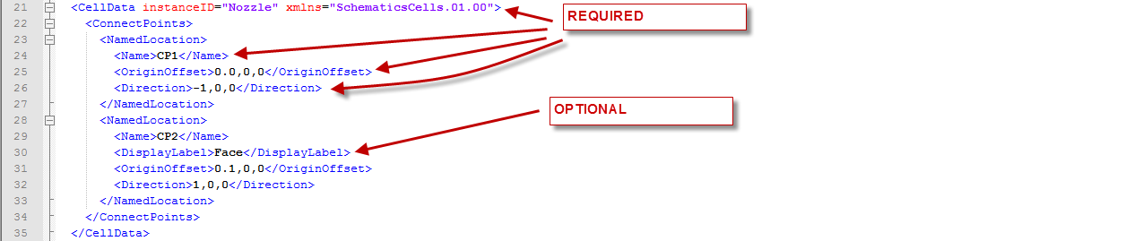

<CellData instanceID="Nozzle" xmlns="SchematicsCells.01.00">
<ConnectPoints>
<NamedLocation>
<Name>CP1</Name>
<OriginOffset>0.0,0,0</OriginOffset>
<Direction>-1,0,0</Direction>
</NamedLocation>
<NamedLocation>
<Name>CP2</Name>
<DisplayLabel>Face</DisplayLabel>
<OriginOffset>0.1,0,0</OriginOffset>
<Direction>1,0,0</Direction>
</NamedLocation>
</ConnectPoints>
</CellData>

From the above:
Name = User defined name. This is REQURIED

OriginOffset = distance from cell origin point to the connect point in X, Y, Z direction. This is REQUIRED but can be “0”

Direction = Direction of connect point from its own location. This is RQUIRED. This is used to determine which direction the cell will be in relation to an adjoining component located at that connect point.

DisplayLabel = User defined label for the connect point – This is OPTIONAL. If no value is needed the omit this line from the record.

Notes

