Adding an Actuator to inline valves from Element Info
Document Type: TechNote
Product(s): OpenPlant PowerPID
Version(s): Selectseries 4+
Original Author: Steve Morrow

Description
To add an actuator to a valve after placement, the OpenPlant_PID.01.02.ecschema.xml must be modified.

OpenPlant_PID.01.02.ecschema.xml
Two modifications must be made. Add the “CONTROL_VALVE_CLASS_LIST” custom attribute and add the new class with actuators.
Modification to VALVE class
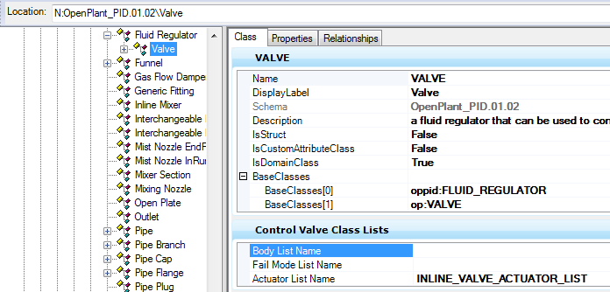

XML
<ECClass typeName="VALVE" description="a fluid regulator that can be used to control (i.e. permit, obstruct, regulate or divert) a fluid stream." displayLabel="Valve" isDomainClass="True"> <ECCustomAttributes>
<CONTROL_VALVE_CLASS_LISTS xmlns="pid.01.01">
<BODY_LIST_NAME></BODY_LIST_NAME>
<ACTUATOR_LIST_NAME>INLINE_VALVE_ACTUATOR_LIST</ACTUATOR_LIST_NAME>
</CONTROL_VALVE_CLASS_LISTS>
</ECCustomAttributes>
</ECClass>

Addition of new actuator class
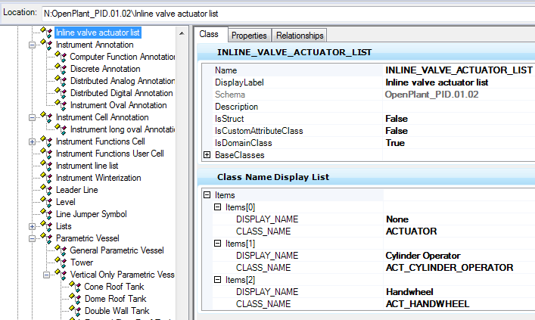

XML
<ECClass typeName="INLINE_VALVE_ACTUATOR_LIST" displayLabel="Inline valve actuator list" isDomainClass="True">
<ECCustomAttributes>
<CLASSNAME_DISPLAY_LIST xmlns="bmf.01.01">
<ITEMS>
<CLASSNAME_DISPLAY_STRUCT>
<DISPLAY_NAME>None</DISPLAY_NAME>
<CLASS_NAME>ACTUATOR</CLASS_NAME>
</CLASSNAME_DISPLAY_STRUCT>
<CLASSNAME_DISPLAY_STRUCT>
<DISPLAY_NAME>Cylinder Operator</DISPLAY_NAME>
<CLASS_NAME>ACT_CYLINDER_OPERATOR</CLASS_NAME>
</CLASSNAME_DISPLAY_STRUCT>
<CLASSNAME_DISPLAY_STRUCT>
<DISPLAY_NAME>Handwheel</DISPLAY_NAME>
<CLASS_NAME>ACT_HANDWHEEL</CLASS_NAME>
</CLASSNAME_DISPLAY_STRUCT>
</ITEMS>
</CLASSNAME_DISPLAY_LIST>
</ECCustomAttributes>
</ECClass>

PowerPID Element Info selection
- Place pipeline
- Place valve in pipeline
- Select valve
- Go to element info
- Go to General Info category and select “Actuator Display Label”

