Connection points and their usage
Document Type: TechNote
Product(s): OpenPlant PowerPID
Version(s): Selectseries 3+
Original Author: Steve Morrow

Description
Connection points are snap able locations which allow for sure connections/relationships and placement between components.

Uses
- Determining a break distance when an in run component (valve) is placed in a Pipe Run.
- Component connections using connect points (sample list, please add to )
  - Nozzle
    - Equipment
    - Pipe Run
  - Instrument to
    - Pipeline
    - Pipe Run
    - Equipment
    - Instrument
  - Offpage connector
    - Pipe Run
  - End fittings (caps, plugs…)
    - Pipe run
  - Pipe Run
    - Pipe runs
    - Pipeline

Usage
Adding connection points are added to components with Component Manager. Please refer to the help for this.

Storage
Connection points are stored in a schema xml file which corresponds to the cell library in which the cell exists. For example of a cell is created and added to Valves.cel, the schema in which the connection points are stored in would be called Valves.cel.sch.ecinstance.xml.
Each cell has its own definition in the schema xml. This definition contains the connection points. Connection points are offset from the origin of the cell. Also contain in this definition is the direction vector and name of the connection point. The connection point name is used as a tooltip when hovering over the handle (Inlet, Outlet…)

Visualization
A key-in can be applied on existing inserted components to determine connection point location.
- Select the component
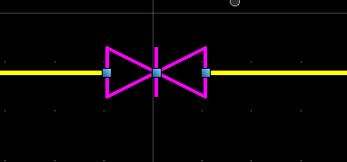
- Open the keyin dialog and type
  - pid component connectpoints
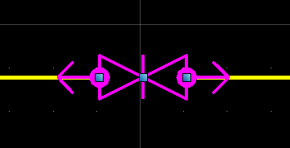
- To remove the connection point indicators
- Select the component and type the key-in
  - pid component connectpoints 0

Pipe run line breaking
By default if there are no connection points, the range of cell is used to determine the line break. Most in run components have proportional break points, that is the points that will compose the break make up the actual range.
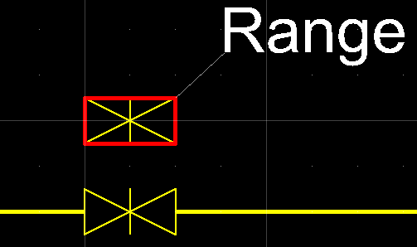

When the range of the in run component does not have proportional break points, a custom attribute must be added in addition to valid connection points (added thru Component manager). This components range is larger than the break that is required:
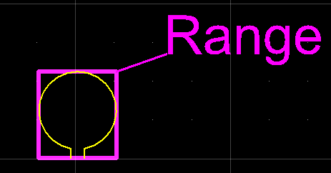
The required break distance is less than the range
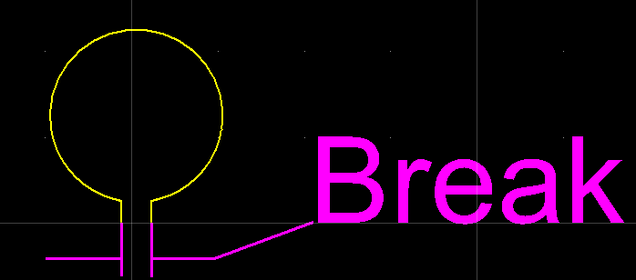
A custom attribute must be added to get the correct break distance (along with connection points)
- Open the class editor
- Find the class
- Add the custom attribute: SCHEMATICS_COMPONENT_CUSTOM_ATTRIBUTES
  - Set USE_PREDEFINED_POINTS_FOR_RANGE to true
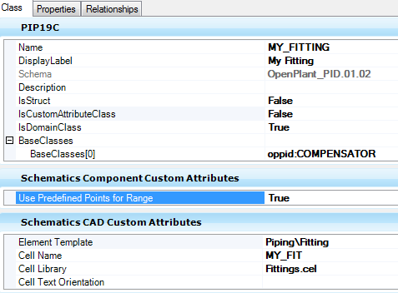

With and without custom attribute and valid connection points:
