OPPID Pipeline To-From SQL
Document Type: TechNote
Product(s): OpenPlant PowerPID
Version(s): Selectseries 4+
Original Author: Steve Morrow/Joao Ferreira

Description
OpenPlant Power PID writes To-From destination data to the NOZZLE table. (To be clear To-From destination data does not refer to Off Page connections). Foreign key values are used to store these relationships. These relationships are made graphically in the OpenPlant Power PID application. When a Pipeline is placed on a piece of equipment, a nozzle is automatically placed and a relationship is made. When a Pipeline or Pipe run is placed on another Pipeline or Pipe run a relationship is created. This type of connection is called a Run termination.
The EC relationships are defined in PlantProjectSchema.01.02_Autoplant_PIW.01.02.mapping.xml.
- NOZZLE_CONNECTS_TO_SEGMENT
- SEGMENT_CONNECTS_TO_NODE
- REDUCER_CONNECTS_TO_SEGMENT
- SEGMENT_CONNECTS_TO_SEGMENT
- EQUIPMENT_HAS_NOZZLE

These mappings determine the table and column in which the database values are written to.

Connection types

Pipeline to Equipment
Records that connect a Pipeline to a piece of Equipment are stored in the NOZZLE table.
These Nozzle records have a corresponding record in the TAG_REG table.
NOZZLE.NLINE = Keytag of Pipe run.
NOZZLE.NEQUIP = Keytag of Equipment.

Pipeline to Pipeline via Pipe run to Pipe run
Records that connect a Pipeline to Pipeline are stored in the NOZZLE table.
The foreign key values are that of the Pipe Run
NOZZLE.NLINE = Keytag of Pipe run.
NOZZLE.NEQUIP = Keytag of Pipe run
NOZZLE.NINT1 = RUN_TERM
The Pipeline value is stored in the PIPE_RUN.LINE_ID column

NOZZLE
KEYTAG | PDIRECT | NDESC | NLINE | NEQUIP | NINT1
0000000603 | From |  | 0000000608 | 0000000602 | VIRTUAL_NOZZLE
0000000605 | To |  | 0000000608 | 0000000604 | SINGLE_NOZZLE
0000000606 | To |  | 0000000609 | 0000000604 | SINGLE_NOZZLE
0000000612 | From |  | 0000000610 | 0000000611 | VIRTUAL_NOZZLE
0000000614 | To | Run Term | 0000000610 | 0000000608 | RUN_TERM
0000000615 | To | Run Term | 0000000609 | 0000000608 | RUN_TERM
This table contains four nozzles and two run termination records

Drawing Example
This simple drawing contains three pieces of equipment, 2 Pipelines and 3 pipe runs and 4 nozzles
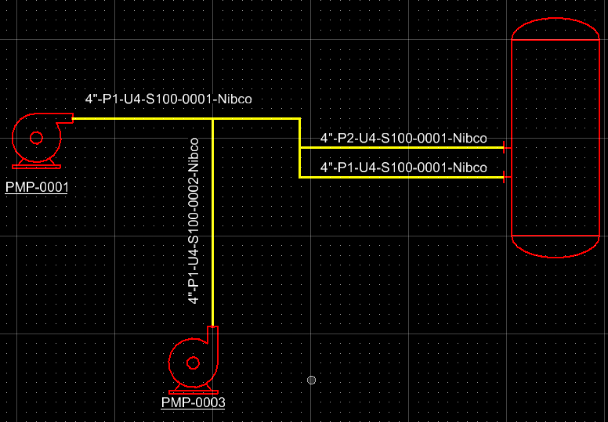

SQL
SELECT TAG_REG.KEYTAG, TAG_REG.TAG_NO, PIPE_RUN.RUN_NAME, NOZZLE.NINT1, NOZZLE.PDIRECT, [TAG_REG_1].[TAG_NO] & "" & [TAG_REG_2].[TAG_NO] AS TAG
FROM (((PIPE_RUN RIGHT JOIN (TAG_REG RIGHT JOIN PROCESS ON TAG_REG.KEYTAG = PROCESS.KEYTAG) ON PIPE_RUN.LINE_ID = PROCESS.KEYTAG) LEFT JOIN NOZZLE ON PIPE_RUN.KEYTAG = NOZZLE.NLINE) LEFT JOIN TAG_REG AS TAG_REG_1 ON NOZZLE.NEQUIP = TAG_REG_1.KEYTAG) LEFT JOIN (PIPE_RUN AS PIPE_RUN_1 LEFT JOIN (PROCESS AS PROCESS_1 LEFT JOIN TAG_REG AS TAG_REG_2 ON PROCESS_1.KEYTAG = TAG_REG_2.KEYTAG) ON PIPE_RUN_1.LINE_ID = PROCESS_1.KEYTAG) ON NOZZLE.NEQUIP = PIPE_RUN_1.KEYTAG;

Design View
