PowerPID Specs Test Plan Whitepaper
Goals:
- Test the SS3 OpenPlant Spec Manager using the OpenPlant spec provider (this is now the default set up for PowerPID SS3)
- Test the Spec Selection Dialog
- Test using no spec (PowerPID can insert components without spec data by setting the spec to “none”)
- Test query results
  - No records found
  - Single record found
  - Multiple records found
- Verify data
  - Property Mappings
  - Alias Mappings
  - End Conditions
- Test using OPPowerPID_Metric Project
- Test Logging
- Test the new OpenPlant Spec Manager using each of the other possible spec providers (AutoPlant, PDS, PSDS). Note that we need some sample specs to run these tests as PowerPID does not ship any specs for these spec providers.
- Test that existing Spec Manager (from SS2) still functions correctly
NOTE: The PDS and PSDS Spec Providers can be configured in different ways. For example, the PSDS provider can be configured to use data from a DataSource or from PlantSpace dat files. The tests outlined here do not attempt to test all of these different scenarios. This test is only to confirm that given a valid setup for a given spec provider that the data is returned properly.
NOTE: To enable spec querying during a component’s placement, the components class must contain a value for the ECCustomAttribute SPEC_MAPPING_CLASS_FOR_OPENPLANT_SPECS (either directly or via inheritance). Without this value, the component is placed without querying the spec data. Below is a list of classes that define spec mappings:
- INLINE_VALVE
- CHECK_VALVES
- CONTROL_VALVE
- ANGLE_VALVE
- THREE_WAY_VALVE
- FOUR_WAY_VALVE
- HORIZONTAL_CENTRIFUGAL_PUMP
NOTE: As of build 08.11.08.15, the default spec setup is to use the OpenPlant Spec Manager and the OpenPlant spec provider. Also the spec files that ship in the project’s specs databases folder are now OpenPlant specs (previously they were AutoPlant specs).
Note: As of build 8.11.08.18, the spec for the pipe run is set based on the SPECIFICATION property of the pipeline. Previously, it was set based on the DESIGN_SPECIFICATION property. Therefore, when placing components to spec, the SPECIFICATION property of the pipeline needs to be set to the desired spec.
Test OpenPlant Spec Manager with OpenPlant Spec Provider (Default Setup)
- This is now the default Spec provider, so no changes need to be made to the default projects that ship with PowerPID. However, you should verify the following in the OPPower_PID_Imperial.pcf file:
    - BMF_SPEC_MANAGER = OpenPlant
    - OPM_DIR_SPECS = $(_USTN_PROJECTDATASET)Specs Databases/
    - OPM_SPECS_PLUGIN_DATABASES = $(_USTN_PROJECTDATASET)Mapping Databases/
    - OPM_SPECPLUGIN_CURRENTSOURCE = OPM
- Start a new drawing using project OPPowerPID_Imperial
- Test using no Spec
  - Place a Major Pipeline setting Design Size to 6” and Specification to None
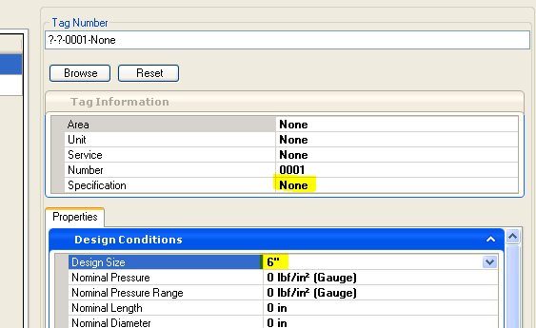
  - Place a Gate Valve, no spec selection dialog should appear, and the valve should be drawn with no end conditions
  - Run Settings->Drawing and select the Settings tab, and then change the End Conditions to Socket Welded. Place another Gate Valve into the same pipeline as before. This valve should be drawn using Socket Welded symbology.
NOTE: The tests below are dependent upon the data that actually resides in the specs. To properly ensure that we are getting the correct data, we really need to get some detailed reports on what components are actually available in the specs. We are working with the SpecGen developers to get a detailed report on the sample specs that would allow us to more easily verify that the correct records are being retrieved for a given class, size, spec combination.
- Test using Spec A1-OPM
  - Place a Major Pipeline setting Design Size to 6” and Specification to A1-OPM
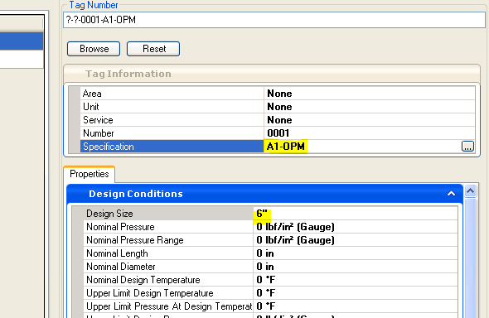
  - Place a Gate Valve into the new pipeline
  - A 6” Flanged gate valve should be drawn (as the A1-OPM only has a single entry for 6” Gate Valves)
  - Repeat the test inserting a 1 1/2” gate valve. You should be presented with the spec selection dialog with socket welded and threaded choices. Select the socket weld valve and complete placement. Repeat but select the threaded valve.
  - Repeat these tests using other valves. Note that most 6” valves in A1-OPM will not present the dialog with multiple choices. Most 1 1/2” valves will have a choice between socketweld and thread valves

- Test using Spec EX-OPM
  - Place a Major Pipeline setting Design Size to 6” and Specification to EX-OPM
  - Place a Gate Valve into the new pipeline, the following dialog should appear
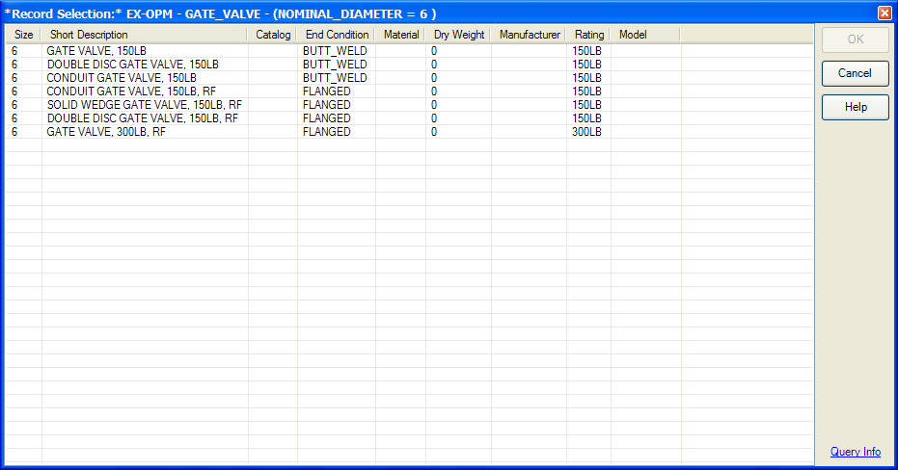
  - Hover over the Query Info link, and the tooltip should appear which shows the spec, search class, and where clause used for the query.
  - Clicking on the Query Info link should show the following dialog:
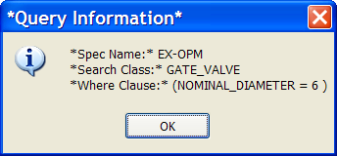
  - Clicking the Help button should bring up the help section for the spec manager
  - Try sorting based on column data by clicking the column headers.
  - Select one of the BW records, select OK, and finish placing the valve.
  - Verify that the following:
    - The proper end condition is drawn for the valve
    - Any properties defined in the property mappings for the valve are updated properly. By default, this should include the properties DESCRIPTION, CATALOG, MATERIAL, DRY_WEIGHT, MANUFACTURER, and RATING
    - Any properties that have alias mappings for the valve are updated properly. By default, this should include END_CONDITION
  - Repeat the test inserting another 6” gate valve, but this time selecting a flanged record.
  - Repeat the test inserting a 1 1/2” gate valve and selecting a socket welded record.
  - Repeat the test inserting a 1 1/2” gate valve and selecting a threaded female record.
  - Repeat these tests using other inline valves (Globe, Ball, etc). Note that most valves in EX-OPM should present the dialog with multiple choices; however, the specs do not contain data for all valves. As mentioned above, we need to be able to somehow cross check the results returned with what is actually in the spec.
  - Test other types of components
    - Angle Valves
      - Place a pipeline containing a 90 degree bend, spec set to EX-OPM, and size set to 4”.
      - Place an Angle Valve at the intersection
    - Three-Way Valves
      - Place a pipeline spec set to EX-OPM, and size set to 4”.
      - Place another pipeline with the same settings so that a “tee” intersection is formed by the two pipelines.
      - Place a 3-Way Valve at the intersection
    - Four-Way Valves
      - Place a pipeline spec set to EX-OPM, and size set to 4”.
      - Place another pipeline with the same settings so that a “tee” intersection is formed by the two pipelines.
      - Place another pipeline with the same settings at the “tee” intersection so that a ”cross” intersection is formed by the three pipelines.
      - Place a 4-Way Valve at the intersection
    - Control Valves
      - Place a pipeline, spec set to EX-OPM, and size set to 1”.
      - Place an Control Valve using body type Globe into the line.
      - Place a pipeline, spec set to EX-OPM, and size set to 2 1/2”.
      - Place an Control Valve using body type Ball into the line.

    - Pumps
      - Run Settings->Drawing and select the Settings tab
      - Set the spec to A1-OPM
      - Place a pump, you should be presented with a spec selection dialog similar to:
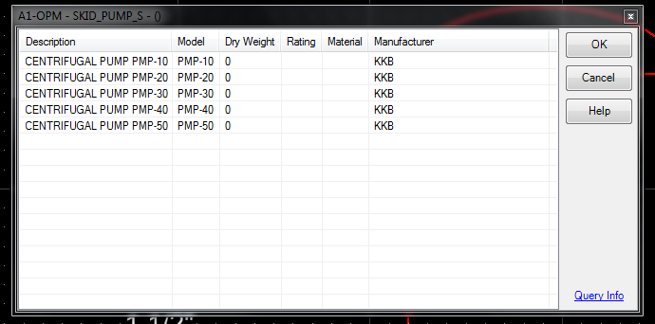

Test Logging
- Set the PowerPID logging level to DEBUG, by adding the following line to the OPPowerPID_Imperial.pcf file
  - PID_LOG_LEVEL = -4
- Open a drawing using project OPPowerPID_Imperial
- Open the Message Center dialog, there should be messages similar to:
  - INFO - Bentley.Plant.ModelingFramework.OpenPlant.SpecManager - *Current Spec set to *None**
  - INFO - Bentley.Catalog.OpenPlantPhysical - Loading OpenPlant_3D_Supplemental_Modeling Schema
  - INFO - Bentley.Plant.ModelingFramework.OpenPlant.SpecReader - *Spec provider set to OpenPlant Modeler Spec Provider*
- Place a 6” Gate Valve using spec A1-OPM as described above, there should be messages in the Message center similar to:
  - LOG_DEBUG - Bentley.Plant.Application.Pid.OpenPlantSpecManagerPlugin - *Property Name = MODEL; Mapped Value = *
  - LOG_DEBUG - Bentley.Plant.Application.Pid.OpenPlantSpecManagerPlugin - *Property Name = RATING; Mapped Value = 150LB*
  - LOG_DEBUG - Bentley.Plant.Application.Pid.OpenPlantSpecManagerPlugin - *Property Name = MANUFACTURER; Mapped Value = CRN*
  - LOG_DEBUG - Bentley.Plant.Application.Pid.OpenPlantSpecManagerPlugin - *Property Name = DRY_WEIGHT; Mapped Value = 0*
  - LOG_DEBUG - Bentley.Plant.Application.Pid.OpenPlantSpecManagerPlugin - *Property Name = MATERIAL; Mapped Value = A216 WCB*
  - LOG_DEBUG - Bentley.Plant.Application.Pid.OpenPlantSpecManagerPlugin - *Property Name = END_CONDITION_CLASSNAME; Mapped Value = FLANGED; Alias Value = FLANGED_VALVE_END_CONDITION*
  - LOG_DEBUG - Bentley.Plant.Application.Pid.OpenPlantSpecManagerPlugin - *Property Name = END_CONDITION_DISPLAY; Mapped Value = FLANGED; Alias Value = End_Condition_Flanged*
  - LOG_DEBUG - Bentley.Plant.Application.Pid.OpenPlantSpecManagerPlugin - *Property Name = DESCRIPTION; Mapped Value = GA-0101 150 ASME Gate valve, sweet service, flanged ends, 6"*
  - LOG_DEBUG - Bentley.Plant.Application.Pid.OpenPlantSpecManagerPlugin - *Property Name = NOMINAL_DIAMETER; Mapped Value = 6*
  - LOG_DEBUG - Bentley.Plant.Application.Pid.OpenPlantSpecManagerPlugin - *Updating Component Data*
  - INFO - Bentley.Plant.ModelingFramework.OpenPlant.SpecReader - *Number of records found = 1*
  - LOG_DEBUG - Bentley.Plant.ModelingFramework.OpenPlant.SpecReader - *Provider: OpenPlant Modeler Spec Provider; Selection Criteria: Spec Name = A1-OPM; Class Name = GATE_VALVE; Conditions: NOMINAL_DIAMETER = 6;*

NOTE: For the tests involving non-OpenPlant Spec Providers, a set of sample specifications can be found in OpenPlantPowerPIDSampleSpecs.zip. For the purposes of the instructions below, it is assumed that the sample specs have been unzipped to C:\Specs.
Test OpenPlant Spec Manager with AutoPlant Spec Provider
- Create a new project OPPowerPID_Imperial_AutoPlant:
  - Copy the OPPowerPID_Imperial directory to a new directory and rename the new directory OPPowerPID_Imperial_AutoPlant
  - Copy the project file OPPowerPID_Imperial.pcf and rename the file to OPPowerPID_Imperial_AutoPlant.pcf
  - Open OPPowerPID_Imperial_AutoPlant.pcf and modify the variable for setting the spec manager, and the variable for setting the current spec provider as follows:
BMF_SPEC_MANAGER = OpenPlant
OPM_SPECPLUGIN_CURRENTSOURCE = PDW
OPM_SPECPLUGIN_PDW_SPECFOLDER = c:/specs/Imperial/AutoPlant/
- Start a new drawing using project OPPowerPID_Imperial_AutoPlant
- Test using no Spec
  - Place a Major Pipeline setting Design Size to 6” and Specification to None

  - Place a Gate Valve, no spec selection dialog should appear, and the valve should be drawn with no end conditions
- Test using CS150
  - Place a Major Pipeline setting Design Size to 6” and Specification to CS150

  - Place a Gate Valve, the following spec selection dialog should appear
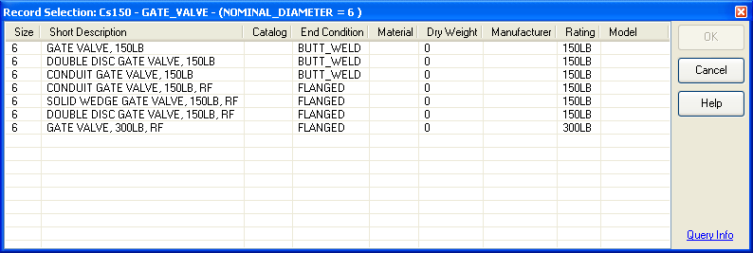
  - Hover over the Query Info link, and the tooltip should appear which shows the spec, search class, and where clause used for the query.
  - Clicking on the Query Info link should show the following dialog:
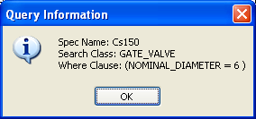
  - Clicking the Help button should bring up the help section for the spec manager
  - Select one of the BW records, select OK, and finish placing the valve.
  - Verify that the following:
    - The proper end condition is drawn for the valve
    - Any properties defined in the property mappings for the valve are updated properly. By default, this should include the properties DESCRIPTION, CATALOG, MATERIAL, DRY_WEIGHT, MANUFACTURER, and RATING
    - Any properties that have alias mappings for the valve are updated properly. By default, this should include END_CONDITION
  - Repeat the test inserting another 6” gate valve, but this time selecting a flanged record.
  - Repeat the test inserting a 1” gate valve and selecting a socket welded record.
  - Repeat the test inserting a 1” gate valve and selecting a threaded female record.

Test OpenPlant Spec Manager with PlantSpace Spec Provider
- Create a DataSource for the PSDS Spec
  - Use ODBC Data Source Admin and add a System DSN using the Microsoft Access Driver (*.mdb)
  - Set the Data Source Name to PSDS_IMPERIAL
  - Select the database file C:\Specs\Imperial\PSDS\English.mdb
- Create a new project OPPowerPID_Imperial_PSDS:
  - Copy the OPPowerPID_Imperial directory to a new directory and rename the new directory OPPowerPID_Imperial_PSDS
  - Copy the project file OPPowerPID_Imperial.pcf and rename the file to OPPowerPID_Imperial_PSDS.pcf
  - Open OPPowerPID_Imperial_PSDS.pcf and modify the variable for setting the spec manager follows:
BMF_SPEC_MANAGER = OpenPlant
  - Open OPPowerPID_Imperial_PSDS.pcf and modify the section for OpenPlant spec variables as follows:
OPM_SPECPLUGIN_CURRENTSOURCE = PSDS
OPM_SPECPLUGIN_PSDS_USING_DataSource = 1
OPM_SPECPLUGIN_PSDS_DSN = PSDS_IMPERIAL
OPM_SPECPLUGIN_PSDS_UNITS = IN
OPM_DEFAULT_SPEC = CS150

- Start a new drawing using project OPPowerPID_Imperial_PSDS
- Repeat tests as described in section “Test OpenPlant Spec Manager with AutoPlant Spec Provider”

Test OpenPlant Spec Manager with PDS Spec Provider
- Create a new project OPPowerPID_Imperial_PDS:
  - Copy the OPPowerPID_Imperial directory to a new directory and rename the new directory OPPowerPID_Imperial_PDS
  - Copy the project file OPPowerPID_Imperial.pcf and rename the file to OPPowerPID_Imperial_PDS.pcf
  - Open OPPowerPID_Imperial_PDS.pcf and modify the variable for setting the spec manager follows:
BMF_SPEC_MANAGER = OpenPlant
  - Open OPPowerPID_Imperial_PDS.pcf and modify the section OpenPlant spec variables as follows:
OPM_SPECPLUGIN_CURRENTSOURCE = PDX
OPM_SPECPLUGIN_PDX_USING_MDBSource = 0
OPM_SPECPLUGIN_PDX_MDBDIR =
OPM_SPECPLUGIN_PDX_PCDDIR = C:/Specs/Imperial/PDS/PDSSpecs/
OPM_SPECPLUGIN_PDX_LIBDIR = C:/Specs/Imperial/PDS/PDSLibraries/
OPM_SPECPLUGIN_PDX_UNITS = IN
OPM_DEFAULT_SPEC = 1C0609

- Start a new drawing using project OPPowerPID_Imperial_PDS
- Repeat tests as described in section “Test OpenPlant Spec Manager with AutoPlant Spec Provider” using spec 1C0609 instead of CS150.
NOTE: The 1C0609 PDS spec does not contain any 1” threaded components. So the test should just include flanged and socket welded components.

Test Existing Spec Manager (Spec Manager from previous versions)
- Create a new project OPPowerPID_Imperial_SS2:
  - Copy the OPPowerPID_Imperial directory to a new directory and rename the new directory OPPowerPID_Imperial_SS2
  - Copy the project file OPPowerPID_Imperial.pcf and rename the file to OPPowerPID_Imperial_SS2.pcf
- Open OPPowerPID_Imperial_SS2.pcf and verify that the variable for setting the spec manager is commented out as follows:
  - #BMF_SPEC_MANAGER = OpenPlant
- Set the spec location to a directory containing AutoPlant specs
  - BMF_SPEC_LOCATION = f:/dev/specs/imperial/autoplant/
- Start a new drawing using project OPPowerPID_Imperial
- Test using no Spec
  - Place a Major Pipeline setting Design Size to 6” and Specification to None

  - Place a Gate Valve, no spec selection dialog should appear, and the valve should be drawn with no end conditions
- Test using CS150
  - Place a Major Pipeline setting Design Size to 6” and Specification to CS150

  - Place a Gate Valve, the following spec selection dialog should appear
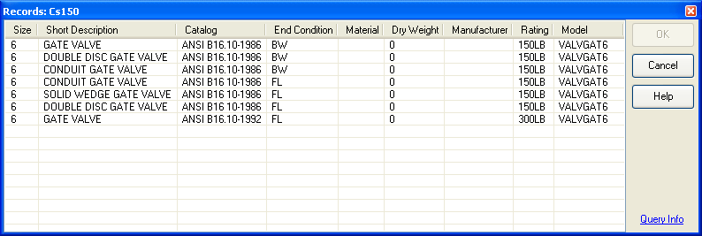
  - Hover over the Query Info link, and the tooltip should appear which shows the spec, tables, and the Sql select statement used for the query.
  - Clicking on the Query Info link should show the following dialog:
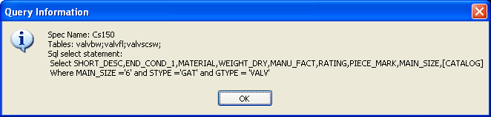
  - Clicking the Help button should bring up the help section for the spec manager
  - Select one of the BW records, select OK, and finish placing the valve.
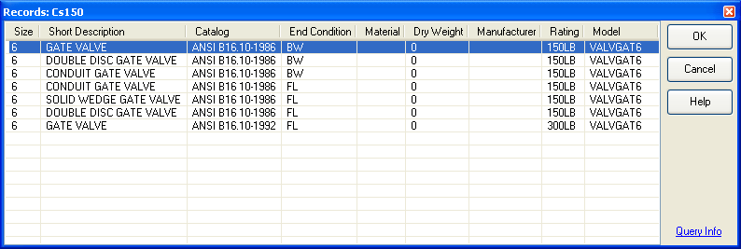

  - Verify that the following:
    - The proper end condition is drawn for the valve
    - Any properties defined in the property mappings for the valve are updated properly. By default, this should include the properties DESCRIPTION, CATALOG, MATERIAL, DRY_WEIGHT, MANUFACTURER, and RATING
    - Any properties that have alias mappings for the valve are updated properly. By default, this should include END_CONDITION

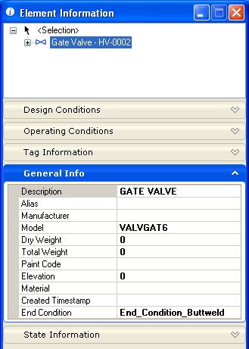
  - Repeat the test inserting another 6” gate valve, but this time selecting a flanged component from the list.
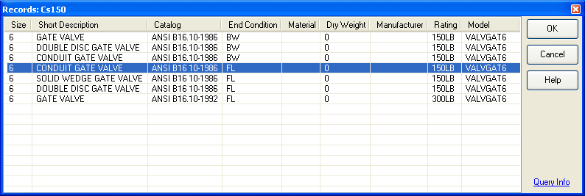

  - Repeat the test inserting a 1” gate valve and selecting a socket welded component from the list.
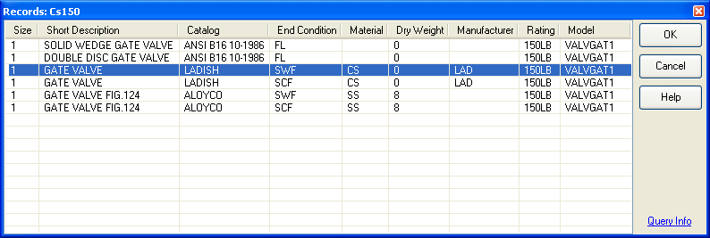

  - Repeat the test inserting a 1” gate valve and selecting a threaded female component from the list.
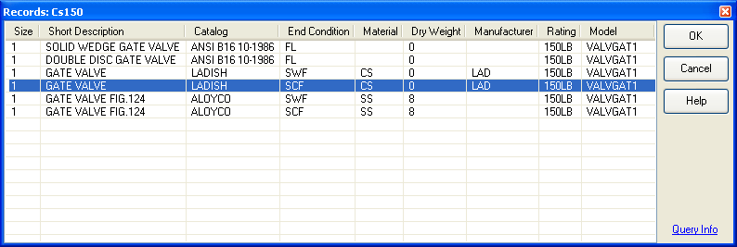

  - Place a Major Pipeline setting Design Size to 6” and Design Specification to CS150
  - Place a Globe Valve, the following spec selection dialog should appear
  - Select any of the records and finish placement
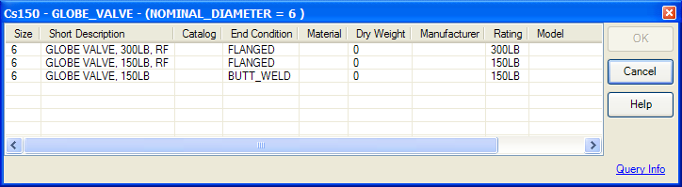

  - Place a Major Pipeline setting Design Size to 6” and Design Specification to CS150
  - Place a Butterfly Valve, the following spec selection dialog should appear
  - Select any of the records and finish placement

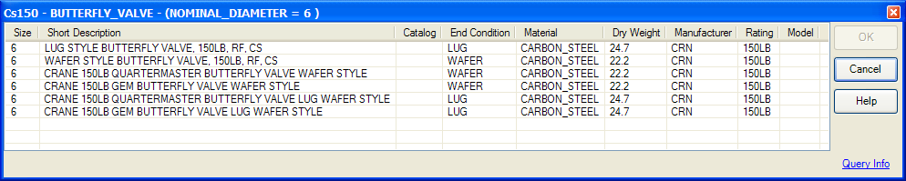

  - Place a Major Pipeline setting Design Size to 6” and Specification to CS150
  - Place a Needle Valve, the following spec selection dialog should appear
  - No dialog should appear as this valve has no spec entries in CS150
  - Select any of the records and finish placement

  - Place a Major Pipeline setting Design Size to 6” and Specification to CS150
  - Place a Ball Valve, the following spec selection dialog should appear
  - Select any of the records and finish placement

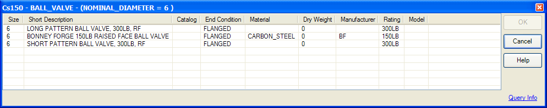

  - Place a Major Pipeline setting Design Size to 6” and Specification to CS150
  - Place a Plug Valve, the following spec selection dialog should appear
  - Select any of the records and finish placement
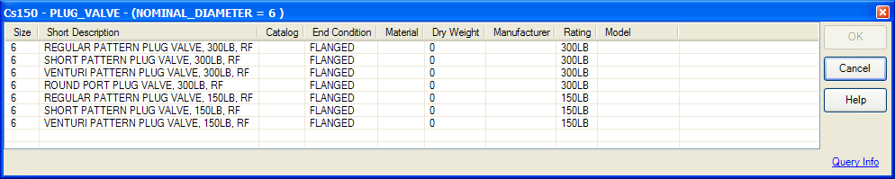

  - Place a Major Pipeline setting Design Size to 6” and Specification to CS150
  - Place a Check Valve, the following spec selection dialog should appear
  - Select any of the records and finish placement
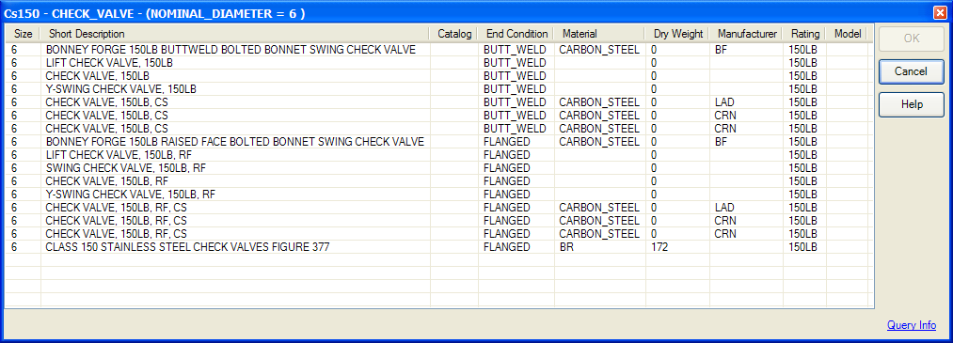

NOTE: For Angle, 3Way, and 4Way valves, use the spec CS
  - Place a Major Pipeline setting Design Size to 6” and Specification to CS, and create a bend
  - Place a Angle Valve, the following spec selection dialog should appear
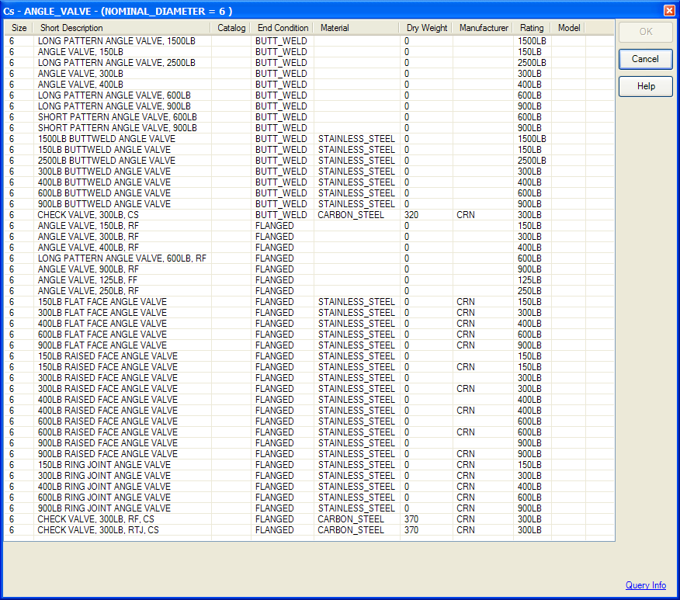
  - Select any of the records and finish placement
  - Place a Major Pipeline setting Design Size to 6” and Specification to CS, and create a tee intersection
  - Place a 3Way Valve, the following spec selection dialog should appear

  - Select any of the records and finish placement

