Cell Orientation procedures
Document Type: TechNote
Product(s): OpenPlant PowerPID
Version(s): Selectseries 3+
Original Author: Steve Morrow

Description
To have component cell placement behave in a predictable way, certain cell orientation rules must be followed. A cell’s direction should be along the X axis and the orientation along the Y axis.

Terminology
Origin
The point, specified during cell creation, about which the cell is placed (the origin corresponds to the data point when the cell is placed in the design).

Connection point
Predefined location point on an OPPID component. A connection point also specifies the direction out (not flow) at that location. These connection points can be used for handle manipulation.

Connection point name
Every connection point must have a unique name for the component/cell. Certain components require specific names, see Rules below.

Connection point display label
Every connection point can have an optional display label. Display labels should be unique name for the component/cell, no other rules apply. Labels are displayed when a component is selected and the pointer is hovering over the edit handle.

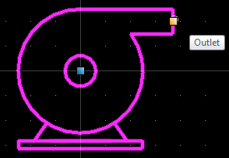

If a component only has one handle, which is at the origin with display label “origin”, then it is a good indication that there is no connection point defined.
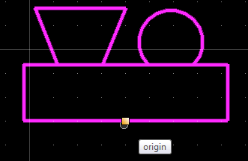

Directions
Positive horizontal direction: +X
Negative horizontal direction: -X
Positive vertical direction: +Y
Negative vertical direction: -Y
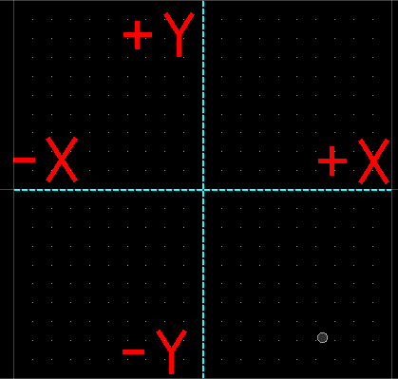

In run
An in run component, that is inserted into a continuous line. The component is orientated to the vector of the continuous line. The line can be gapped according to in run’s defined connection points or the range of the in run cell. Inline components are Valves, Control Valves, Flow Elements, fittings…
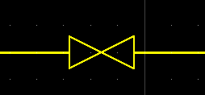

Data Change
A component, that causes a new Pipe Run to be created. The component is orientated to the vector of the continuous line. The line is gapped according to data change’s defined connection points. Data Change components are Reducers, Spec Breaks, Pressure Safety Valves… If the data change is some type of reducer, change in size or pressure, then the direction of large to small depends on the reducing property value of the two connecting pipe runs.

Rules
In run
In run components are orientated in +X
Rules for Branch (3 way, Tee):
Main in +X
Branch in +Y

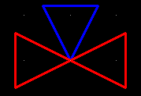
Rules for angles:
CP1 in +X
CP2 in +Y
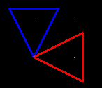

Rules for inline data change
Connection point names for data change must be CP1 and CP2.
CP1 in -X and “larger” value (main)
CP2 in +X and “smaller” value (reducing)
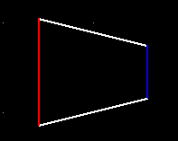
Note: A spec break, which doesn’t involve a reducing property, must have CP1 in -X and CP2 in +X as above.
Rules for angle data change:
CP1 in +X and “smaller” value (reducing)
CP2 in +Y and “larger” value (main)
