How to create a new Pipeline with a Reducer or Spec break
Document Type: TechNote
Product(s): OpenPlant PowerPID
Version(s): Selectseries 3+
Original Author: Steve Morrow

Description
When a data change (reducer or spec break) is placed, a new Pipe Run is created. Currently only Pipe Runs are created, we are evaluating how to create a new process line on data change placement. The use case below details how to have a Data change with two Pipelines using OpenPlant Power P&ID functionality.

Use Case
- Place a Major Pipeline
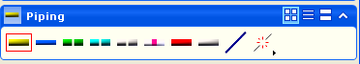

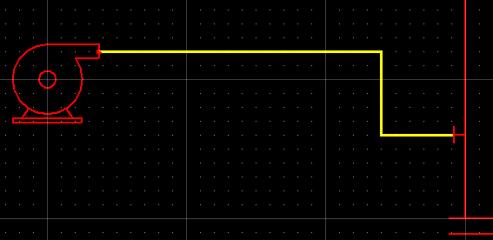

- Place a Reducer on the just placed Pipeline
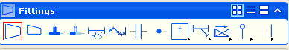
Enter new sizes, etc…
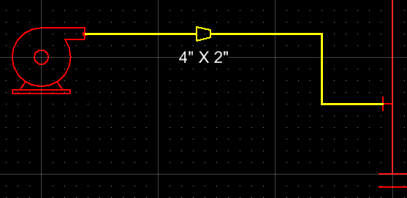

- From the Piping menu select “Remove Pipe Run from Pipeline”
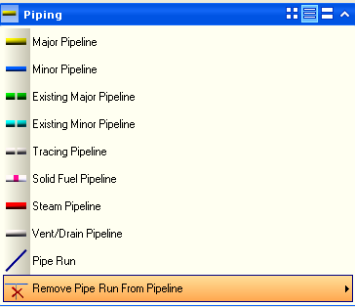

- Select the Pipe Run on the right and hit accept button (on my machine that is the left mouse button)
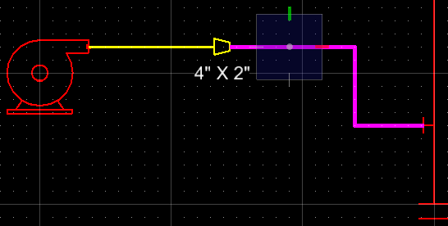

- Select the Pipe Run and go to the element info. Notice that there is no Pipeline associated.
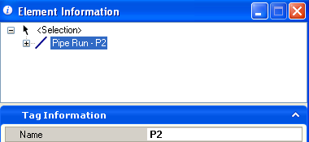

- Keep the Pipe Run selected and go to the task navigation and once again select Major Pipeline.
This OPPID functionality allows for the selected item to associate to a Parent component. Instrument Loops also has this capability.

- A dialog is displayed, select “Yes”
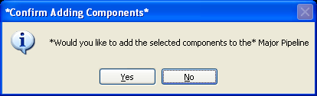

- The selected Pipe Run now has a new Pipeline.
Select the Pipe Run on the left and the right. Notice that each Pipe Run has its own Pipeline.
