OPPID Component Manager Tips
Document Type: TechNote
Product(s): OpenPlant PowerPID
Version(s): SelectSeries 3+
Original Author: Steve Morrow

Class and schema indications
The main dialog contains the options for creating new and editing existing classes. Selecting classes from this list enables or disables the toolbar options.
If a class is selected and the toolbar option is disabled, that means that class is in a system or protected schema.
An example of a protected system schema is pid.01.02.ecschema.xml. These system schemas contain property, placement and internal attributes that OpenPlant Power P&ID requires and SHOULD NEVER be modified. A visual notification that a node class selection is in a system schema is the lack of a specific icon.
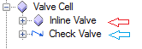
New classes and modifications are added to the schemas located in DataSet\Schemas folder: \WorkSpace\Projects\OPPowerPID_Imperial\Dataset\schemas.
All components that can be placed in an active drawing need to have a class definition in OpenPlant_PID.01.02.ecschema.xml schema. The key-ins in the task menu definitions use this schema name: pid insert OpenPlant_PID NEW_PUMP.

A system class is selected: No specific icon and no toolbar options available
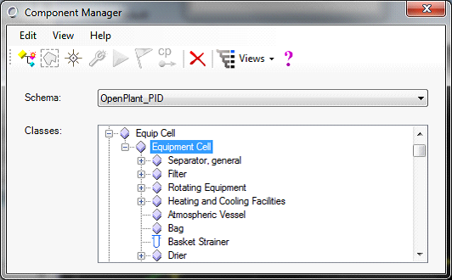

Editable class selected: specific icon and toolbar options available. View help for the edit options.
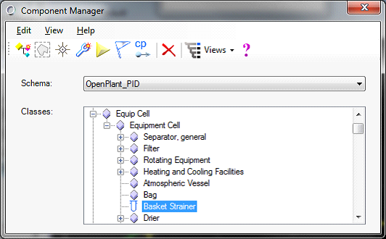

Visualization
The best way to visualize the main dialog class hierarchy is to use the Single Hierarchical view:
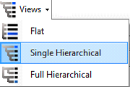
This groups components into their logical sections base its parent Base Class.

New components
New components created through Component Manager are always written to OpenPlant_PID.01.02.ecschema.xml.
The Target and Source schema will be OpenPlant_PID.01.02.ecschema.xml.
Select a base class from the displayed list. This will allow your new class to inherit properties and behavior. Behavior: Break a line, rotating , relationships,…
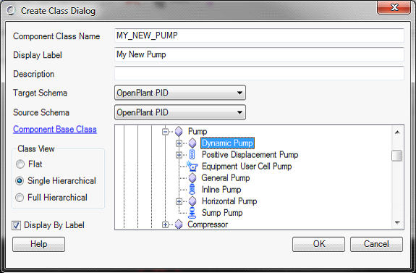
Using Dynamic Pump as a Base class, create a new class called MY_NEW_PUMP. Open OpenPlant_PID.01.02.ecschema.xml schema in Class Editor or in notepad++ and search for this class.

XML View
<ECClass typeName="MY_NEW_PUMP" displayLabel="My New Pump" isDomainClass="True">
<BaseClass>DYNAMIC_PUMP</BaseClass>
</ECClass>

<ECClass typeName="DYNAMIC_PUMP" description="A pump which impels fluid by reaction forces from moving (rotating) vanes or blades inside a pump casing." displayLabel="Dynamic Pump" isDomainClass="True">
<BaseClass>PUMP</BaseClass>
<BaseClass>op:DYNAMIC_PUMP</BaseClass>
</ECClass>

Note: Creating a new class does not create a place able component. This only creates a new class in OpenPlant_PID.01.02.ecschema.xml in the same way that Class editor would.

Create a class with graphics
- Draw native MS elements: Circle, lines…
- Select new components from elements from the toolbar
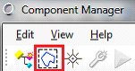
- Select Base Class and give a Class name and display
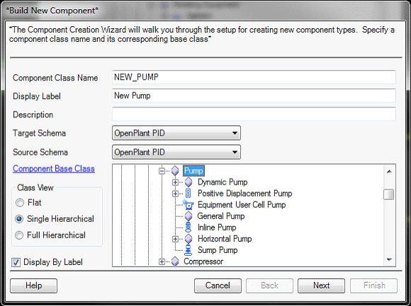
- Follow prompts to add Origin, cell library, connection points and annotation (See help for details)
- Add to Task Menu (See help for details)

New class is added to OpenPlant_PID.01.02.ecschema.xml with graphics and placement routines. If step 5 above is completed, the component can be placed. Also the key-in can be run:
pid insert OpenPlant_PID NEW_PUMP.
The cell is added (step 4) to the appropriate cell library and the corresponding connection point schema: Equipment.cel.sch.ecinstance.xml

XML view
These are the modifications that are done for a place able component.
OpenPlant_PID.01.02.ecschema.xml
<ECClass typeName="NEW_PUMP" displayLabel="New Pump" isDomainClass="True">
<BaseClass>PUMP</BaseClass>
<ECCustomAttributes>
<SCHEMATICS_CAD_CUSTOM_ATTRIBUTES xmlns="schematics.01.02">
<ElementTemplate>Misc\Default</ElementTemplate>
<CellLibrary>Equipment.cel</CellLibrary>
<CellName>NEW_PUMP</CellName>
</SCHEMATICS_CAD_CUSTOM_ATTRIBUTES>
</ECCustomAttributes>
</ECClass>

Equipment.cel.sch.ecinstance.xml

<CellData instanceID="NEW_PUMP" xmlns="SchematicsCells.01.00">
<ConnectPoints>
<NamedLocation>
<Name>Cp1</Name>
<OriginOffset>-0.625, 0.0625, 0</OriginOffset>
<Direction>-1, 0, 0</Direction>
</NamedLocation>
</ConnectPoints>
</CellData>

