Virtual Machine Setup

Software Versions
The following software versions were used: -

Operating System
Windows 2003 Enterprise Edition

Core software
Adobe Acrobat 9
MicroSoft Office 2007
SQL Server 2005

Bentley Released Software
MicroStation v8i (Build 8.11.7.107)
ProjectWise v8i (Build 8.11.7.107)
i-model Composer (Build 8.11.7.xxx)
ProjectWise Navigator (Build 8.11.7.xxx)

Bentley BETA/Pre-Released Software
Plant Framework v8i (Build 8.11.7.26)
OpenPlant PowerPID v8i (Build 8.11.7.36)

Demo Environment Setup

Create a new SQL Server database
Create a new SQL Server database allocating 10MB for the initial size of the primary data file and the log file: -
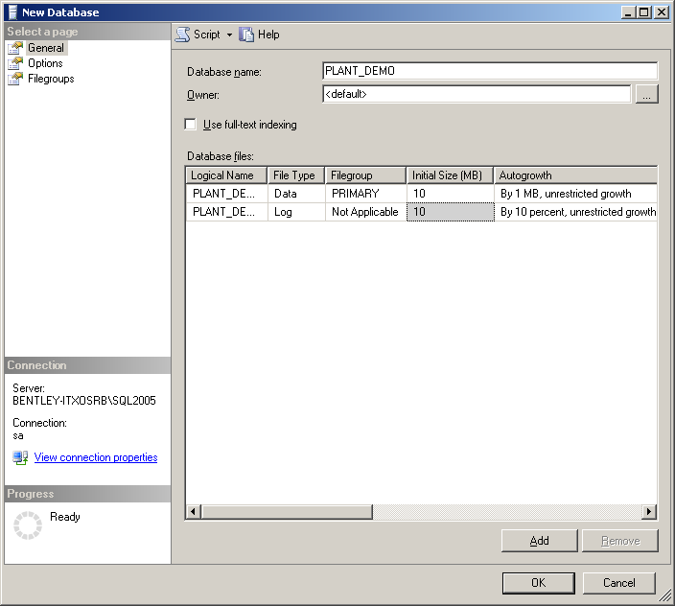
Note: The screen shot is taken from SQL Server 2005. It will look different in earlier versions of SQL Server.

Create an ODBC Datasource for ProjectWise
Select Control Panel > Administrative Tools > Data Sources (ODBC) or the location you normally access the ODBC setup and select the SYSTEM DSN tab.
Click the Add button and scroll down the displayed driver list and select the SQL Server driver. Click Finish.
Enter a name for the Data Source and select the SQL Server to connect to; i.e. : -
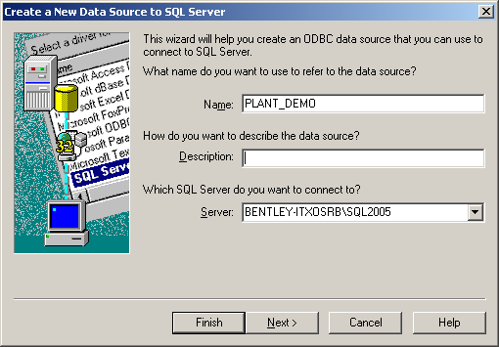
Click Next and complete the login credentials for SQL Server; i.e. : -
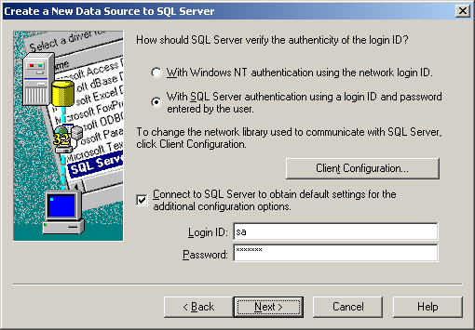
Note: This screenshot is showing the login credentials for an SQL Server authentication using a login and password and is for information only - you may have a different setup on your system.
Click Next and select the SQL database you created earlier as the default database; i.e.: -
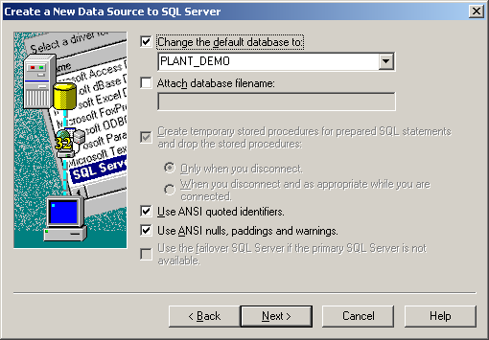
Click Next
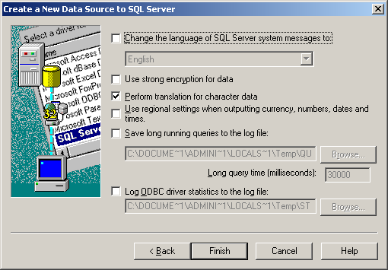
Click Finish to create the data source.
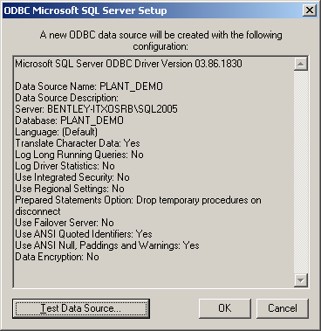
You may optionally want to test the connection by clicking the Test Data Source button: -
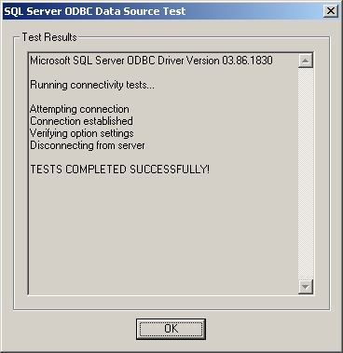
Click OK through to the finish.

Create a new ProjectWise Datasource
In ProjectWise Administrator, right click the Datasources node and select New Datasource to create a new ProjectWise datasource.
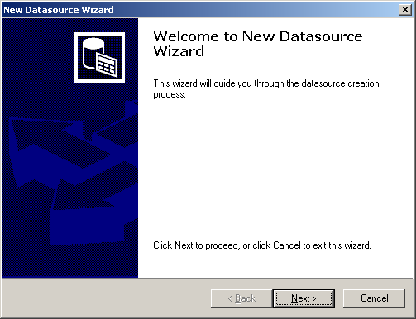

Click Next and select the location for the datasource; i.e. : -
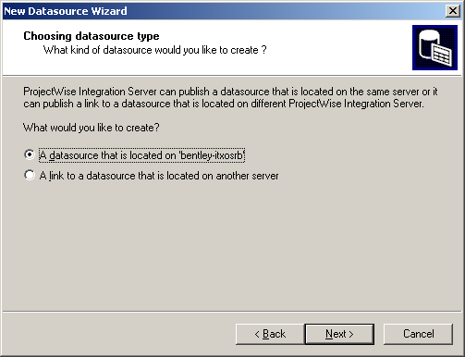
Click Next and provide a name for the ProjectWise datasource and optionally a description; ie. :-
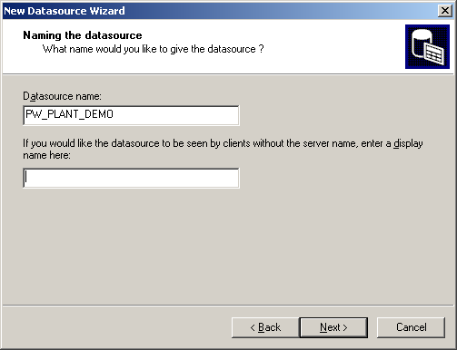
Click Next and select the ODBC Datasource created earlier; i.e. : -
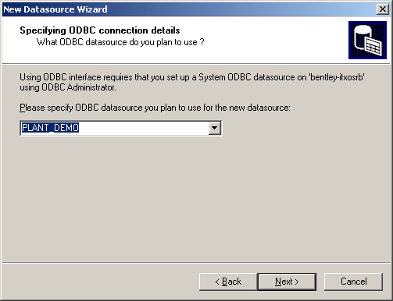
Click Next and enter the administrator username and password for SQL Server; i.e. : -
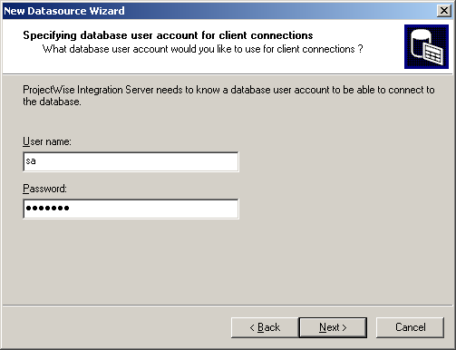
Click Next and provide an Administrators username and password for ProjectWise; i.e. :-
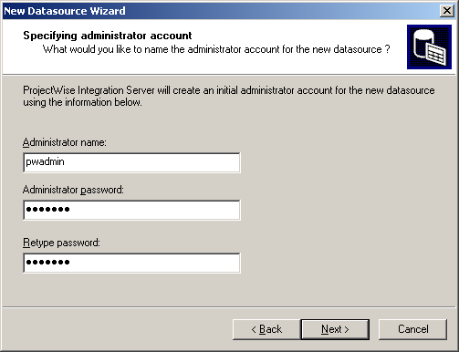
Click Next. Toggle OFF the option to Create datasource from template; i.e. : -
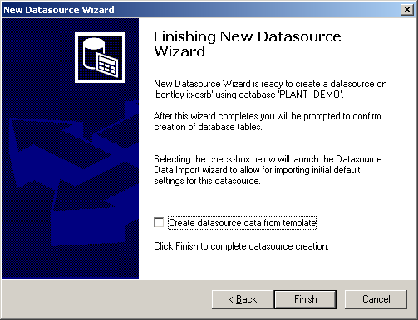
Click Finish. Toggle on the Enale “Create” button option; i.e. : -
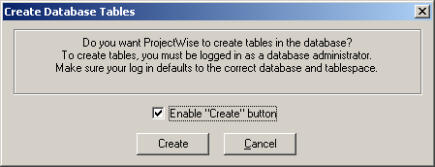
Click Create to start creating the ProjectWise tables.
Enter the storage information for ProjectWise and enter the Administrator password; i.e. :-
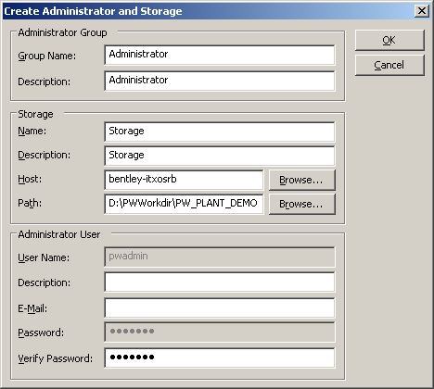
Note: The folder specified as the Storage Path MUST NOT exist. The installer must create this folder. Also DO NOT modify the Storage Name or Description as this will screw things up too!

Click Ok and the ProjectWise datasource should be created: -
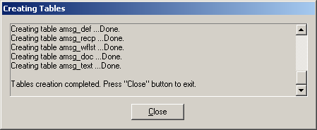
Click Close to complete.

Create a new Plant Project Database
In Project Administrator, either create a new Project Root or select an existing one.
Right click on the Project Root and select New to create a new Plant Project.
Set the provider to SQL Server and leave the Project Schema Location as an Access Database; i.e. : -
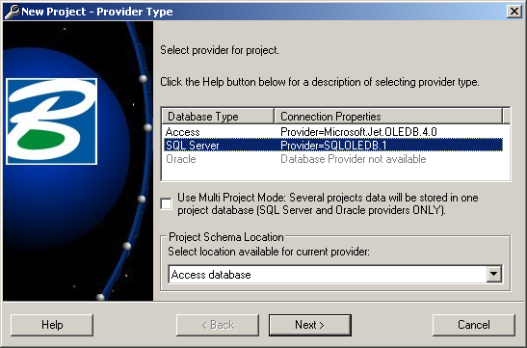

Click Next and set the Units as required and toggle ON the Use Central Project Mode; i.e. : -
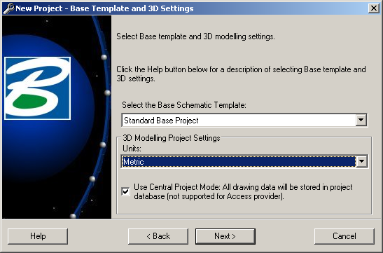
Note: If you do not specify Central Project Mode, you cannot integrate the Project with ProjectWise.
Click Next and Next again past the Project paths dialogue: -
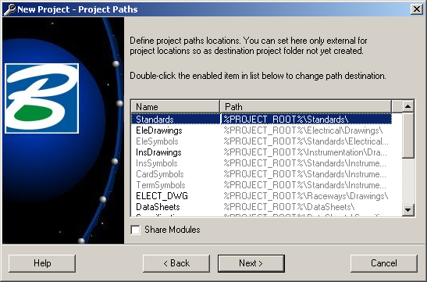
Complete the project details entering a Project Name and, optionally, the other fields also; i.e. : -
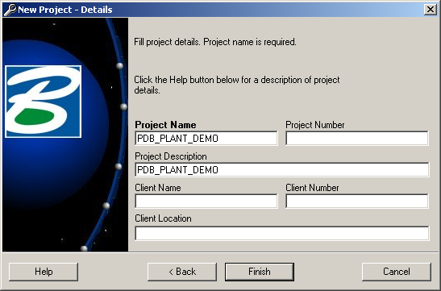
Click Finish. You are then prompted to enter the SQL Server connection details; i.e. : -
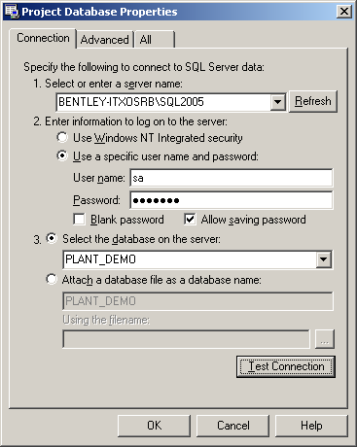
Note: You can optionally test the connection.
Click Ok to start the creation of the Project Database. On completion, you are prompted to login to the project. Enter the Supervisor username and password: -
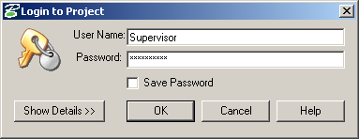
Click Ok.

Configure ProjectWise Integration for the Plant Project
Select Configure under the ProjectWise node for the project and complete the dialogue as follows: -
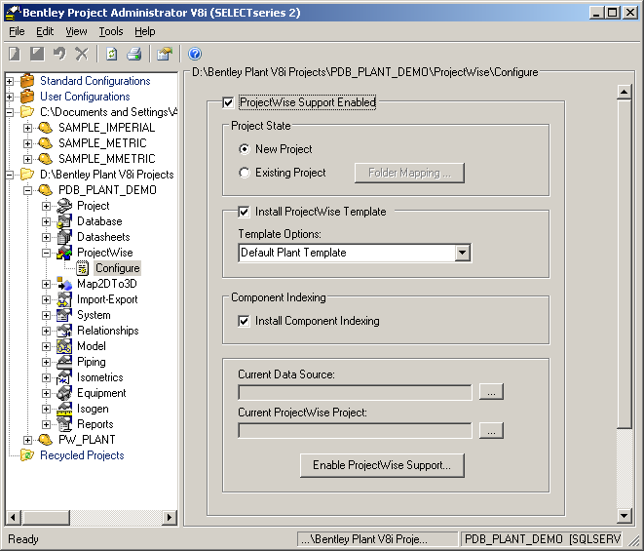
Click on the … next to the Current Data Source towards the bottom of the dialogue and login to the correct ProjectWise datasource: -
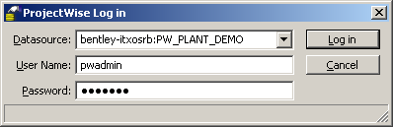

If prompted to select a ProjectWise Working Directory; you can create a new folder as required then click Ok: -
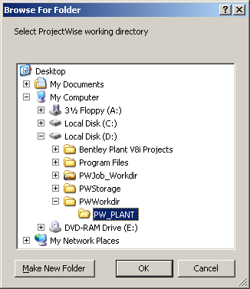
Note: you will be prompted for the Working Directory only if you haven’t previously logged into the ProjectWise Datasource via ProjectWise Explorer.
Finally, click on the Enable Project Support button at the bottom of the dialogue. The installation of the Bentley Plant Schema will start. This is done in two steps: -
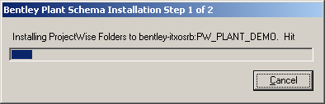
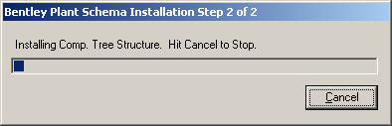
Note: this installation process, particularly step 2, may take a few minutes – be patient, it’s a good sign!
Eventually you should get the following message: -
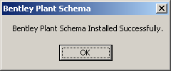
Whoohoo! It worked
To check that the integration worked properly, you can log into the ProjectWise datasource via ProjectWise Explorer and check that the Folder tree and Component tree are available: -

Configuring OpenPlant PowerPID
There is a sample PlantDemo workspace available for initial demonstration purposes.

Configuring the PlantDemo Workspace
Copy the PlantDemo project folder and PlantDemo.pcf file into the OpenPlant PowerPID Projects directory; i.e. : -
C:\Documents and Settings\All Users\Application Data\Bentley\PowerPID V8i\WorkSpace\Projects
Modify the PCF file to map the AP_PROJECT_ID and the AP_PROJECT_ROOT; i.e. : -
AP_PROJECT_ID=0002
AP_PROJECT_ROOT=D:\Bentley Plant V8i Projects

Note: Both these values may well be different on your system.

Configuring the PlantDemo Schemas
The PlantDemo workspace contains some modifications made to the original as-delivered OpenPlant PowerPID schemas. The revised schemas are located in the ..\Data\Resources directory under the project. To avoid a conflict with the as-delivered schemas, we need to remove (backup) the corresponding as-delivered schemas.

Create a folder on the desktop to contain the as-delivered schema files. Navigate to the PowerPID v8i install location; i.e. : -

D:\Program Files\Bentley\PowerPID V8i\PowerPID\schemas

And move the following schemas to the new folder on the desktop: -

OpenPlant.08.11.ecschema.xml
OpenPlant_Supplemental_Mapping_OPPID.08.11.ecschema.xml
PlantProjectSchema.08.11.ecschema.xml
PlantProjectSchema.08.11_mapping\PlantProjectSchema.08.11_Autoplant_PIW.01.00.mapping.xml

The as-delivered schema directory should now only contain the following schemas, and the PlantProjectSchema.08.11_mapping directory should be empty: -

Setting up the OpenPlant PowerPID Workspace Profile
There are two ways to define Workspace Profiles in ProjectWise; Unmanaged and Managed.

Setting up an Unmanaged Workspace Profile
In ProjectWise Administrator, login to the ProjectWise Datasource. Locate the WorkSpace Profiles node and expand it.
Right click Unmanaged and select New Workspace Profile to create a new Workspace Profile. Enter the Name and Description for the Workspace Profile; i.e. : -
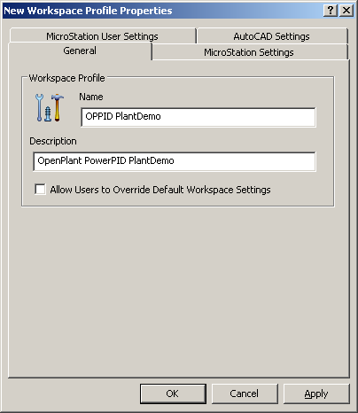

Select the MicroStation Settings tab. Select the … next to the Root Directory and navigate to the OpenPlant PowerPID Workspace directory: -
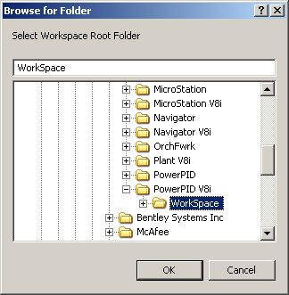
Note: By default this is the C:\Documents and Settings\All Users\Application Data\Bentley\PowerPID V8i\WorkSpace directory.
Select the … next to the User Configuration File Name and select the untitled.ucf located in the C:\Documents and Settings\All Users\Application Data\Bentley\PowerPID V8i\WorkSpace\Users directory.
Click Open to set the User Configuration for the Workspace Profile.
Select the … next to the Project Configuration File Name and select the plantdemo.pcf located in the C:\Documents and Settings\All Users\Application Data\Bentley\PowerPID V8i\WorkSpace\Projects directory.
Click Open to set the Project Configuration for the Workspace Profile.
Select the … next to the User Interface Name and select the Default folder located in the C:\Documents and Settings\All Users\Application Data\Bentley\PowerPID V8i\WorkSpace\Interfaces\PowerPID directory.
Click OK to set the User Interface for the Workspace Profile.

The Workspace Profile properties dialogue should now be as follows: -
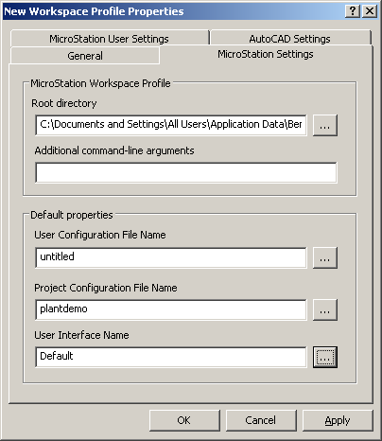
Click Apply and then Ok to create the Workspace Profile.

General Maintenance

Modifications to the PW Views
In the pre-release build 8.11.7.26 of the PlantFramework, there is an error in the SQL statement associated with the PW_AT_PIPERUN view created during the Plant Project integration with ProjectWise. This prevents the PIPE_RUN components from being published to the ProjectWise Component Tree.
Start SQL Server and locate the PW_AT_PIPERUN view. Edit it and modify the WHERE clause to: -
WHERE (B.LINK_TAB = 'PROC_LNK')
Save the changes made.

Modifications to the RUN_CONN table
In the pre-release build 8.11.7.26 of the PlantFramework, there is an error in the Project Databse Synchronise that is looking to populate a field in the RUN_CONN table that does not exist.
Start either Project Administrator or SQL Server and locate the RUN_CONN table. Edit it and add a new column named OPPID_LNK.

Disassociate P&IDs
The P&IDs associated with the PlantDemo project may retain a connectivity to the original Plant Project. To disassociate the P&IDs from the original in order to re-connect to your project, you will need to perform the following.
Start OpenPlant PowerPID and select the PlantDemo workspace.
Open each of the example P&IDs in turn and issue the following key-in: -
pid plantproject disassociate
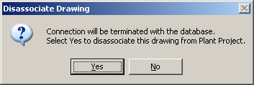
Click Yes to disassociate the P&ID. This MUST be performed on all three example P&IDs.
When you next start OpenPlant PowerPID and select the PlantDemo workspace, the P&IDs are connected to the Project Database defined in the PCF file.

Configuring ProjectWise Explorer
Start ProjectWise Explorer and login to the ProjectWise Datasource.
Locate and select the PID Drawings folder. Right click and create a New Folder as follows: -
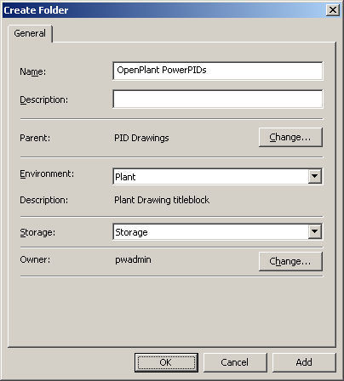
Click Ok to create the new folder.
Right click on the new OpenPlant PowerPIDs folder and select Properties. Select the Workspace Tab.

Change the Workspace Type to Workspace Profile and then select the newly created OPPID PlantDemo workspace Profile: -
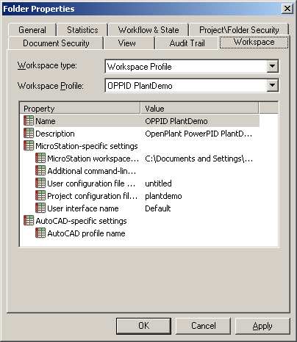
Click Ok to save the changes.
Select the example P&IDs in the directory and drag them into the OpenPlant PowerPIDs folder in ProjectWise. Select the No Wizard option when presented with the Select a Wizard dialogue and click Ok.
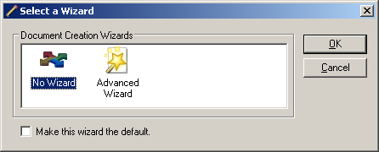
The P&IDs are now imported into ProjectWise.
Select all three P&IDs and hit the Space Bar to display the document properties.
Change the Application to Bentley OpenPlant PowerPID and click Save.
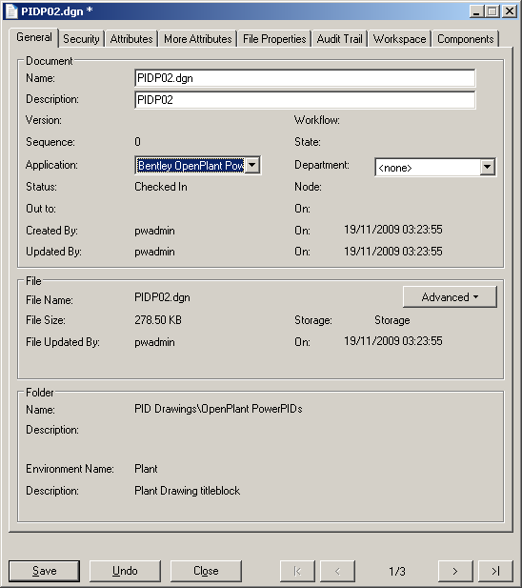
Using the scroll arrows, scroll to the next P&ID and set the Application. Continue until all P&IDs have the Bentley OpenPlant PowerPID application set against them.
You should now be GOOD TO GO!

