Open the document in question. See if “Holders” are highlighted. If it is, there will be a transmittal that has been processed
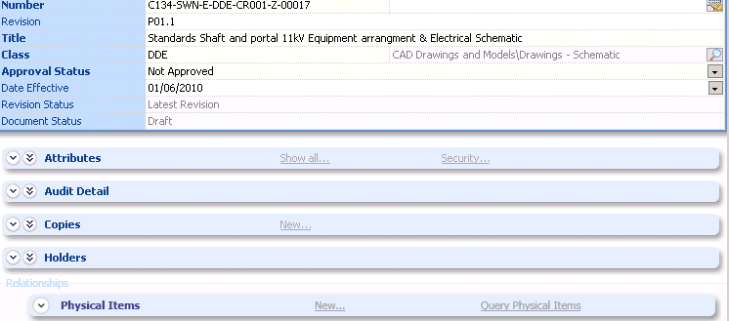

Drop down on “Holders” and the list of persons with transmittals will be displayed
