- Go to Physical Item root class and create a new attribute using type “Fixed Value”
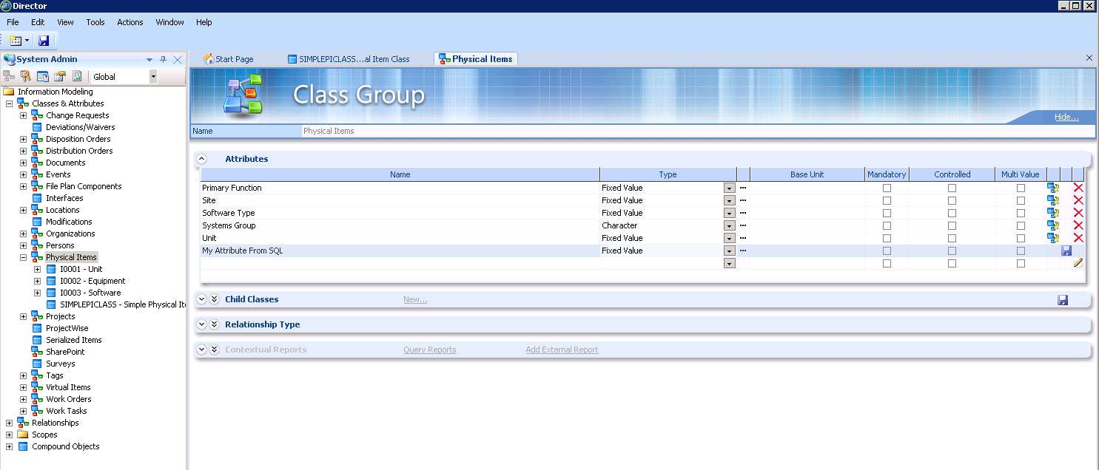

- Click on the three dots next to the type to access the screen to configure your fixed attribute:

- On first tab (Data Source), enter the connection information to the database that you will query to get values. You can choose (local) to access data within your own eB database without additional connection configuration:
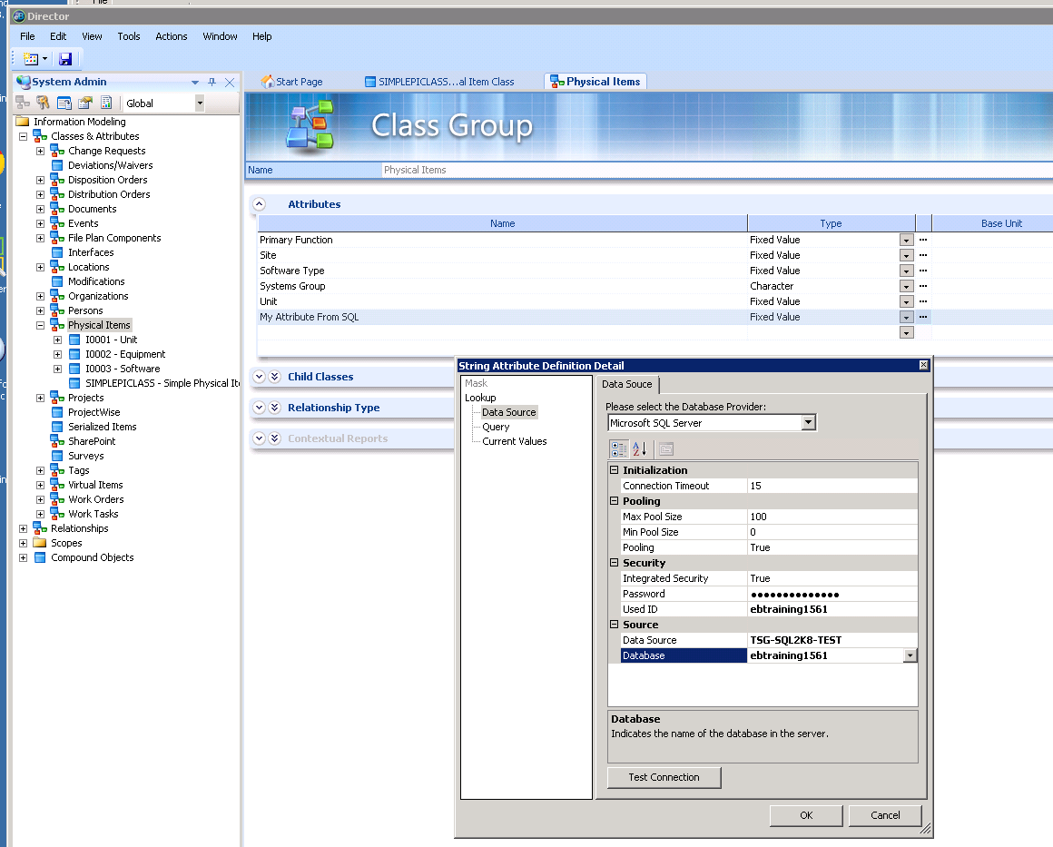

- Under “query” enter the query that will return your values:
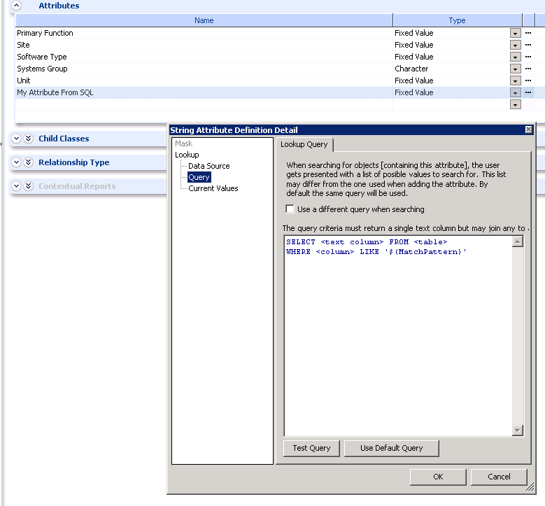

- The Current Values will be populated with the results of your Lookup Query.

