The Main Place (tool / module / functionality) we have delivered to client in V8i and CE. We were not able to satisfy the client requirement in CE, they don’t want to change the look and feel of the V8i implementation.
The Yellow Colour one is the V8i generated (our code) and the brown colour (if am not wrong) is the one we generated (our code) in CE.
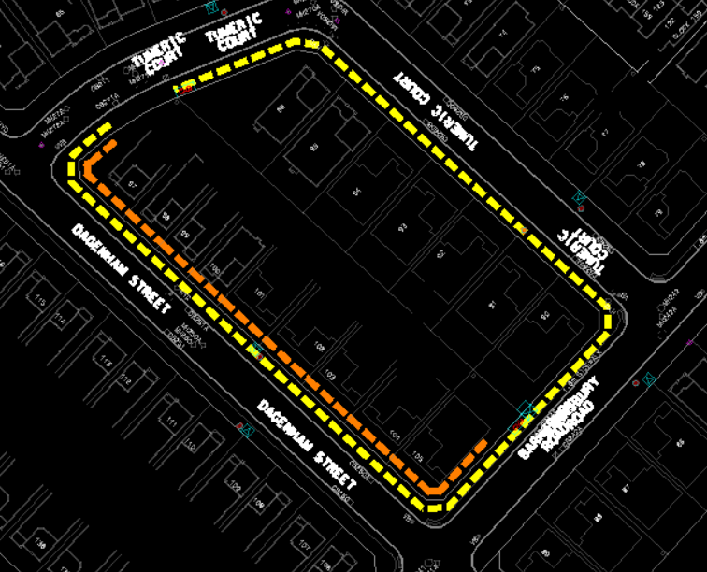
Grey colour is the landbase, which user will select as source.
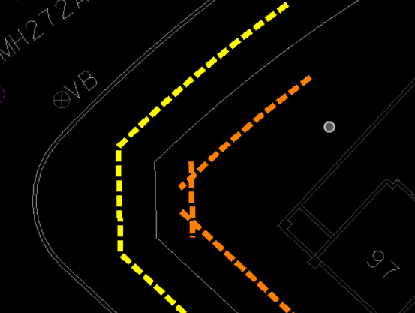

The V8i will generate a single line string as output (1 line selected in the screen)
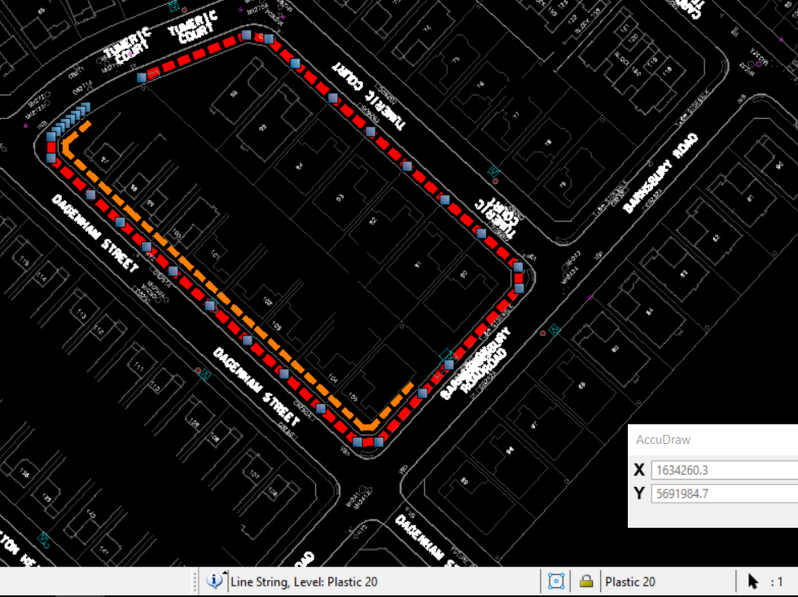
The CE edition is generating individual line strings (13 selected in the screen) and the output should be a single line.
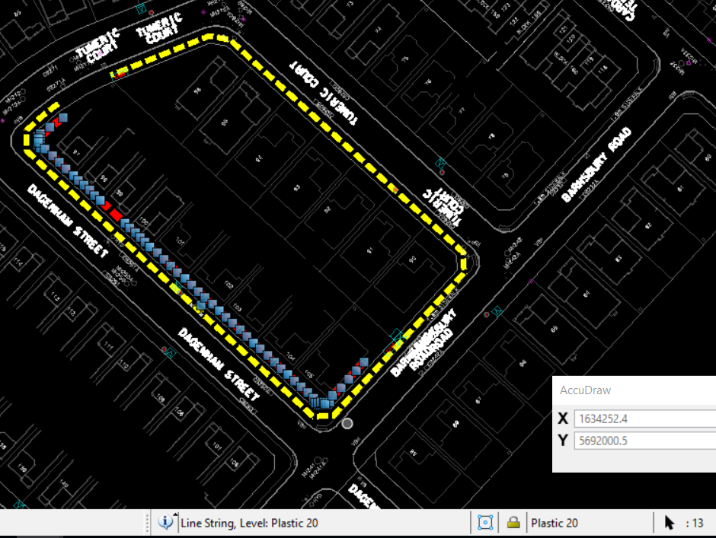

This the UI we gave to user (this is CE where we gave ‘Join’ extra button).
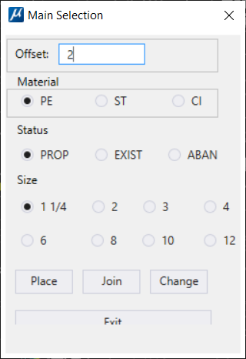
The functionality is basically doing a copy parallel of the selected land base feature when user clicks on the Place button.
We tried to achieve it in CE using key-ins (Clicked on the Place Button, we called Copy Parallel and move parallel Key in), please follow the screen shots below
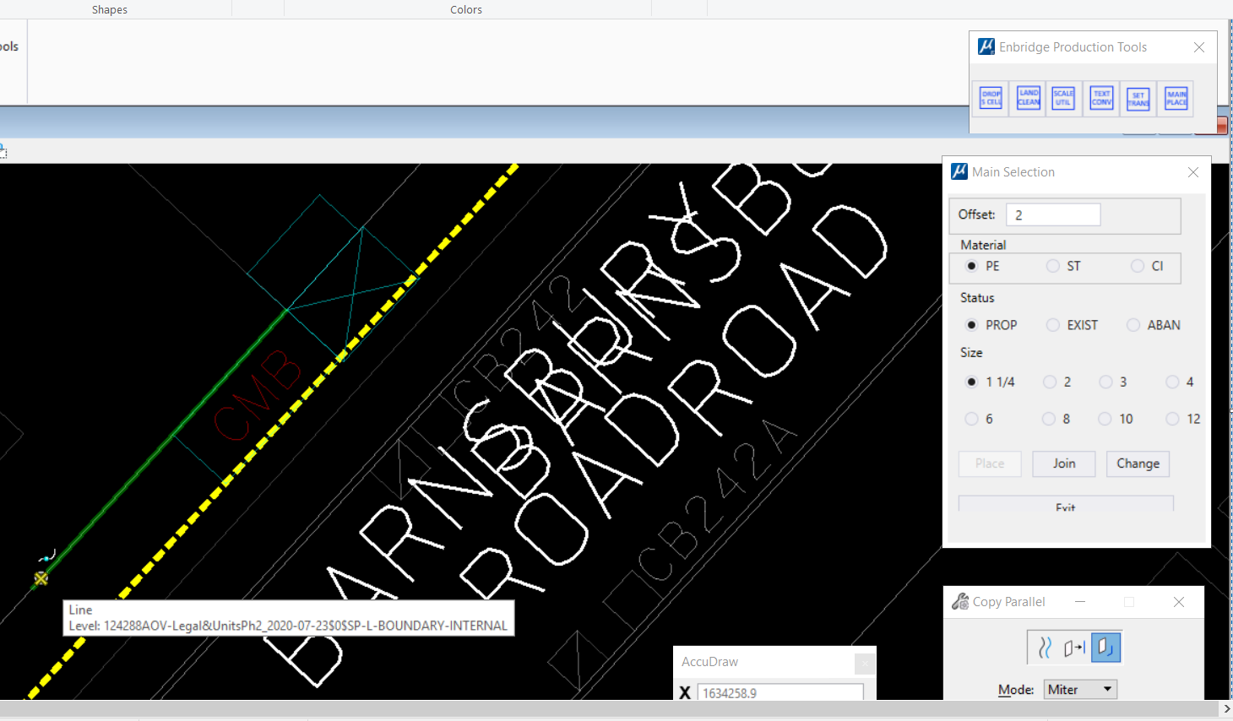
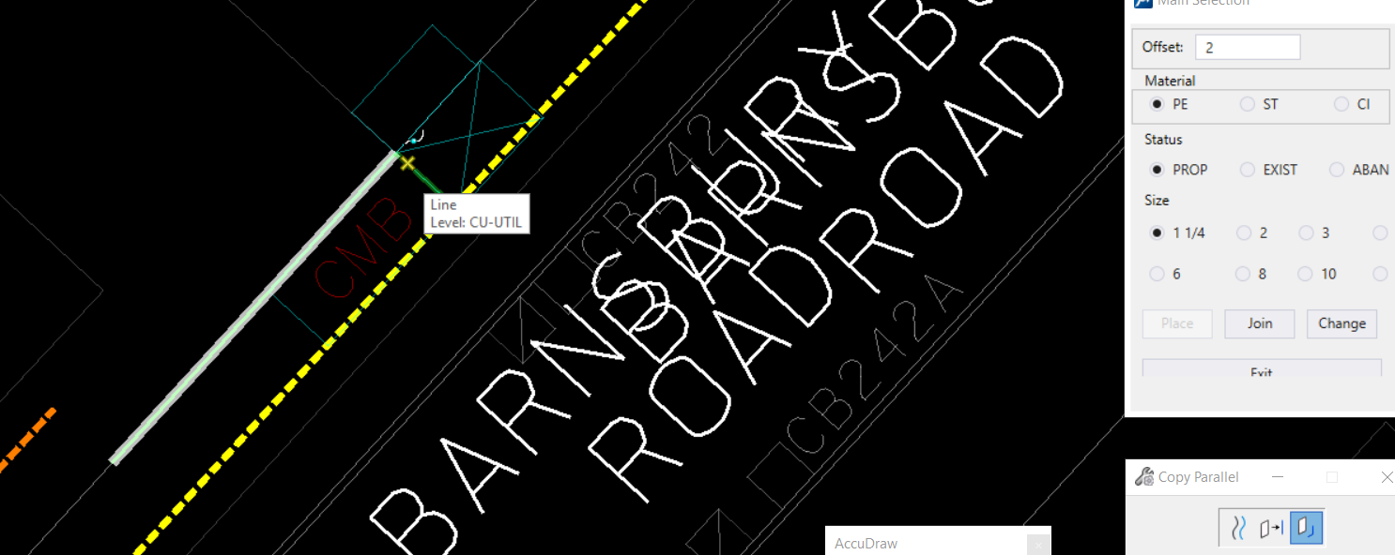
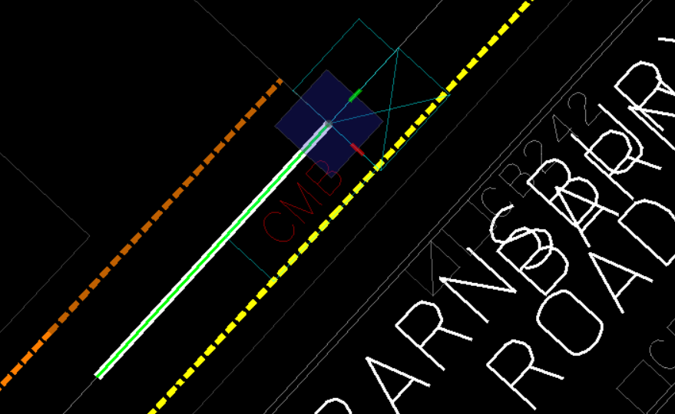
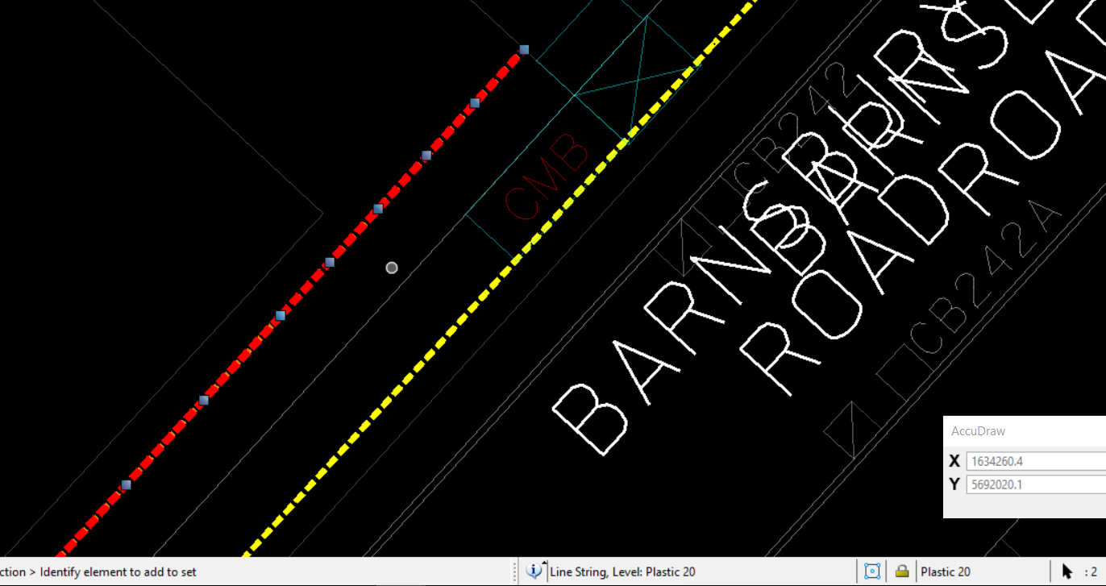
We don’t have the source code of V8i to go through the code and implement in CE.

