- Do positioning and got the Positioning dialog with Unmanaged Shape in Shape column coming as “***”
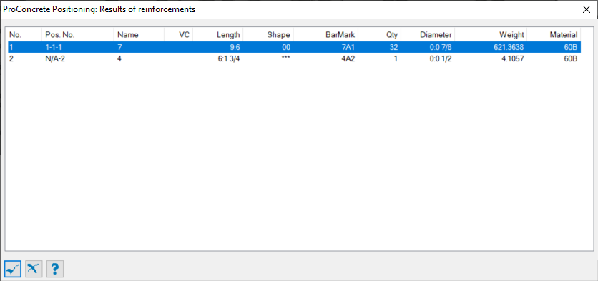

- Double click the unmanaged shape row and it will open up with Rebar Shape Management dialog
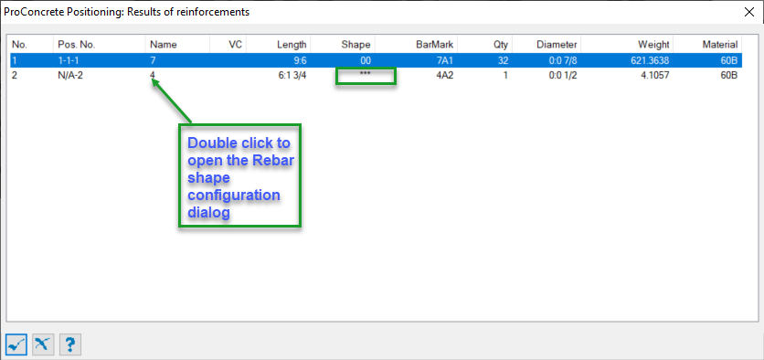

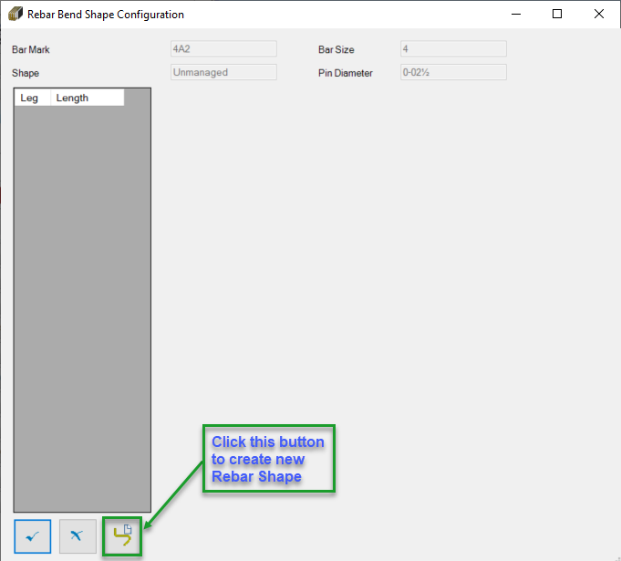

- Give a new name of the shape and say Ok

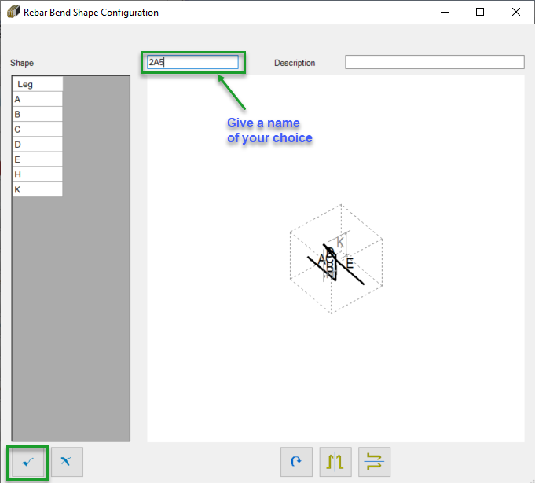

- Open up with new dialog box with all the leg definition, Shape mark and assigned Shape name.

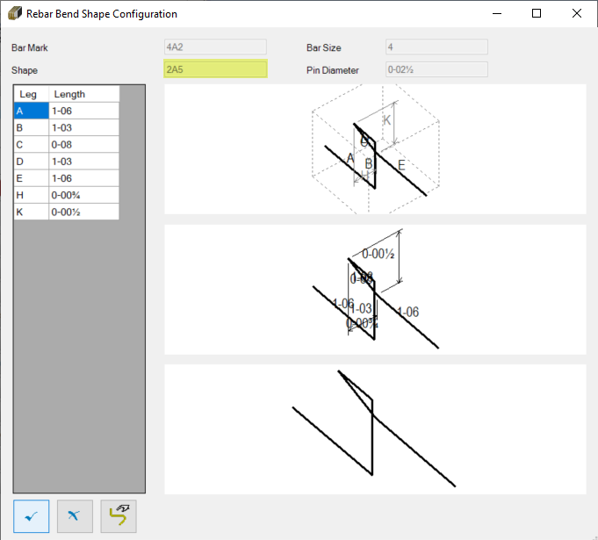

- Now say ok and in the positioning dialog box new shape will be reflected.
