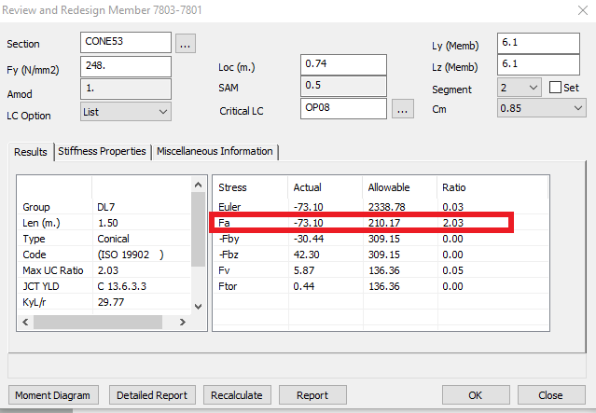

>>>>>>>>>>>>>>>>>>>>>>>>>>>>>>>>>>>>>>>>>>>>>>>>>>>
Detailed review report of member 7803 - 7801
<<<<<<<<<<<<<<<<<<<<<<<<<<<<<<<<<<<<<<<<<<<<<<<<<<<
Units: Length -(cm) Force -(kN) Stress -(N/mm2)
Design Code - ISO 19902:2007(E)
(Ultimate limit state)
- Resistance Factors
Tension 1.0500 Compression 1.1800
Bending 1.0500 Shear 1.0500
Hoop Buckling 1.2500
-----------------------------------------------------------------------
****** Member Infomation ******
Group DL7
Section Name CONE53
Total Length 1.50 (m)
Location 0.74 (m)
Segment 2 of 2
LC Option List
Critical LC OP08
------------------------------------------------------------------------
****** Basic Properties ******
Section Type Cone
Larger Outside Diameter 134.62
Wall Thickness 3.80
Smaller Outside Diameter 106.68
Cylinder Thickness A 2.54
Cylinder Thickness B 3.80
Half Apex Angle (Deg.) 10.35
Elastic Modulus 210.00 1000(N/mm2)
Shear Modulus 77.00 1000(N/mm2)
Yield Strength 248.00 (N/mm2)
Axial Area A 1394.96
Mom. of Inertia Iy 2.4E+006
Mom. of Inertia Iz 2.4E+006
Shear Area Y 1394.96
Shear Area Z 1394.96
Tors. Constant J 4.8E+006
------------------------------------------------------------------------
****** Member's Properties ******
Slenderness Ratio (KL/r)y 29.77
Slenderness Ratio (KL/r)z 29.77
Radius of Gyration ry 41.33
Radius of Gyration rz 41.33
Eff. Length Factor Ky 2.00
Eff. Length Factor Kz 2.00
Overall Buck. Length Ly 6.10 (m)
Overall Buck. Length Lz 6.10 (m)
Final (K*L)y 12.20 (m)
Final (K*L)z 12.20 (m)
- Segmented Member: Overall buckling length is re-calculated
from apprximate buckling load effectively at this segment.
Leffy 1.52 (m)
Leffz 1.52 (m)
- KL/r of cone calculated by the averaged diameter (half of two ends)
TUB Ring Spacing INF
Reduction Factor Cmy 0.85
Reduction Factor Cmz 0.85
------------------------------------------------------------------------
****** End Forces and Moments ((kN), (kN-m)) ******
Tor. Moment Mx 45.5124
Bending Moment My -1530.8928
Bending Moment Mz 2127.1609
Axial force fx -11235277.0000
Shear force fy -908008.1875
Shear force fz 130213.6016
------------------------------------------------------------------------
****** Acting Stresses (N/mm2) ******
Axial stress fa -73.0961
Bending Major fby -30.4393
Bending Minor fbz 42.2952
Shear fv 5.8708
Torsional Shear fvt 0.4427
Hydro Hoop Stress fh 0.0000
- NOTE: Equivalent axial and bending stresses within cone (Eq 13.6-1~3).
Ds = 134.62 at section of consideration.
------------------------------------------------------------------------

//////////////////////////////////////////////////
CHECK AS EQUIVALENT TUBULAR SECTION
//////////////////////////////////////////////////
****** Basic Allowable Stresses (w/o. Rsist Fact.) (N/mm2) ******
Axial Tension Ft 248.0001 (Eq 13.2-1)
Shear Fv 143.1829 (Eq 13.2-16)
Axial Compression Fc 240.6894 (Eq 13.2-5,6)
(Lambda) 0.3256 (Eq 13.2-7)
Local Buckling Fyc 248.0001 (Eq 13.2-8,9)
Elastic Local Buckling Fxe 3498.8188 (Eq 13.2-10)
Bending Fb 324.6060 (Eq 13.2-13~15)
Euler Buckling Y Fey 2338.7856 (Eq 13.3-5)
Euler Buckling Z Fez 2338.7856 (Eq 13.3-6)
- NOTE: DE = DMAX/cos(Alpha) = 136.85 at larger end of cone (except Fey,Fez).
The larger value of KL/r at the average section (in member properties list) is applied
--- Reported Allowable Stresses (with Resist. Factors)
Axial 210.1696
Major Axis Bending 309.1486
Minor Axis Bending 309.1486
Shear in Local Y 136.3647
Shear in Local Z 136.3647
Euler Buckling 2338.7856
------------------------------------------------------------------------
******** Unity Checks without Hydro Pressure ********
Compression + Bending (Eq 13.3-7) 0.5063
(Eq 13.3-8) 0.5164
Euler Buckling 0.0313
Local Buckling (Eq 13.6-8) 0.5957
Combined Shear (Eq 13.2-17,19) 0.0463
------------------------------------------------------------------------
//////////////////////////////////////////////////
CHECK AT CONE-TUBE JUNCTION
//////////////////////////////////////////////////
--- CONE-TUBE Junction
CONE Diameter at Junction D 134.62
CONE Thickness at Junction T 3.80
TUBE Diameter at Junction DC 134.62
TUBE Thickness at Junction TC 2.54
Half Apex Angle (Deg.) Alpha 10.35
- NOTE: Junction at LARGE end.
--- Global actions and localized stresses (N/mm2)
Global Axial (TUBE) fat -106.6014
Global Bending (TUBE) fbt 76.7261
Global Axial (CONE) fa -73.0961
Global Bending (CONE) fb 52.1098
Local Bending at CONE 1 fbjc1 -16.8215 (Eq 13.6-5)
CONE 2 fbjc2 -103.2240
Local Bending at TUBE 1 fbjt1 -37.6500 (Eq 13.6-4)
TUBE 2 fbjt2 -231.0364
Hoop stress at CONE 1 fhc1 11.9467 (Eq 13.6-7)
CONE 2 fhc2 73.3101
Hoop stress at TUBE 1 fht1 17.8731 (Eq 13.6-6)
TUBE 2 fht2 109.6766
Hydro Hoop in CONE fhc_P 0.0000
Hydro Hoop in TUBE fht_p 0.0000
--- Allowable stresses at junction (N/mm2)
CONE TUBE
Fy 248.0039 248.0039
Fxe 3498.8188 2377.3601 (Eq 13.2-10)
Fyc 248.0001 248.0001 (Eq 13.2-5~6)
Fhe 2371.1201 1584.9066 (Eq 13.6-17)
Fh 248.0001 248.0001 (Eq 13.6-17)
- NOTE: Diameter, Thickness of cone and tube at junction are applied, respectively.
DE = 136.85 for cone side.
--- Junction Yielding and Buckling check (Sec 13.6.3.3~4)
*** Capped-end pressure NOT included ***
fh,j S_max 1 S_max 2 UC_YLD UC_BUK | UC
CONE 1 11.947 -37.808 -4.165 0.1905 0.0000 | 0.1905
CONE 2 73.310 -228.430 -21.982 1.1541 0.0000 | 1.1541
TUBE 1 17.873 -67.525 7.775 0.3303 0.0000 | 0.3303
TUBE 2 109.677 -414.364 47.709 2.0268 0.0000 | 2.0268
- NOTE: Check the junction of either larger or smaller end of cone.
Two locations to be analyzed on each side (cone and tubular).
S_max 1, 2 are the possible maximum axial tensile and
compressive stresses on two points at each location. Unit (N/mm2)
fh,j is the total hoop stress (Eq 13.6-26). Unit (N/mm2)
UC_YLD is calculated from (Eq 13.6-13,14) when fh,j is positive.
UC_BUK is calculated from (Eq 13.6-18,21,22) when fh,j is negative.
------------------------------------------------------------------------
******** Reported Unity Ratios ********
Critical Unity Ratio 2.0268 (C 13.6.3.3 ) JCT YLD
Combined Unity Ratio 2.0268
Axial Component 2.0268
Bending Major Y-Y 0.0000
Bending Minor Z-Z 0.0000
Shear 0.0463
Torsional Shear 0.0032
Euler Buckling 0.0313

