How to locate OpenFlows Flood files
EXPORT WORKSPACE FILE
- Export Workspace file

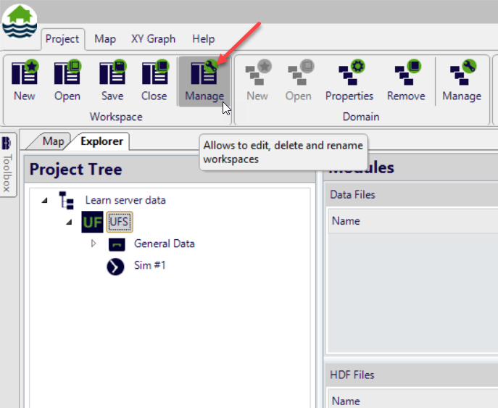

- Select the desired workspace to be exported and click on export button

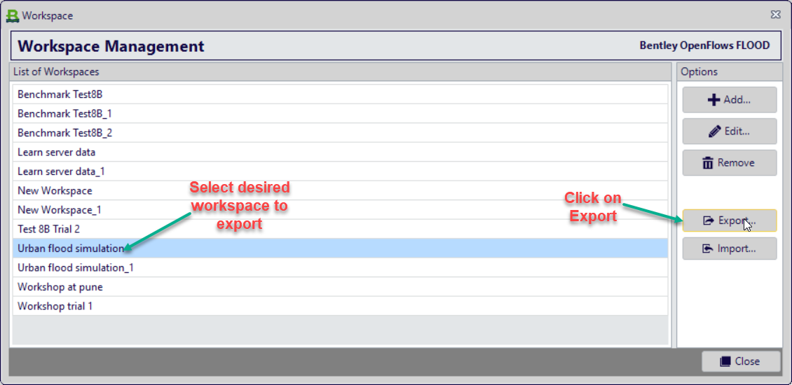

- Select the folder location and save the workspace, don’t forget to click on include result files.
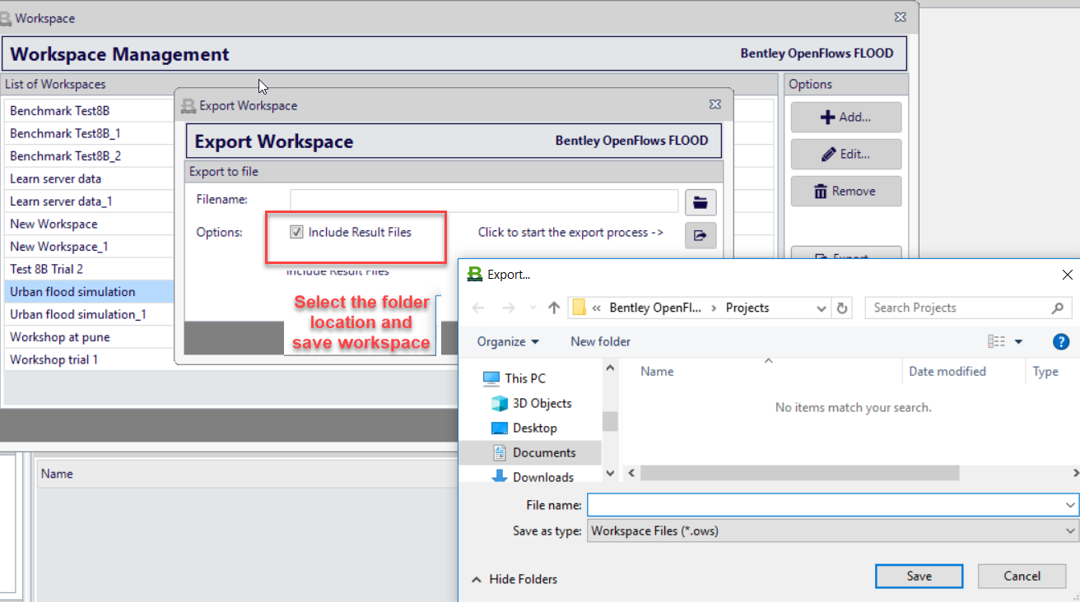

Upload this .ows file using sharefile link.

