Bentley Guide

eB Create Back Up and Restore Back Up

Document No. B00098723
--
Revision 01

Document

Document number: | B00098723
Revision number: | 01
Date: | 04 July 2017
Status: | Not Approved
Author: | Carma de Villiers

History

Revision History

 | Revision no | Revision date | Summary of changes
 | 01 | 2017/07/04 | New Document
Table of Contents
Document 2
Revision History 2
1. Introduction 3
2. Purpose 3
3. Create Back Up and Restore Back Up 3

Introduction
The intention of this document is to show the user to back up and restore database back up of a user to the development environment at Bentley.

Purpose
The purpose of this document is to provide a clearly defined process restoring a database in SQL and eB.

Create Back Up and Restore Back Up
Do Back up
Select SQL Server
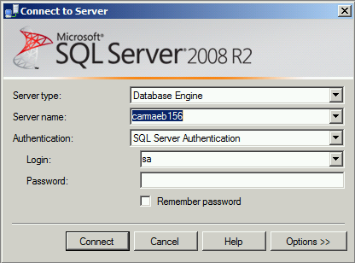
Select Database that needs to be backed up
Right click on the database
Select Tasks
Select Back Up
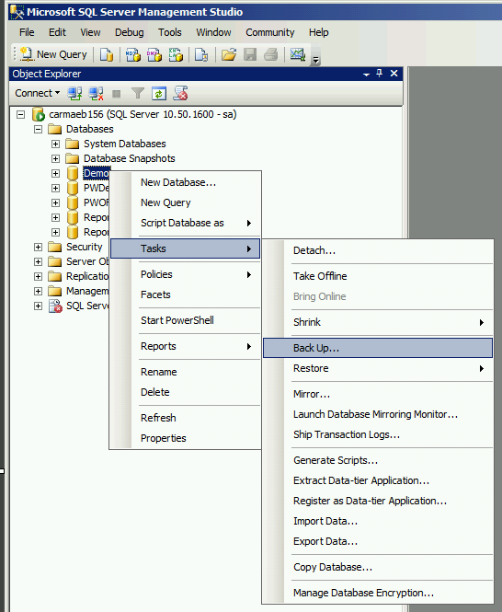

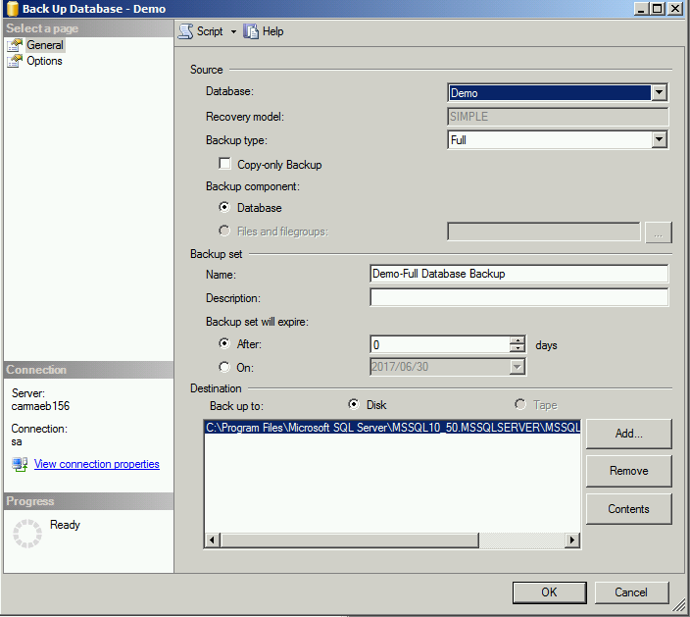
Remove Back up path if one already exists: and add the required path
Select OK
Backup will now be executed
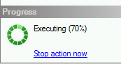
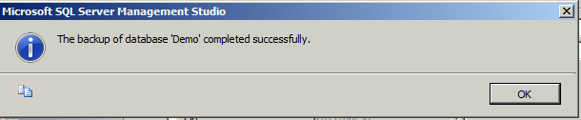

Restore Back Up
Go back to SQL
Go to Databases right click and select Restore Database
Select required back up and right click
Select restore back up

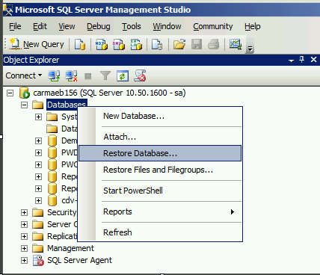
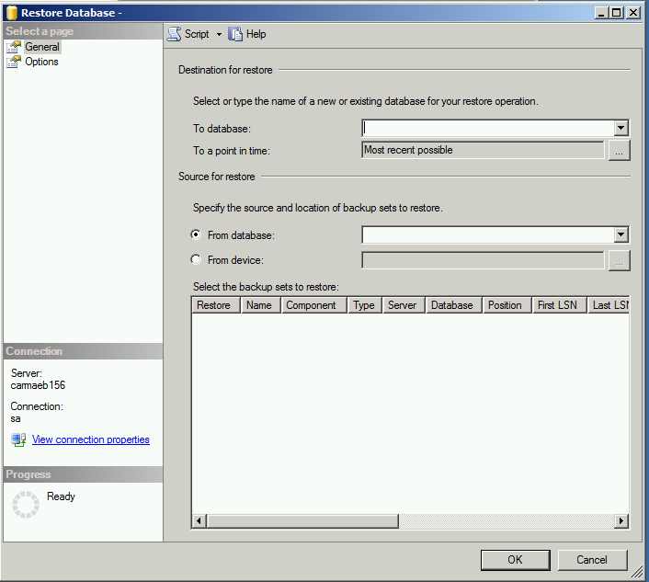

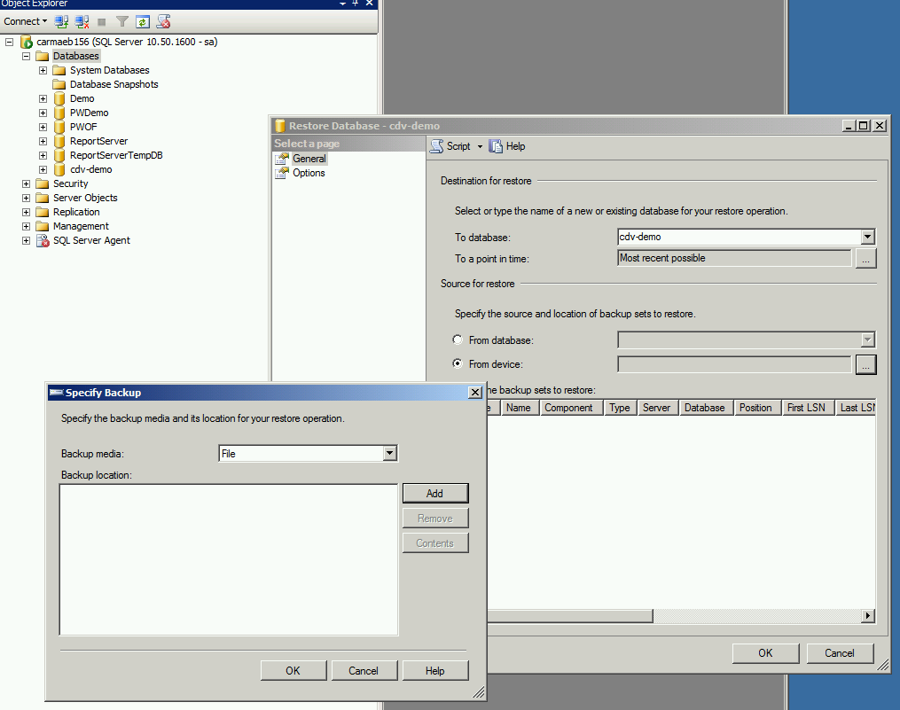

Select Device

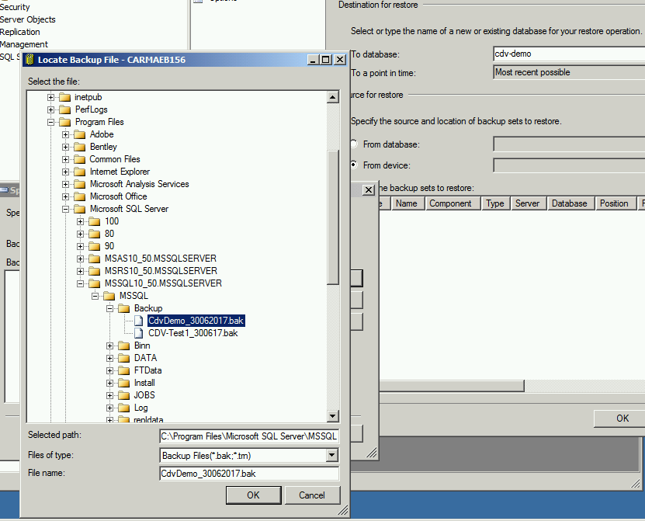

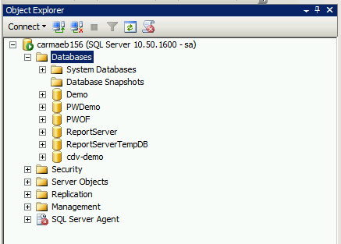

Search the database
Highlight backup
Ok
OK
Now the name will be available
Add database to SQL
Ok
Refresh

SMC
Select Server
Data Sources
Right click
Add data Source

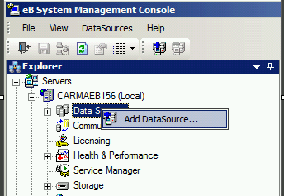

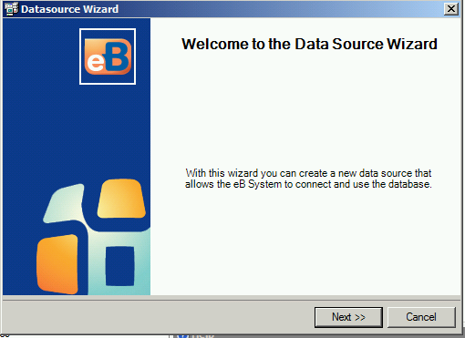
Database
Select required database
Next
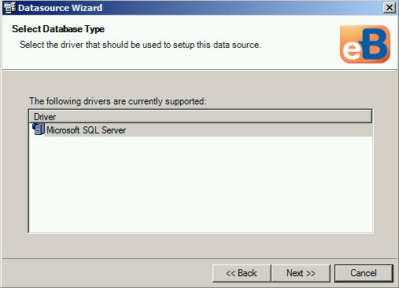
Net
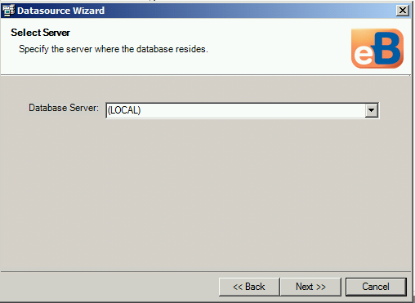
Local (If server is separate specify SQL server name)
Sa or service account applicable
Add relevant password

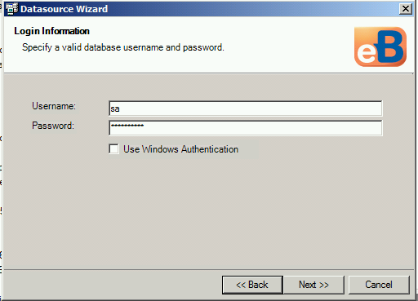

Add the new database name
Next
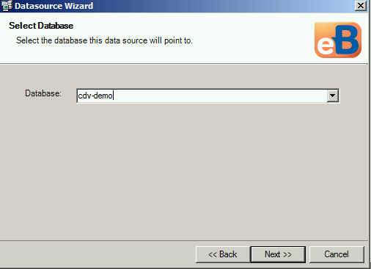

Next

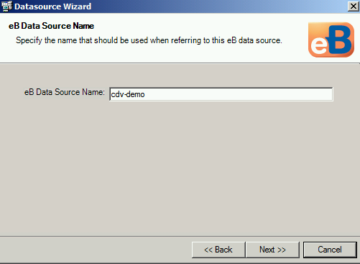

Next

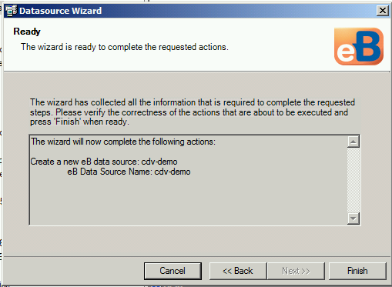
Finish
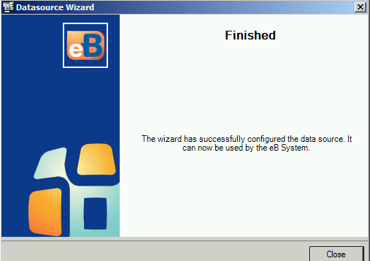

Data source added
Refresh
(if required – select upgrade)

Community
Right click
Add Community
Select Application Server
Select required database

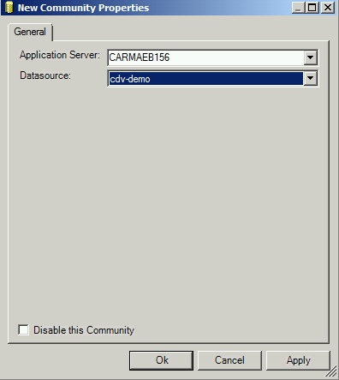
Admin – password for eB
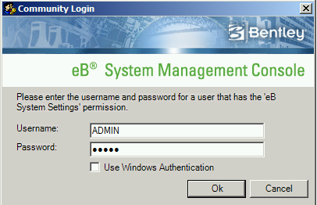
Apply
OK

Storage

Right click
Storage Wizard
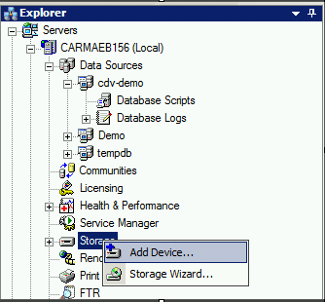
Select Add a new Repository
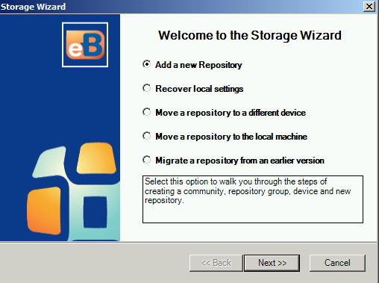
Next
Select Create a new Community or Use an existing Community
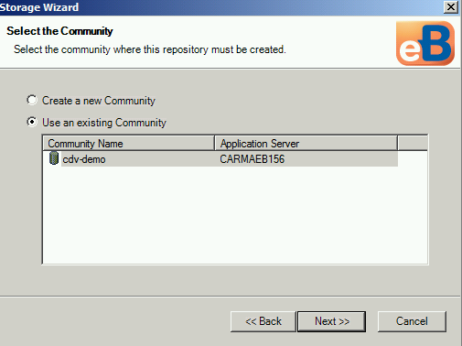
Next
IF selecting Use an existing Community, select the existing Community
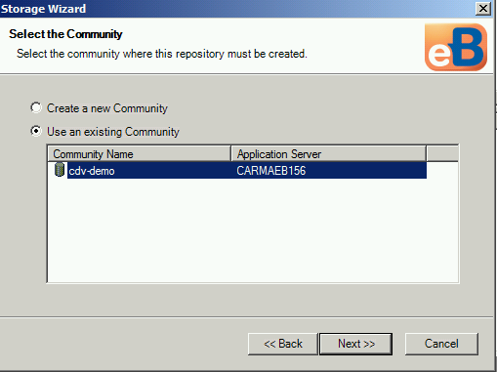
Next
Use an existing Device
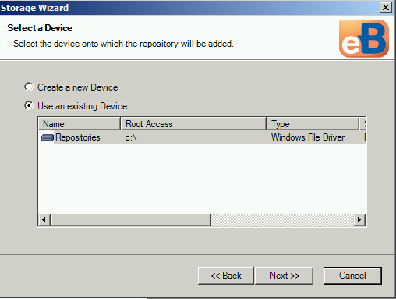
Next
Select the required Repository or create new
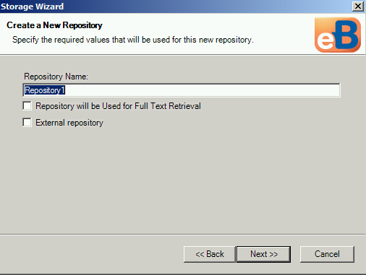
Next
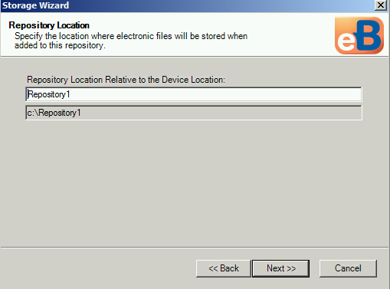
Specify the Repository
Next
Create a new Group or Use an existing Group
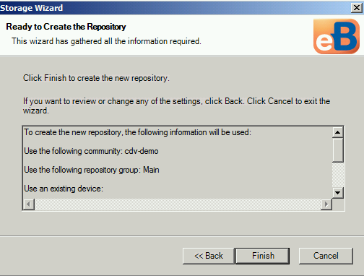

Finish
Once all the information has been added the Wizard can be closed
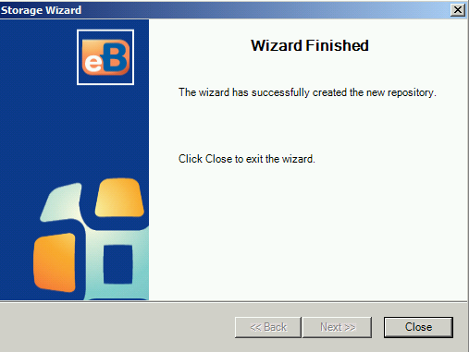
Close

New Device. This step is not always required and is used to add it manually. If you select new device using the wizard, it will present you with additional screens to add it.

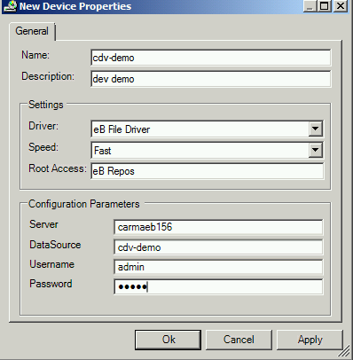
Name (Generic)
Root Access – eb repos
Copy path and past
Next
Generic repo
Next
Next
Next

Main
Finish
Folder created inside repo
Refresh Storage

Work Queue

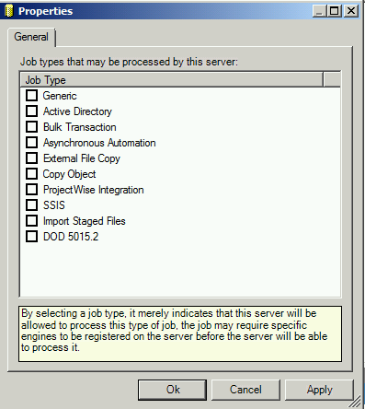

Enable – Generic
All but not Active Directory
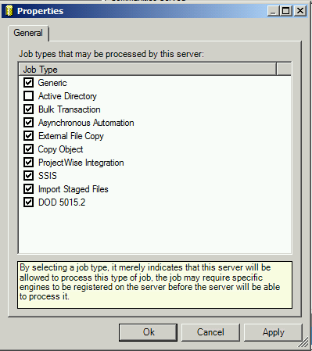
OK

Doc Creation
Just enable

Snapshots
Just enable

Publisher
Do as above
Create publisher folder
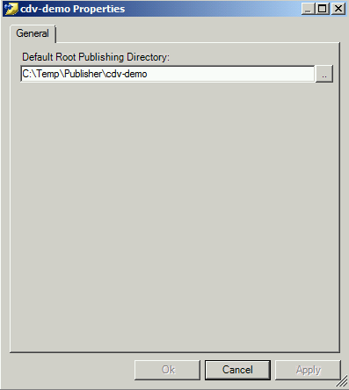

Mail Distribution
IP address or mail.bentley.com
ebadmin.bentley.com
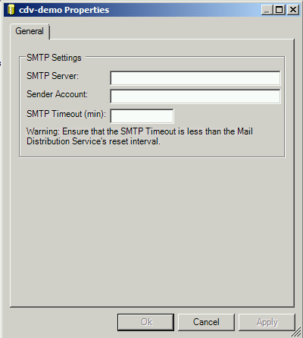

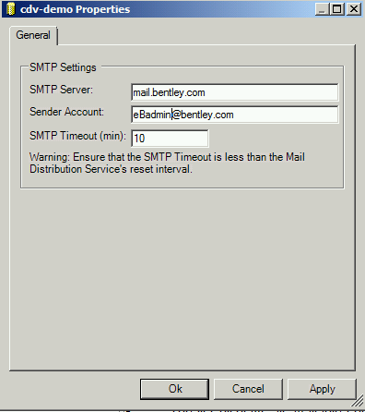
Apply

FTR
Set up
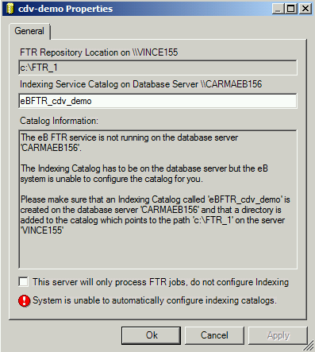
Renditioning
Same

Log into Director
Find the data source
Log in

