When i start application (Fiber v8i) i don't see Bentley Communications menu , i don't have access to modules (Strand, Fiber etc.), what is wrong? or how to enable this menu? While startup the application below shown Text window is popping up.
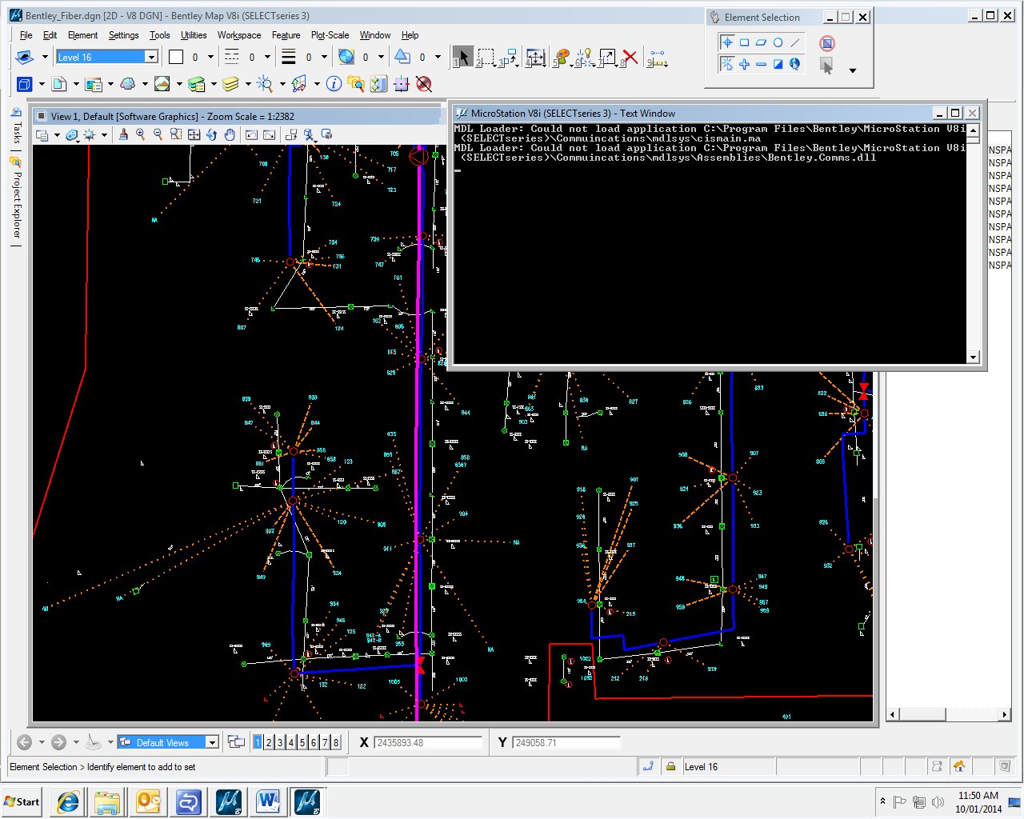
I was followed the installation process as the document “readme_BentleyCommunications.pdf” and applied workspace macros parameters as mentioned.
I've tried to manually run cismain.ma (Utilities -> MDL Applications) but i get information as shown below
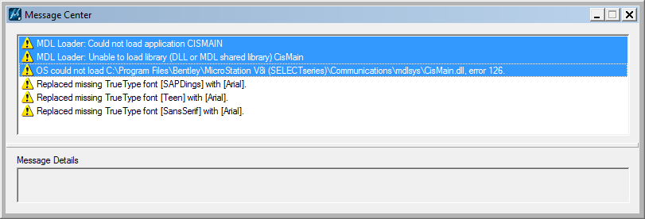
I am using the software’s in my system as mentioned below
System OS: Windows 7 (32-bit)
Database: Oracle Database 11g Release 2 Client 32-bit
Bentley MicroStation V8i (Select series 3): 08.11.09.459
Bentley Fiber: V8i (Select series 3): 08.11.09.123

