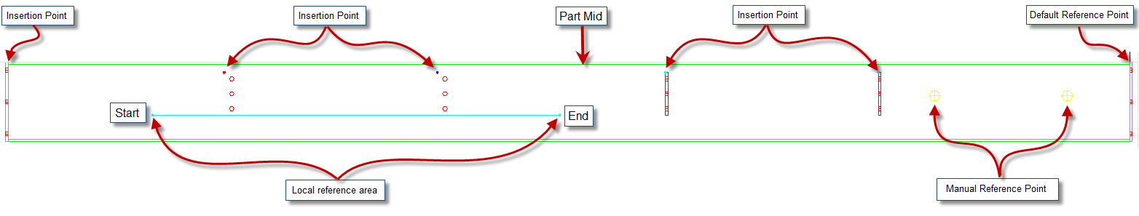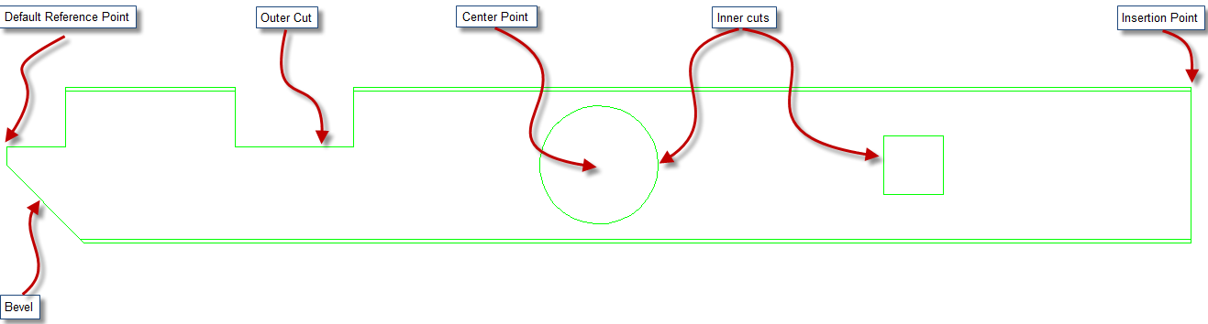
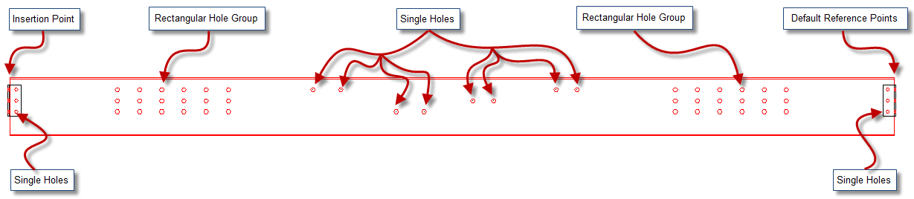
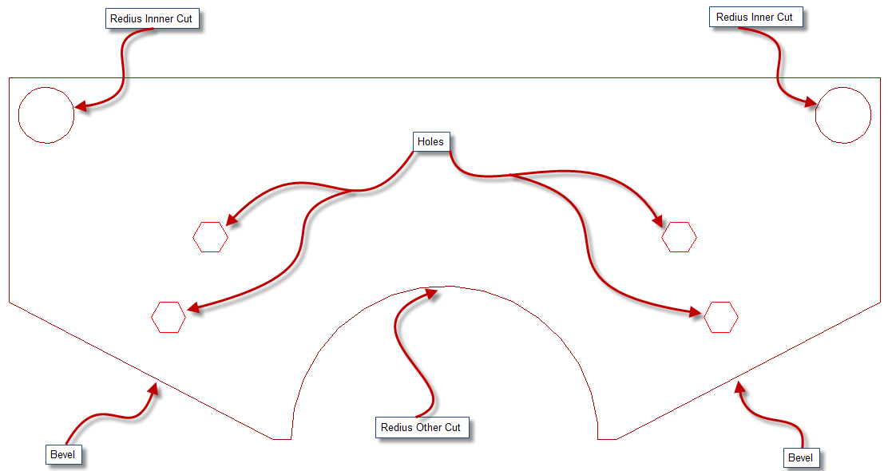

Dimension Points: Manually added "Dimension Point under PS3D properties dimension points.
Local Reference Point: Manually added "Local references Point" under PS3D properties dimension points.

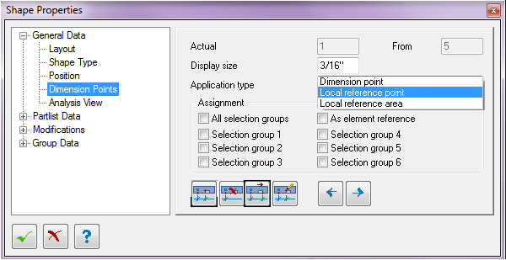

Local Reference Area: Dimension point will start at "local reference Area" (under PS3D properties dimension points).
Edge: Dimension will move to the nearby point, insertion or Reference point (Apply for shape only)
Manual Reference Point: Reference Point are added from the PS3D properties – Position
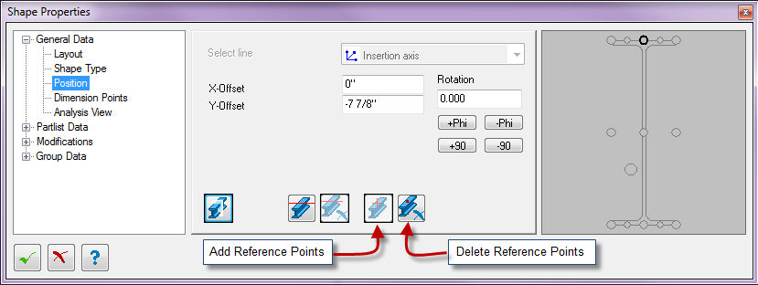

- Add Dimension Group:
  - User Group
    - Associate with Object :
      - Do not Dimension---> Current dimension will be off
      - Dimension---> Current dimension will be turned on

      - Al l---> Not used
      - Only edge points--->Not used
- Add Modification:
  - Outer Contour:
    - Associate with Object :
      - Standard---> Dimension the shape from start to end including all outer edges.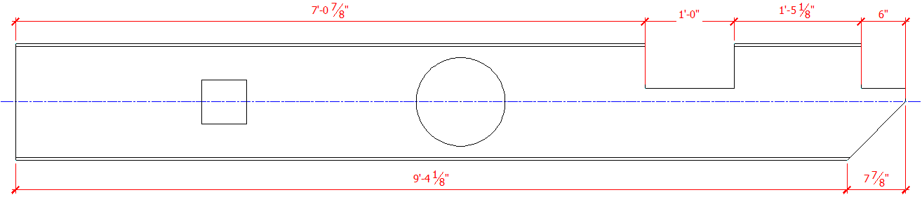
      - Single Outside---> Will dimension all outer edges/faces for shape, plates, openings and cutouts. (The dimension will be aligned to each edge/face.) Plus all dimensions will be placed outside.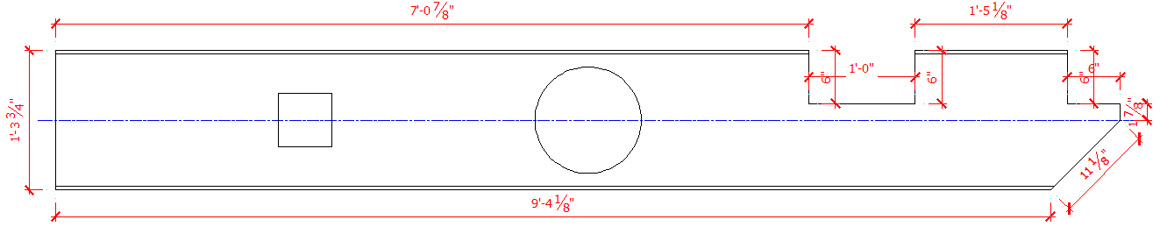
      - Single Inside---> Will dimension all inner edges/faces for shape, plates, openings and cutouts. (The dimension will be aligned to each edge/face.) Plus all dimensions will be placed inside. 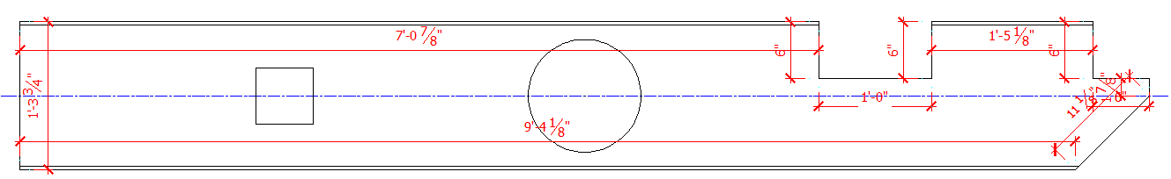
      - Standard+Single Outside---> All Outer edges will be dimension (The dimension will be aligned to each edge/face plus a horizontal dimension will be added.) Plus all dimensions will be placed outside. 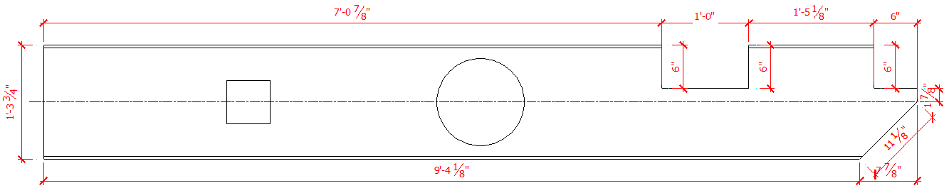
      - Standard+Single Inside---> All inner edges will be dimension (The dimension will be aligned to each edge/face plus a horizontal dimension will be added.) Plus all dimensions will be placed inside. 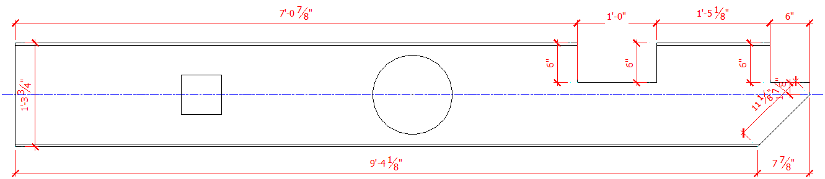
      - Min/Max---> Options more used for dimensioning round shapes. Inner and outer edge of the round shape will be dimension.
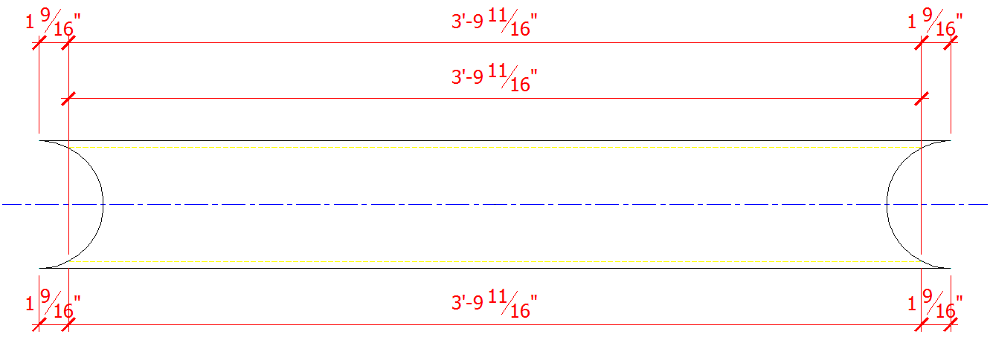
      - Standard+Min/Max--->

  - Inner Contour:
    - Associate with Object :
    - Standard---> Will Dimension the element form start to end including all inner edges.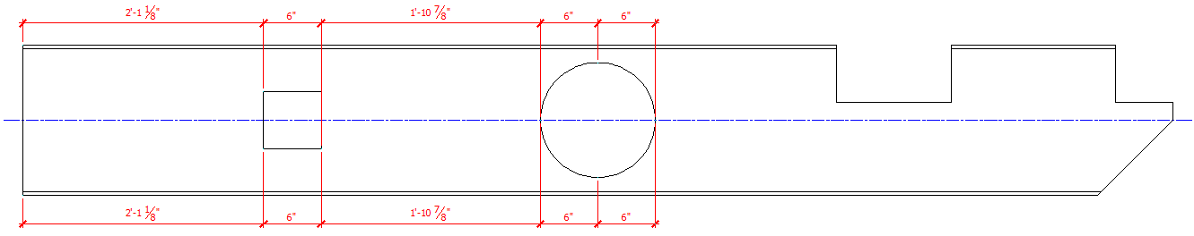
    - Single Outside---> Will dimension all Inner edges/faces for shape, plates, openings and cutouts. (The dimension will be aligned to each edge/face.) Plus all dimensions will be placed outside. (Doesn’t apply for arc to circular cutout).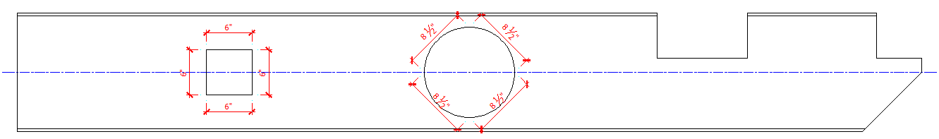
    - Single Inside ---> Will dimension all inner edges/faces for shape, plates, openings and cutouts. (The dimension will be aligned to each edge/face.) Plus all dimensions will be placed inside. (Doesn’t apply for arc to circular cutout).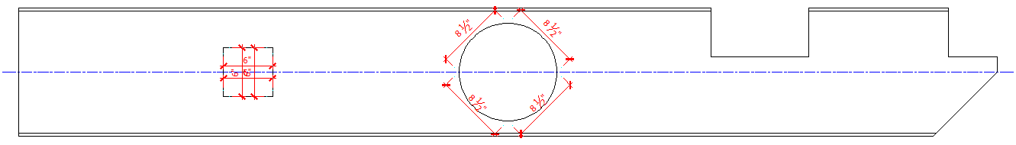
    - Standard+Single Outside ---> Starting from the insertion point all Outer edges will be dimension (The dimension will be aligned to each edge/face plus a horizontal dimension will be added.) Plus all openings and cutouts dimensions will be placed outside. (Doesn’t apply for arc to circular cutout).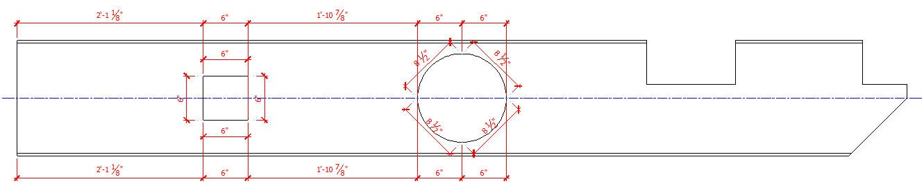

    - Standard+Single Inside---> All inner edges will be dimension (The dimension will be aligned to each edge/face plus a horizontal dimension will be added.) Plus all openings and cutouts dimensions will be placed i. (Doesn’t apply for arc to circular cutout).
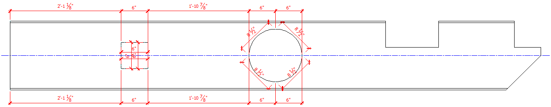
    - Min/Max--->
    - Standard+Min/Max--->

  - Holes as Top View and Holes as Side View:
    - Associate with Object :
    - Together---> All holes will be dimension horizontally and vertically up to the nearest edge.

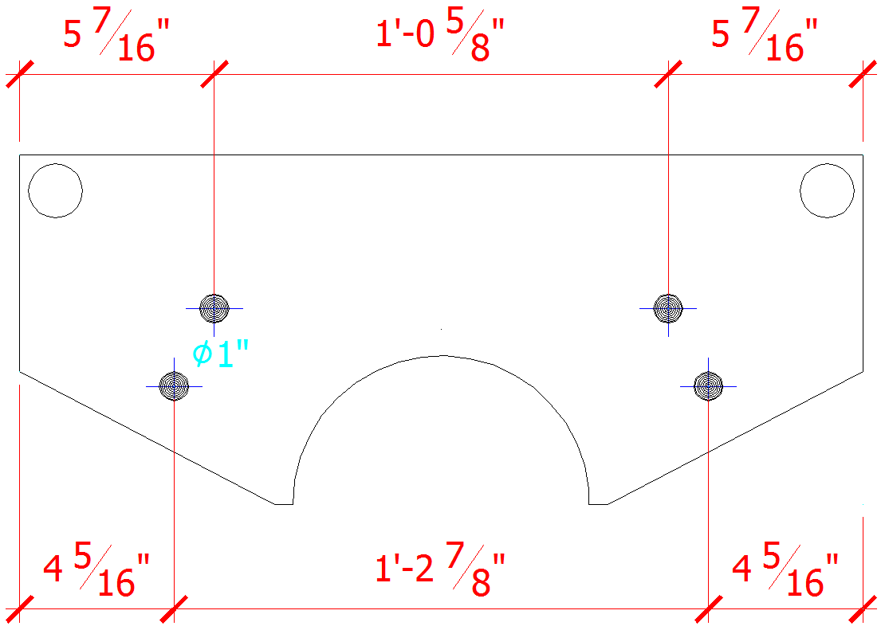
    - Edge Assignment---> Dimension holes to the nearest edges regardless of the edge orientation. The dimension will display in line with the referenced edge.

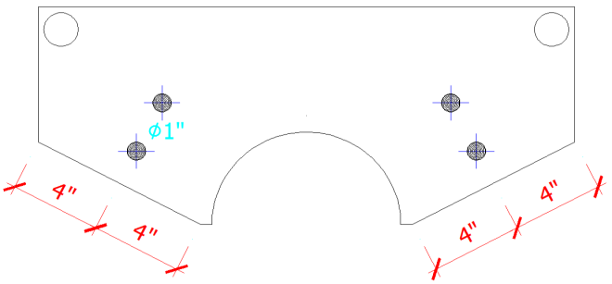

    - Together + Edge--->All holes will be dimension horizontally and vertically up to the nearest edge plus dimension will display in line with the referenced edge.
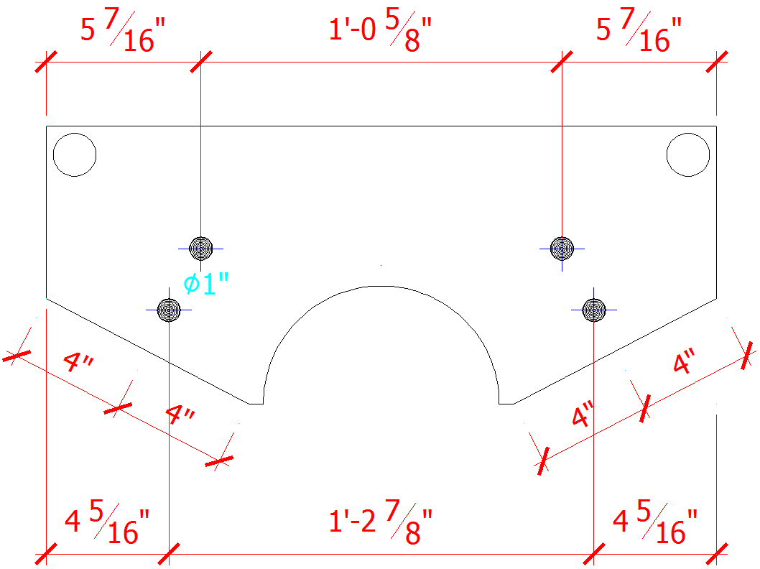
    - Hole Groups---> All holes will be dimension as Groups.
- Hole Groups + Edges---> Holes will be dimension as groups plus dimension will display in line with the referenced edge.
    - Connection Shape---> Dimension points will start from the connecting shape reference point.

  - Cut Angle:
    - Associate with Object :
- Angle to Vertical--->Cut edges will be dimension using Angular Dimension (Vertical Dimension).
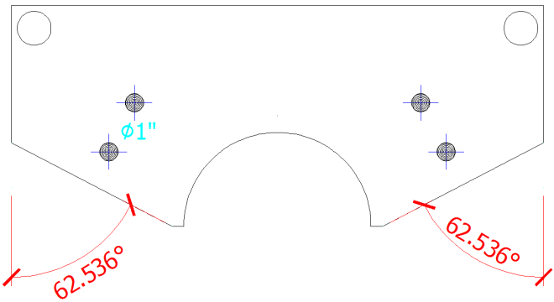2
- Angle to Horizontal--->Cut edges will be dimension using Angular Dimension (Horizontal Dimension).
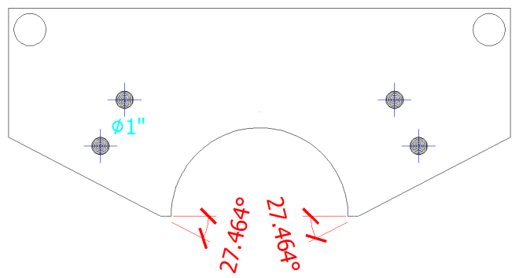
- Bevel Symbol--->Bevel dimension will be turn on.
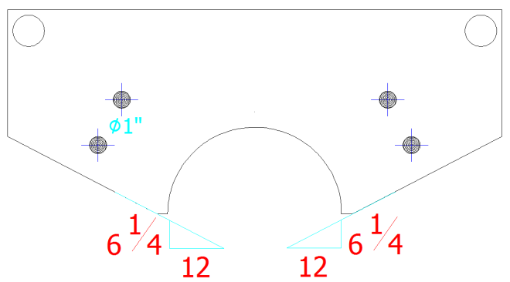
  - Redius Centerpoint:
    - Associate with Object:
- Outer Contour--->All Outer radius cuts will be dimension from the center point.
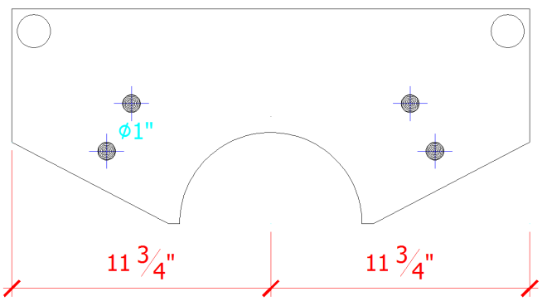
- Inner Contour---> All inner radius cuts will be dimension from the center point.
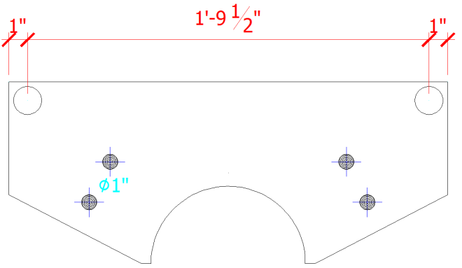
- Together---> All inner and other cuts will be dimension from the center.
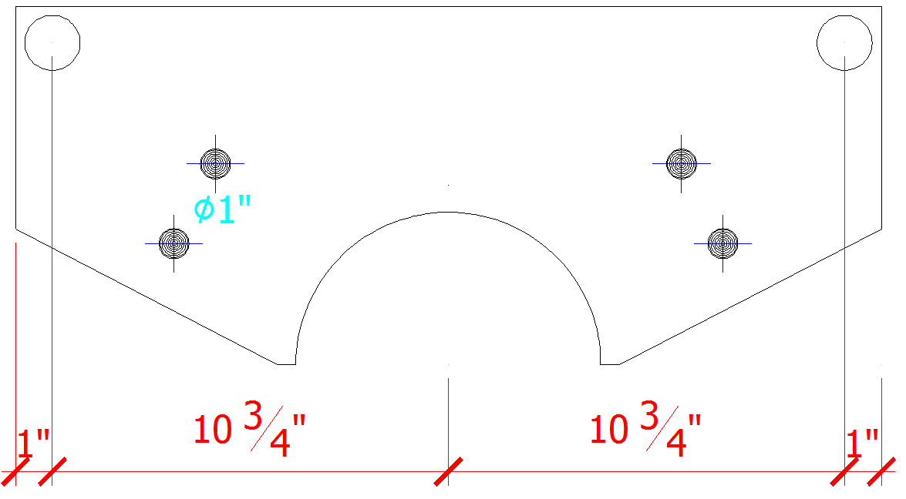
- Separate---> All inner and other cuts will be dimension from the center but with different dimension line.
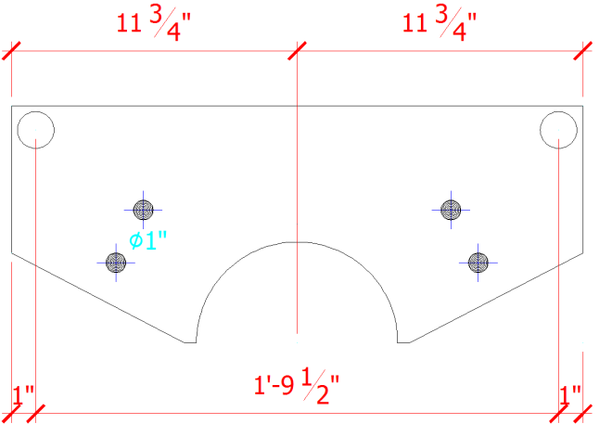
  - Add special Group:
    - Reference points:
- Dimension---> All manual references point will be dimension.
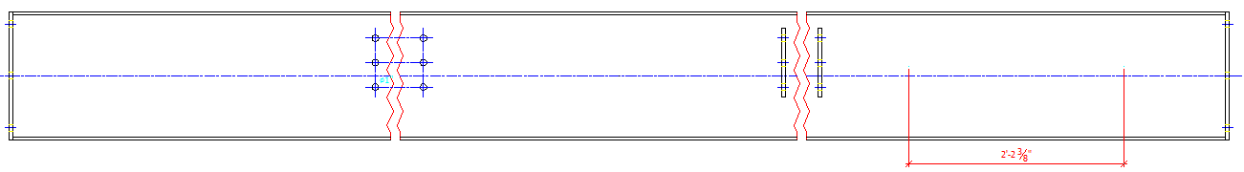
- Local Reference Plane:
- Dimension---> Connecting shape reference point will be dimension. This dimension works in hand with “Holes as Top view” or “Holes as Side view” as well as Miscellaneous Reference Points options.
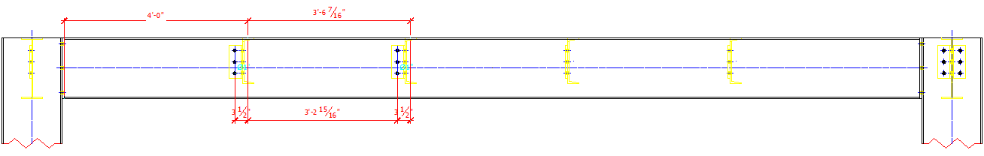

    - Us Cope:
- Dimension---> Will dimension any other edge cuts done using cope, notch and polycuts
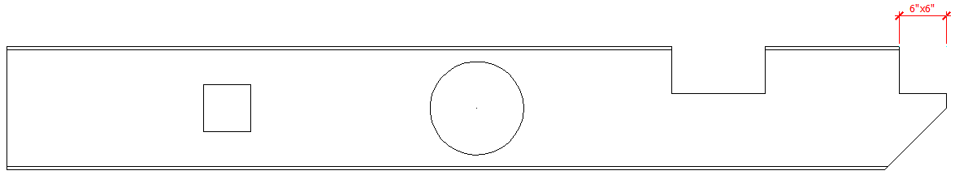

    - Referenced
- Standard ----> dimension point starting from the opposite side of Default reference point.
  - References point ----> 1st insertion point of shape (apply only for shape)
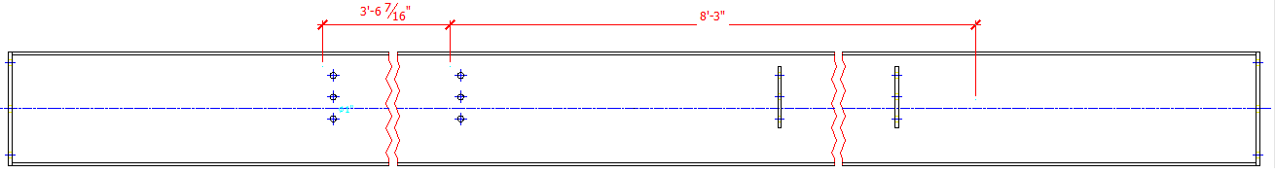
  - Nearest References Point ---> Manually added "Local references Point" under PS3D properties dimension points
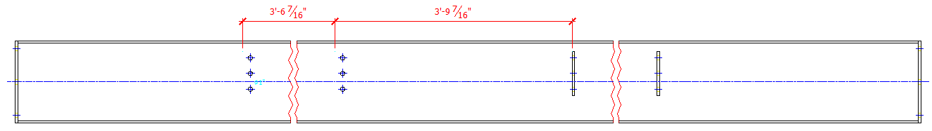
  - Edge of part---> Will dimension to the nearby point, insertion point or end point (apply for shape only)

  - Near reference points ---> Will dimension to the nearby Edge Reference point Reference (work if reference points are add from the PS3D - Position)
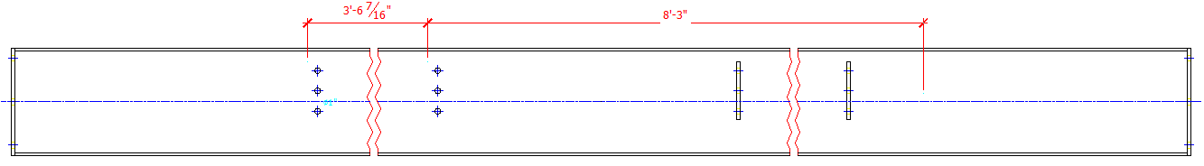

  - Edge Reference zone ---> Dimension will start from the nearby reference area.
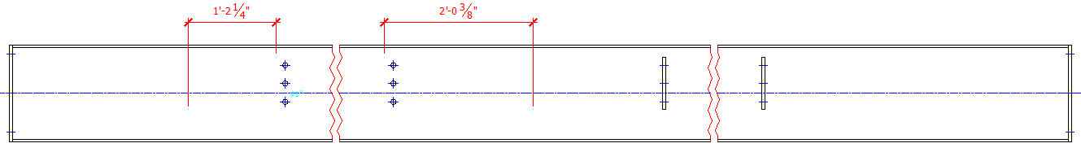

  - Start of part ---> Dimension point begins at start of shape.
  - Start Reference zone ---> Dimension point will start at "local reference Area" (under PS3D properties dimension points)1st point
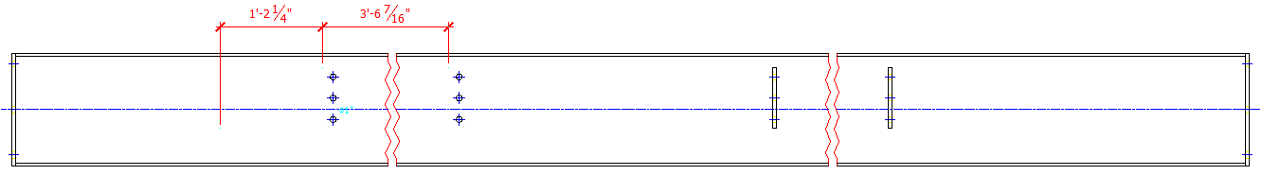
  - Pat mid ---> Dimension point will start at middle of the shape
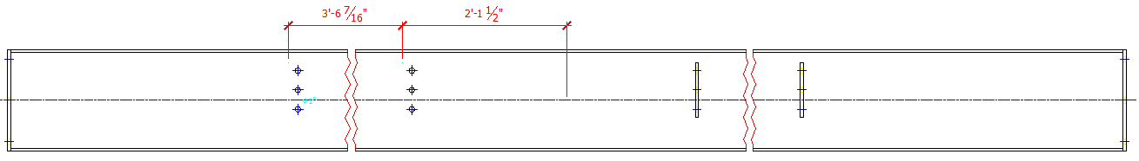
- Connection shape---> All supporting connection holes will be dimension starting from the supporting references point.
- Additional dimension line
  - NO---> no additional dimension will be added
  - Part ---> Additional dimension will be till the end of the shape.
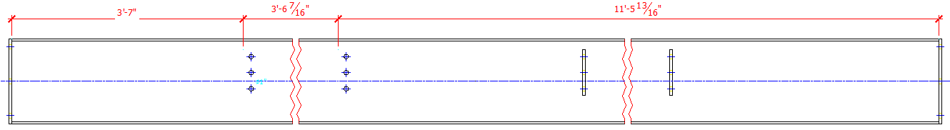
  - Reference points ---> Dimension all reference Points
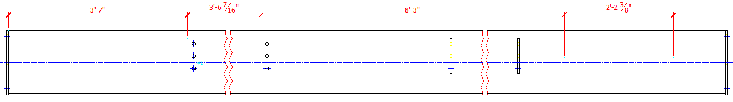

  - Part + reference Point ---> All reference points including the end of the shape will be dimension.
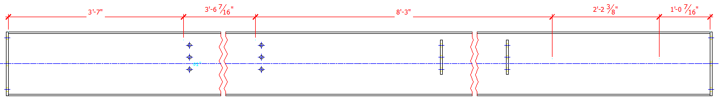
  - Reference Points ---> All local references points will be dimension. 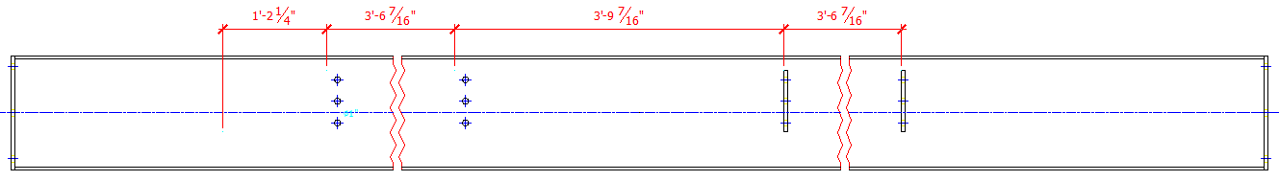
  - Reference zones ---> All local reference point will be dimension.
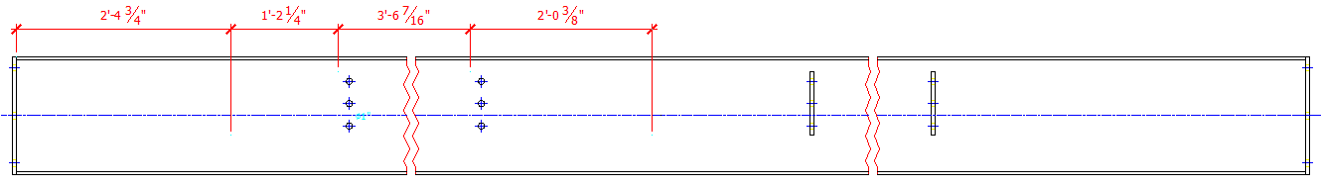
  - Ref.points and –zones ---> All local reference point and local reference zone will be dimension
