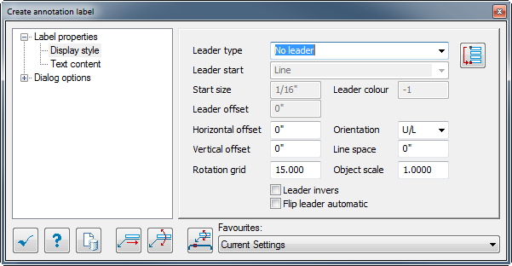
Leader Type:
No Leader: no line will be added.
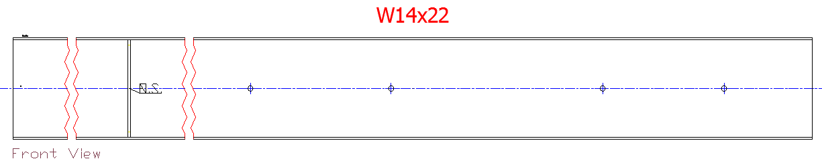
Base Line: Line will be added under the text

Center Line: Line will start from the Prosteel element and end at the center of text
Leader Start:
Line:
Arrow: Arrow will be added at leader start
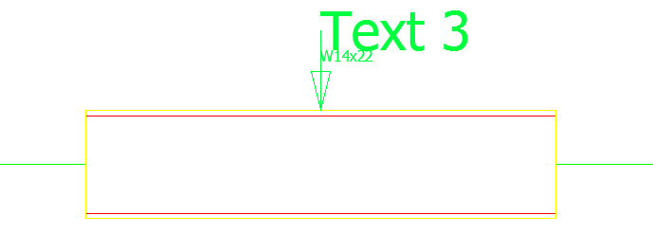

Circle: Circle will be added at leader start
Start size: This option allow the user to control arrow and circle size for leader start
Leader color: allow the control the leader line color.
Leader Offset: With base line Leader type it will extend the line by the given value, but with the Center Line leader type it will puss the label by the given value.
Baseline:
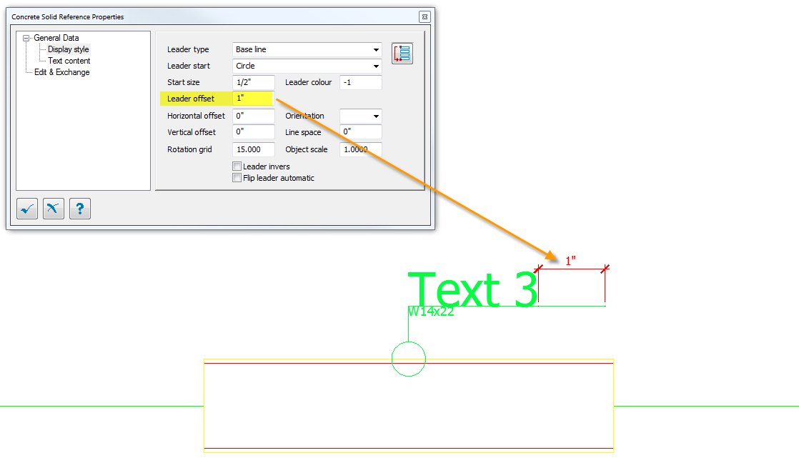
Center Line:
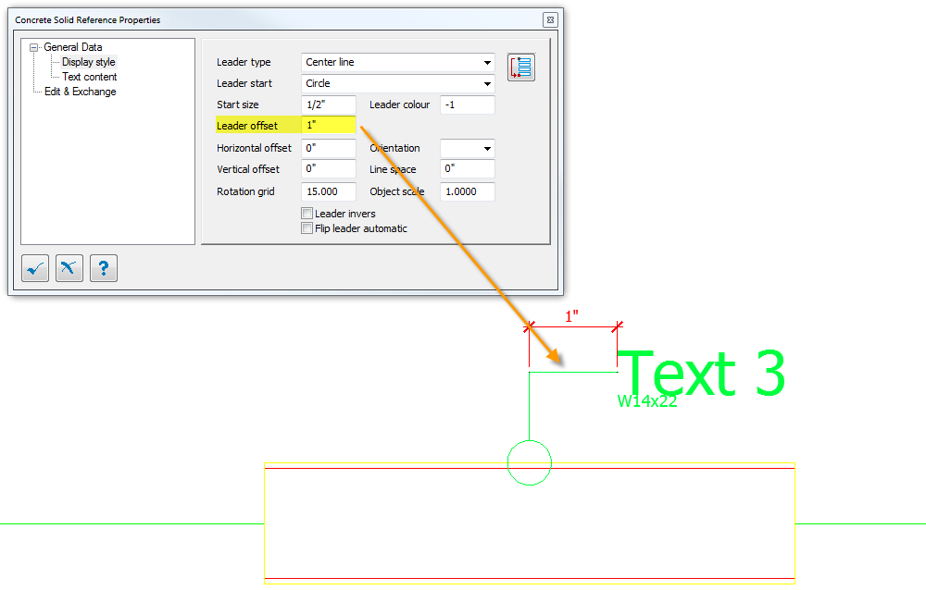
Horizontal Offset: (work with Baseline and CenterLine)
It will allow the user to move the text horizontally by the given value.
Vertical Offset: (work with no leader and Baseline)
Rotation Grid: Allow to insert a rotation degree angle. (Rotation is done by the right grid line)
Orientation:
GR/L: Groups Left***
U/L: Upper Left
U/M: Upper Middle
U/R: Upper Right
M/L: Middle Left
M/M: Middle Middle
M/R: Middle Right
O/L: Down left
O/M: Down Middle
O/R: Down Right
Line Space: user can add distance between each text.
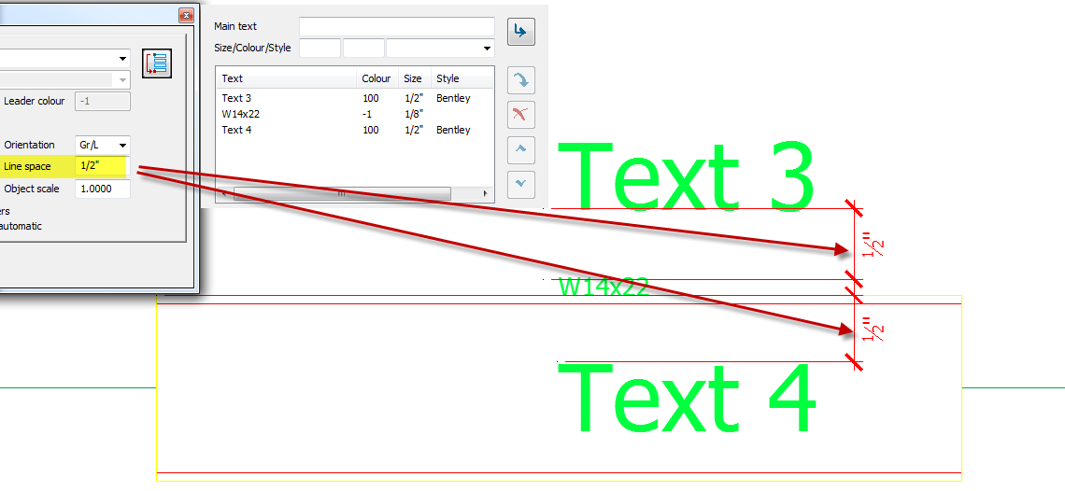
Object scale: This is a global scale for all Text content which can also be control individual from the text Content tab with color and text style
Leader Invers: Text will be mirror automatically
Flip Leader automatically: This option will allow the user to mirror the text manually using the grid points.
Please note that when color value is set to (-1) It’s will use the active layer in AutoCAD or level in MicroStation.

