Company Name

eB

Adding Templates
DOCUMENT NAME | User Manual for
DOCUMENT NUMBER | USE-000114
DATE CREATED | 01 April
REVISION STATUS | Not Approved
REVISION NUMBER | 1
AUTHOR
OWNER | DocQnet Systems International

© Copyright 2013 DocQnet Systems International.
All rights reserved. No part of this document may be reproduced, translated, stored in a retrieval system, in any
for or by any means, electronic, mechanical or otherwise, without the prior written permission of the owner

Table of Contents

Company Name 1
Adding Templates 3
Pre-Requistes 3

Adding Templates

Pre-Requistes
- eB Director installed
Adding Templates

Creating Templates is an Administrator function and no permissions should be granted to unauthorised users. Please make sure that the template is really needed before creating. Once a template has been used it cannot be deleted. If no longer in use it can be made Obsolete.

Creating templates on eB will allow adding documents faster. When adding templates it will be for specific documents i.e. specifications. The template will contain the required Attributes, Responsibilities, Security, Virtual Item or any other required attributing information.

Log into eBDirector with your own:
User Name and Password

From the main menu bar select VIEW - Open System Admin (F8), so that System Admin shows in the left hand pane.

Click on Documents and on the right hand side the Class Group - Documents will be displayed.
To create a new Class, select Child Class on the right hand pane and select New.

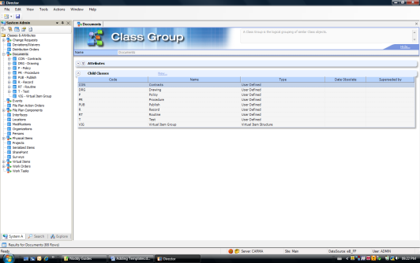

Add the code i.e. Policy = POL and add the Name, Description and Type. The Type will be selected from the Drop Down and for general documents the User Defined would be selected. When all the details have been added, select Add.

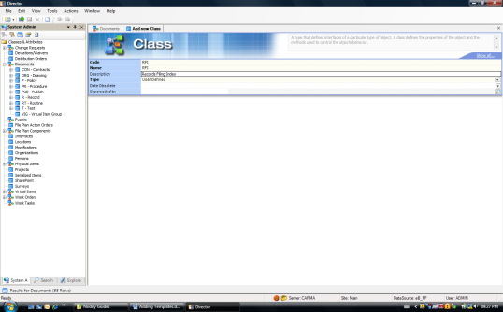

Now the class attributing information can be populated.

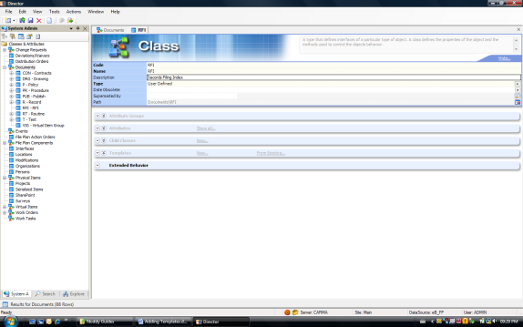

Select the Attributes that need to be displayed on the Class and click on the Attributes that must be Inherited.
Select the Templates and create the template as required by selecting New

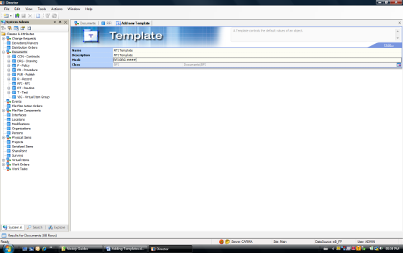

Add the information and if an Automated number is required add the Mask as it must be displayed, depending on your Organisations numbering system. Now select Add

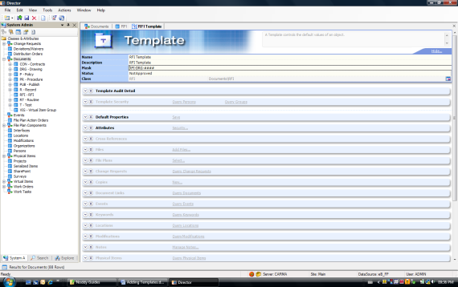

Add the Template Security by searching the Person or Roles, selecting from the Results window by dragging and dropping to Template Security.

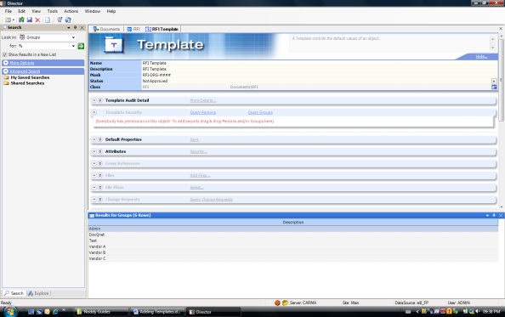

Also select the View, Modify, Approve and Can Use options.

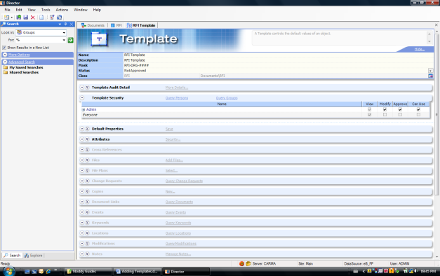

Add the Default Properties:
- If you want the revision to be displayed when creating a document from this template, add the revision the way it should be displayed.
- The Title – add it in brackets as the title will be changed with each new document added.
- Approval Status – set to Not Approved, as all required attributing information should be completed and then only will the document be approved.
Once all information have been completed, select Save.

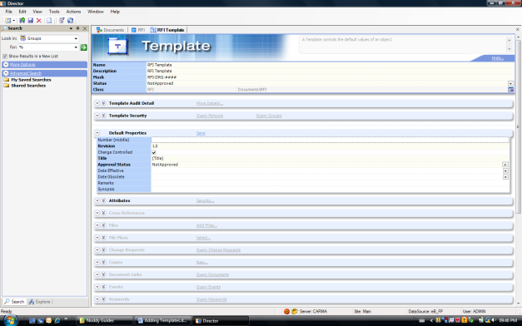

Now complete all the relevant attributing information for the Template that should appear on the new document

If an electronic document template must be added, select Files – Add Files

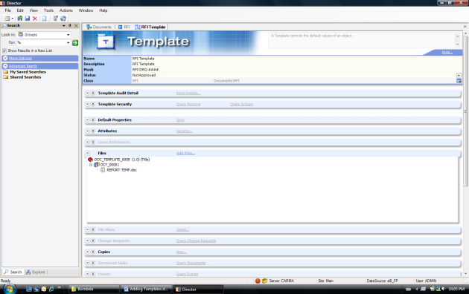

Save after all information has been added.

If the Template is correct and will now be used, it must be Approved.
Select the Status and on the drop down select Approve and close.

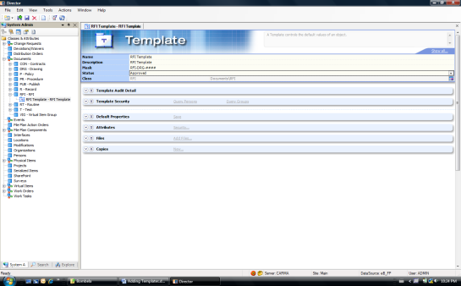

If for any reason the Template is not correct, go back to the Template and set the Status back to Not Approved. Do the required changes and Approve again. If the Template has not been Approved, you will be unable to use it.

Creating a New document from a Template

When a new document is created the New from Template option will be displayed. If it is the first time the new template will be used it will not show on the Template list.

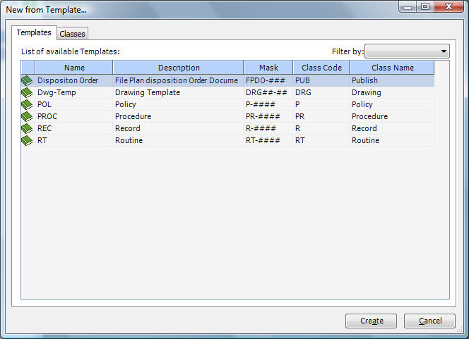

Select Classes and go to Documents, RFI (newly created template) and then the Create option will be displayed at the bottom. Select Create. (The next time the option will be displayed under Templates)

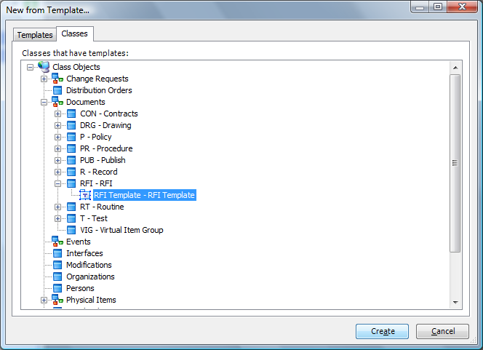

Once the Template has been used to create a new document, all the information selected on the template will be displayed on the new document. Now update the title and any other information like the document number if an automated number is not being used, the revision and any other information needs to updated.

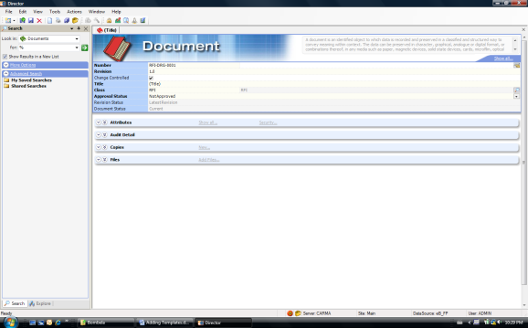

The file added is an electronic template of the document format. The electronic file will be displayed in grey and have the (Copy pending) in brackets

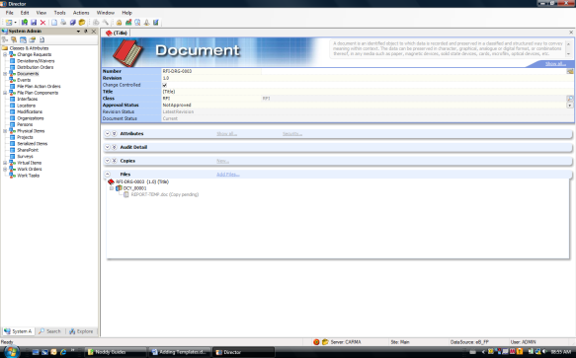

In order to update the document, the document needs to be checked out, changed and checked back. Please follow the instruction in the CheckinCheckout guide that is available in eB.

