I have ProjectWise share linked to my desktop
When I go to update files on the desktop linked Share Folder, they are not syncing with the files on the Browser. See Below where I edited an excel file and saved it.
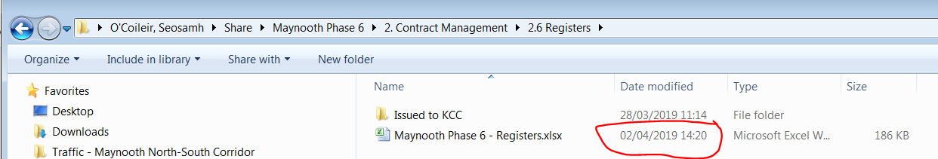
The changes I made to the excel file are not appearing on the file in the browser.
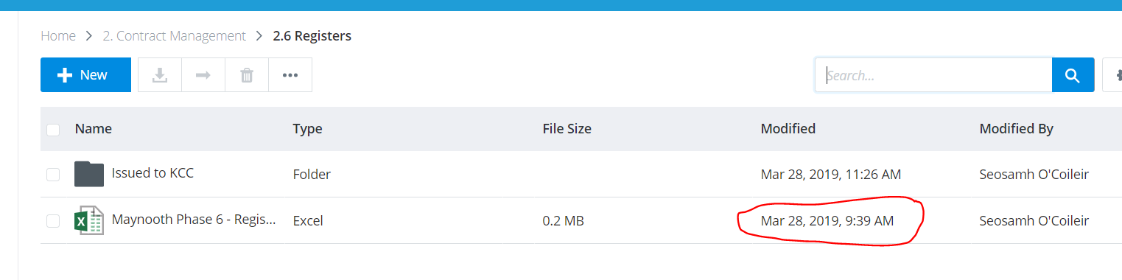
However if I add a new file to a folder, the new file will sync.
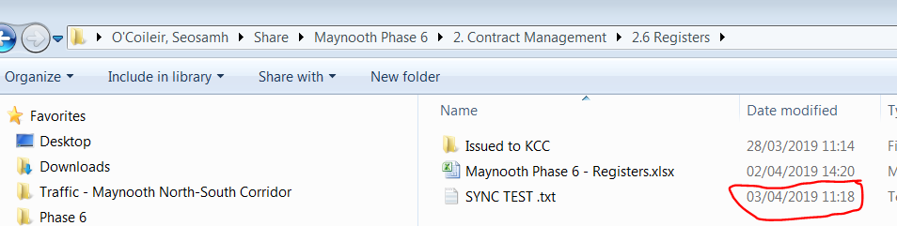

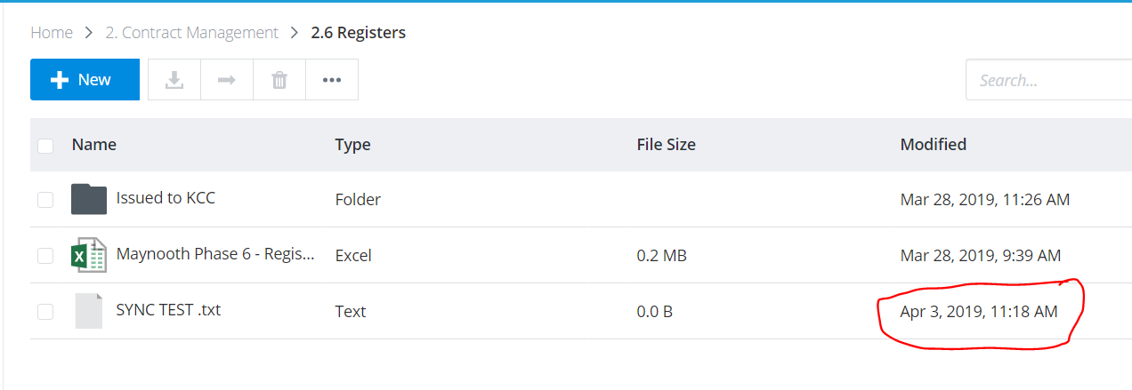

This is a major issue as there a number of users accessing files in these folders, and files are being updated on a daily basis.

