- Terrain: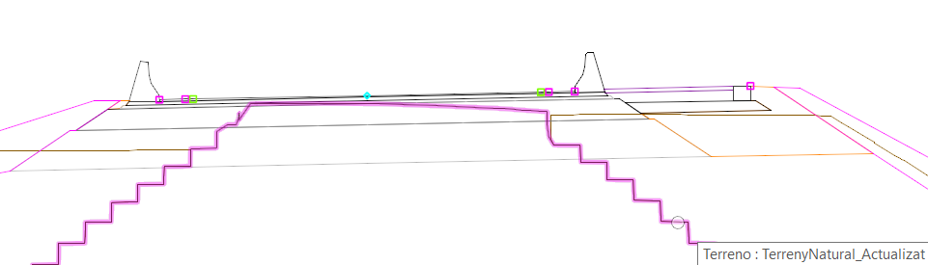
- Corridor elements: 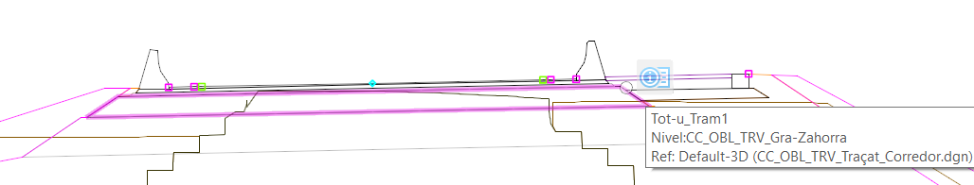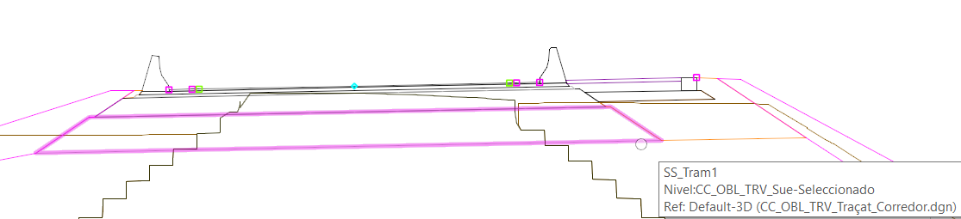
- Cut: 