A conflict occurs only at the time of a Merge. It must be resolved before the merge. A conflict can already occur between 2 versions of the same Oracle user. If the accessed Oracle tables are not in optimistic mode, but are in pessimistic mode, then the last person to commit to a given version will always be successful (i.e.: the edits will overwrite the existing values in the table) and no conflict will be reported.

Conflicts allow three states of the same feature instances: ACTIVE, BASE, and CHANGED BASE.
- ACTIVE: The state of the database from the version that is conflicting.
- BASE: The database from the Parent version at the time the child version was created, before any edits were made. This can also be a child of LIVE (or deleted, not visible?).
- CHANGED BASE: The database from the other child version that was created and committed before or simultaneously with the ACTIVE version.

Example:
Open the Select Version dialog. The version east_city_lots_version2 is in red.
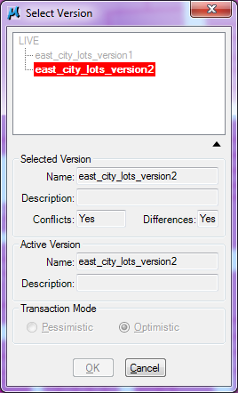
To resolve the conflicts open the Conflict Inspector.

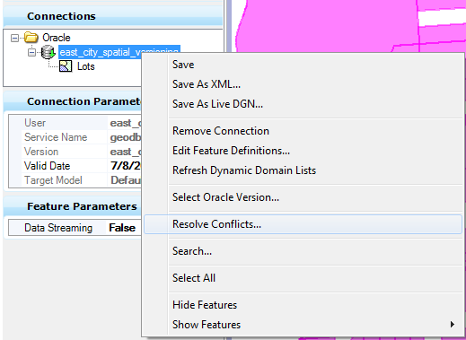
Note: The option Resolve Conflicts is only available w/ a version w/ transaction mode is Optimistic Locking.
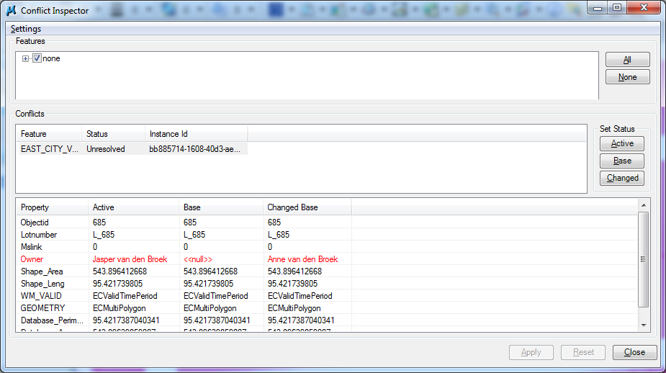

Resolve the conflicts in the Conflict Inspector. Select the Feature and click Active to use the current Status. The dialog should be empty
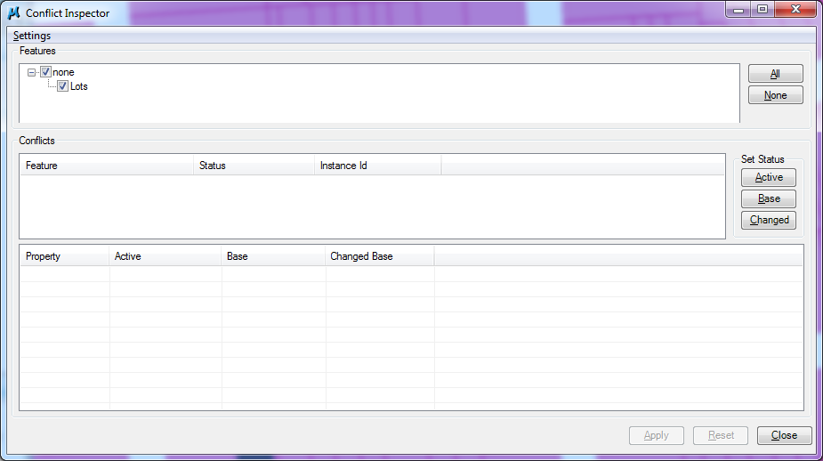

Click close, you will be asked to commit the current conflict session, click Yes to continue.

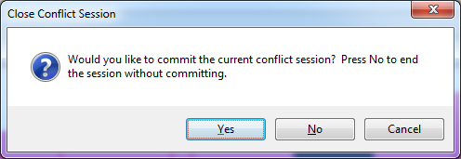

Merge the version East_city_lots_version2 into Live.
