AutoPipe _display issue

Some characters not display correctly, even the non-Unicode was set to Chinese

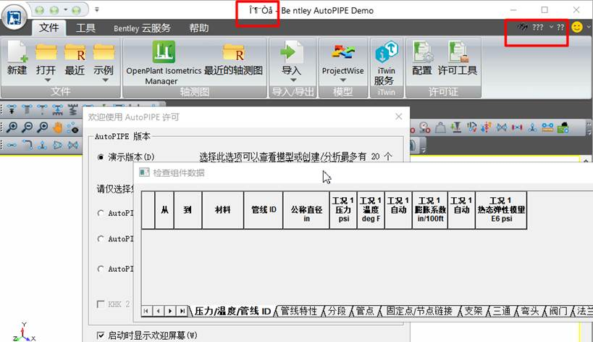

To solve this issue, the formats also need to set to Chinese （following to location below）

